Assessing Urban System Vulnerabilities to Flooding to Improve Resilience and Adaptation in Spatial Planning

Riccardo Pasi[1], Christophe Viavattene[2], Goffredo La Loggia[3], Francesco Musco[4]

Abstract

Fluvial, pluvial and coastal flooding are the most frequent and costly natural hazard. Cities are social hubs and life in cities is reliant on a number of services and functions such as housing, healthcare, education and other key daily facilities. Urban flooding can cause significant disruption to these services and wider impacts on the population. These impacts may be short or long with a variably spatial scale: urban systems are spatially distributed and the nature of this can have significant effects on flood impacts. From an urban-planning perspective, measuring this disruption and its consequences is fundamental in order to develop more resilient cities.

Whereas the assessment of physical vulnerabilities and direct damages is commonly addressed, new methodologies for assessing the systemic vulnerability and indirect damages at the urban scale are required. The proposed systemic approach recognizes the city as a collection of sub-systems or functional units (such as neighborhoods and suburbs), interconnected through the road network, providing key daily services to inhabitants (e.g., healthcare facilities, schools, food shops, leisure and cultural services). Each city is part of broader systems —which may or may not match administrative boundaries—and, as such, needs to be connected to its wider surroundings in a multi-scalar perspective. The systemic analysis, herein limited to residential households, is based on network-accessibility measures and evaluates the presence, the distribution among urban units and the redundancy of key daily services. Trying to spatially sketch the existence of systemic interdependences between neighborhoods, suburbs and municipalities, the proposed method highlights how urban systemic vulnerability spreads beyond the flooded areas. The aim is to understand which planning patterns and existing mixed-use developments are more flood resilient, thereby informing future urban development and regeneration projects.

The methodology has been developed based on GIS and applied to an Italian municipality (Noale) in the metropolitan area of Venice, NE Italy.

**Keywords**: flood impact modeling; urban systems; systemic vulnerability; spatial planning; adaptation

# Introduction

Flooding from a wide range of sources is the most frequent and costly natural hazard (IPCC 2012). It is commonly accepted that flood risk is growing, as a consequence of both climatic and non-climatic factors (Ronco et al. 2014). Several studies state that most of this increase has to be attributed to non-climatic factors, showing that the majority of losses arise in urban areas (Jongman et al. 2012). As a consequence, the improvement of society’s resilience or the reduction of its vulnerabilities is the main objective, as tackled by several papers and governmental policies (Djordjević et al. 2011; Thieken et al. 2014; DEFRA 2004; UNISDR 2004; EEA 2005; EC 2013).

As recently stated by De Moel et al. (2015), among the existing risk-assessment methods there is a clear need for information on indirect flood impacts—understanding how failures within a system can cascade through a system—and a critical need to improve the understanding of the effects of flooding on critical infrastructures and facilities, given their importance to society and economy. Others (Merz et al. 2010) highlighted the relevance of indirect damage—especially in large disasters—and the difficulty in their economic evaluation with the current methods. A new simple, quantitative, flood-impact assessment methodology—focused on the indirect impact produced by a flood over the functioning of an urban area as a whole—is then proposed.

# Theoretical Framework

## Flood Risk and Vulnerability Assessment

Risk assessment represents the necessary first step of any serious risk-reduction strategy. The classical formalization of the risk concept (as a function of hazard, exposure and vulnerability) is assumed. If hazard and exposure are straightforward concepts, a brief note about the more complex notion of vulnerability is required. Vulnerability is recognized as reflecting both fragility in the face of external stress (receptors’ susceptibility) and the processes that deprive people of the means of coping, without incurring damaging losses (receptors’ coping capacities and resilience) (UNISDR 2009; IPCC 2012). Systemic vulnerability and resilience are strongly related concepts: resilience, in fact, emerged as a way to understand how systems prepare for, respond to and recover from shocks (Zhou et al. 2010). Quoting the UNISDR (2012) definition, a flood-resilient city is assumed to “resist, absorb, accommodate to and recover from the effects of a flood hazard in a timely and efficient manner, including through the preservation and restoration of its essential basic functions”. On the contrary, urban-system vulnerability is here understood as the inability to continue providing efficient support for citizens’ daily activities when some urban components have been flooded.

Systemic impacts are understood to mean how the direct losses caused by a hazard propagate within and between various systems, generating other losses beyond the hazard areas. A system refers in general to a set of elements interconnected and somehow organized, providing functions and outputs. They are usually approached through the characterization of their single, elementary units, the disclosure of their physical and functional interconnections and the definition of their boundaries (Viavattene et al. 2015). The spatial distribution of these elements defines the existing relationships, the uniqueness and the adaptability of the system.

## Urban System Theories

Urban system theory was first developed by geographers and economists: in the 1930–40s, Christaller (1933) and Lösch (1940) developed the ‘central place theory’, conceiving of urban settlements in terms of a hierarchy, in which each place provides the majority of goods and services to be found in places lower down the hierarchy, plus an additional range of more specialized ones. Over time, emerging gaps between the model and real-world led to the theory almost being abandoned, but its essence evolved into the urban systems approach (Berry 1964; Pred 1977). Urban systems theory conceives of urban places as forming an interdependent hierarchy, the structure of which is determined by the spatial distribution of centers of production and consumption (e.g., factories, offices, shops, cultural and leisure activities) (Aiken et al. 1987). Being part of a system, each city interacts with the other centers on a similar level, but also cities at different levels are dependent upon one another (e.g., for specialized services and commodities). Improvements in transport and communications, together with “the blurring and rearticulation of urban territories” (Brenner and Schmid 2012), have extended the range of influence of urban centers: contemporary cities exist in a world of flows, linkages and connections, being relationally networked with other cities via transnational webs of capital, labor and communication infrastructures. Nowadays, the explosion of the city outwards from traditional spatial and theoretical frameworks makes it more difficult to model contemporary urban systems and their operation mode. Despite this, a method to assess how flood impacts spread within a city beyond the flooded areas will be developed. The articulation of urban areas—in fact—somehow determines the organizational pattern and the spatial distribution of urban functions, conditioning both the accessibility to facilities and inhabitants’ adaptation capacities (Marinosci et al. 2015).

# Assessing Systemic Flood Impacts over Urban Areas

Urban areas are served by a wide variety of infrastructures providing the services of modern urban life. Their flood-induced impairment can be highly impactful, given that the gradual increase of interdependence between urban units has multiplied the effect of disturbances on systems across the scales (Finka and Kluvánková 2015). These infrastructures include—among others—utilities (power, water, telecommunications, etc.), transport services and public facilities; the proposed method addresses the last two elements. The aim is to focus on how direct flood impacts on public services and the road network may influence the system as a whole. As a result, the model provides a quantitative evaluation of the functional loss of each urban unit, precious information for spatial planners and decision makers to prioritize mitigation measures and foster adaptation strategies.

## Literature Review

From a review of the literature, Penning-Rowsell et al. (2013) explored indirect losses to inhabitants’ daily lives accrued through the flooding of transportation networks, utilities and public services (i.e., schools and hospitals). In their assessment, based on UK data, potential losses to the provision of public services are appraised in economic terms. Indirect losses generated by the flooding of schools, for instance, are assessed through the loss of parents’ earnings due to the need to take time off to care for their children. They provide some methods to estimate indirect losses, but without analyzing the role of the spatial distribution of urban systems. Menoni et al. (2002) attempted to evaluate the systemic vulnerability of a territorial system (at the regional scale) by assessing lifeline failures due to earthquakes. Their model, focusing on a large number of indirect damages, aims to define where to engage in more detailed studies (such as towns and cities most affected). The study highlighted the need to quantify, through spatial analysis, the contribution of infrastructure (e.g., road networks) and structures (hospitals, industries, schools etc.) in a city system to support decision making regarding the type and location of mitigation interventions. Pascale et al. (2010) and Sdao et al. (2013) focused on the estimation of dependencies within an urban system in terms of physical damage and functional relationships between operative centers and industries at risk or roads and private buildings at risk, due to landslide or flood events. However, they did not analyze the spatial accessibility and operability relationships—based on path connections—within the urban system. Albano et al. (2014) developed a methodology based on GIS to estimate flood consequences on the urban scale with a model that estimates the degree of accessibility between strategic emergency structures and exposed receptors. The approach makes possible defining a hierarchy among various roads, but just in the emergency-management perspective and in the emergency phase.

## The Proposed Assessment Method

This study tries to overcome the limitations of the approaches just discussed. The assessment is limited to the impacts suffered by the residential households of a given municipality, analyzing the spatial distribution of some facilities and their redundancy. It is based on GIS, essentially working on accessibility measures through road-network analysis. As highlighted by Lotfi and Koohsari (2009), the use of public facilities can be linked to accessibility, and thus residential proximity to facilities and services can be theorized as contributing to health and well-being. The practical importance of service distribution in urban areas is based on the need for services underpinning the viability of urban life (Erkip 1997), and the distribution of the benefits of consuming them is distance dependent (White 1979).

The proposed method has been applied in the municipality of Noale, a small town (16,000 inhab.) that is part of the Venice metropolitan area, whose area is characterized by a flat morphology and a significant exposure to fluvial and pluvial flood. Furthermore, Noale is part of one of the most well-known examples of Italian urban sprawl (Indovina 1990; Fregolent and Tonin 2010), possessing high urbanization rates and a complex system of functional interdependencies with the surrounding urban areas.

The following main steps have been addressed for modeling urban systems:

* Defining and classifying urban units: urban areas are recognized as a collection of sub-systems or units (e.g., urban centers, suburbs, villages). Since the most detailed information on population is at the census-tract level, census tracts are assumed as reference units; furthermore, given that Italian census tracts are grouped in localities (ISTAT 1992, 2012) according to their physical and socioeconomic features, this classification is used as a basis for the identification and demarcation of the urban units within the case-study area.
* Defining urban system boundaries: each unit is home to its inhabitants, whose demand for services cannot be usually satisfied within the same unit. In order to tackle the daily-life dynamics of citizens, the scale of analysis is widened beyond the municipal boundary, using data on work-commuting flows to contain the wider urban system where inhabitants seek the various types of services. Across many socioeconomic issues—in fact—the labor market is the most crucial domain within which the life chances of people are shaped, representing their geography of opportunity (Coombes et al. 2012).
* Defining the key daily services: the service equipment of each urban unit determines its role within the system. Spatial-planning practices have traditionally addressed the issue through a careful allocation of public services, implicitly assuming that the public provision of services is beneficial to residents’ well-being (Witten et al. 2003). Through a literature review mainly related to spatial equity issues (Tsou et al. 2005; Lotfi and Koohsari 2009; Taleai et al. 2014), recurrent categories of basic facilities have been identified. These same categories largely correspond with those set by the Italian town-planning legislation. Despite a great variety of facility types that can be included in these broad categories, the focus has been kept on really essential daily facilities, grouped into four main categories (see Table 1).
* Measuring accessibility in normal conditions: Accessibility is commonly defined as the ease with which activities can be reached from a certain place and with a certain transport system (Morris et al. 1979; Johnston et al. 2000). Several alternative measures of accessibility can be used, including the consideration of various transport modes, the issue of multipurpose travels etc.; in this study, these complicating factors are ignored, using simple road-distance metrics. Furthermore, several methods (or indices) to measure accessibility can be used (Talen and Anselin 1998): a travel-cost approach has been chosen, averaging only the closest facilities (stopping at the first natural discontinuity in their distance ranking).[5] Accessibility values (in meters) to each type of facility are hence calculated and assigned to each urban unit.
* Measuring accessibility in case of flood: To this extent, the flood-hazard scenario can be added and the distance calculation repeated, at first excluding both flooded services and roads (thus representing the flooding phase)[6] and after excluding only flooded services (thus trying to mimic the recovery phase and implicitly assuming a faster recovery capacity for roads than for services).[7] The new accessibility values (in meters) to each type of facility for both flooding phases are calculated and assigned to each urban unit.
* Defining an impact-scoring method: The flood-induced impacts suffered by the inhabitants of each urban unit are finally calculated through a scoring method based on the relative change between the accessibility values in case of flood compared to those in normal conditions ([Xflooded – Xnormal] / Xnormal).[8] In this way, the increased distances between units and services in the two flooding phases are used to indirectly map the existence of interdependencies among the various urban units, as well as their different degrees of vulnerability.
* Weighting each facility type by means of multicriteria analysis techniques: In doing so, each urban unit gets a single accessibility (or impact) value in each phase, representing its overall situation with respect to all types of services; an hypothetical weights distribution is shown in Table 1.
* Multiplying urban-units’ impact scores by their population (used as exposure factor), thus achieving a realistic representation of the risk.

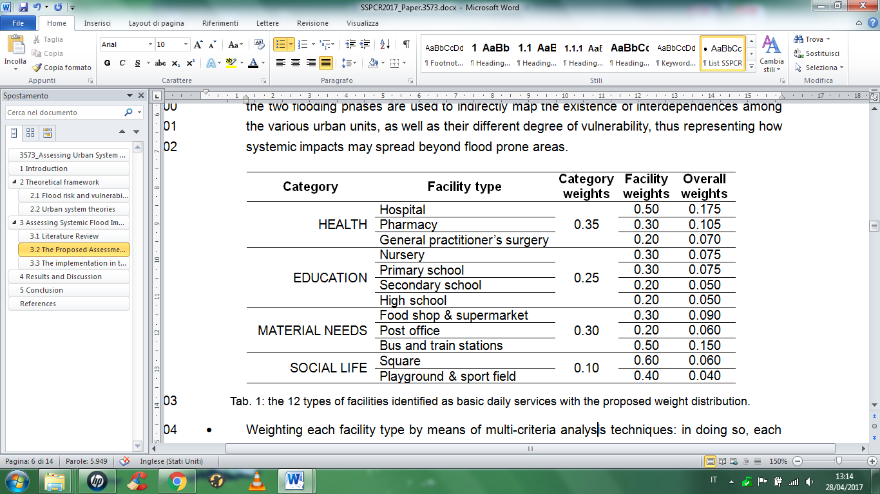

**Table 1**: The 12 types of basic daily facilities (and their weights) as identified by the authors (Sect. 3.2, 3rd bullet point).

## The Implementation in the Case-Study Area

The case-study area is the Italian municipality of Noale, part of the Venice metropolitan area.

For the definition of Noale urban units, the ISTAT (2012) classification of census tracts in localities, the layer with the official boundaries of the main settlements of Noale (provided by city officials) and some basic photo-interpretation techniques have been used. Five types of urban units—for a total of 20 units—were identified (see Fig. 1):

* the urban center (Noale), i.e., the main clustered settlement characterized by a compact building fabric, several squares and street, and a wide range of urban services;
* the villages (Moniego, Briana, Cappelletta) that are the minor clustered settlements, physically separated from the urban center, and typically equipped with a parish and few local services;
* the rural-urban fringes, identified as those linear settlements extending along the main roads and physically adjacent to a clustered settlement, usually not containing any service;
* the inhabited nuclei, made up of a few grouped buildings that do not generate any socioeconomic attraction on the surroundings and do not host any public space or service;
* the industrial areas, recognizable by the typical shapes, sizes and geometries of industrial buildings, and randomly serviced by some types of facilities (especially commercial ones).

For the definition of the urban system of Noale, a subset of eleven municipalities—all belonging to the local labor-market area of Venice (ISTAT 2015)—have been chosen on the basis of commuting data.[9]

For the identification and localization of the existing services and facilities, a field survey was carried out; however, much of the geo-localization work has been done remotely using free web directory lists, public authority websites and web applications (i.e., Google Maps and Google Street View).

For obtaining accessibility values in normal conditions, distances have been measured based on the road network by means of a shortest-path algorithm applied between the centroid of each urban unit (thus assuming residents as homogeneously distributed inside each unit) and the exact location of each facility. To this purpose, the centroid of each urban unit and each facility node-point was associated with a road-network node; the road network of the whole urban system was hence built within a GIS environment as a graph. In the case-study area, the road-network graph was primarily built with official data provided by the regional spatial data repository (IDT),[10] later edited and refined—especially within the Noale municipality—in order to add all the missing minor roads necessary to connect all the node-points of the urban units and services (see Fig. 2).

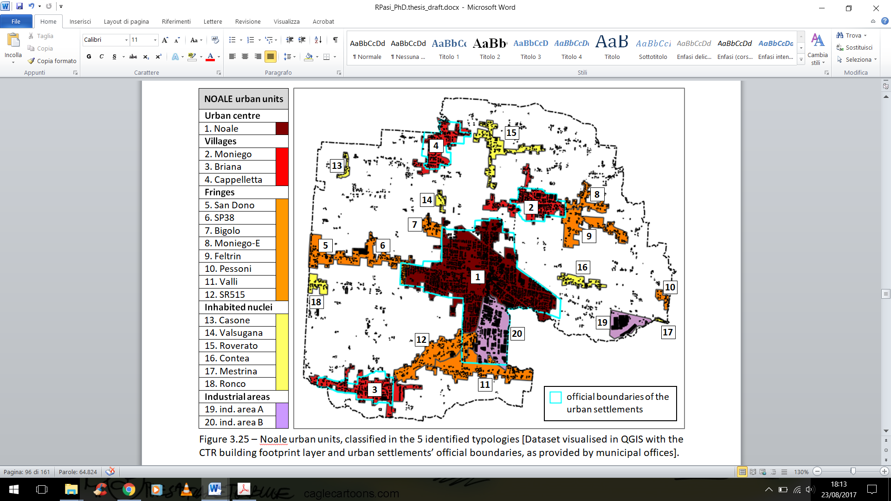

**Fig. 1**: The urban units of Noale municipality, classified in the five locality types.

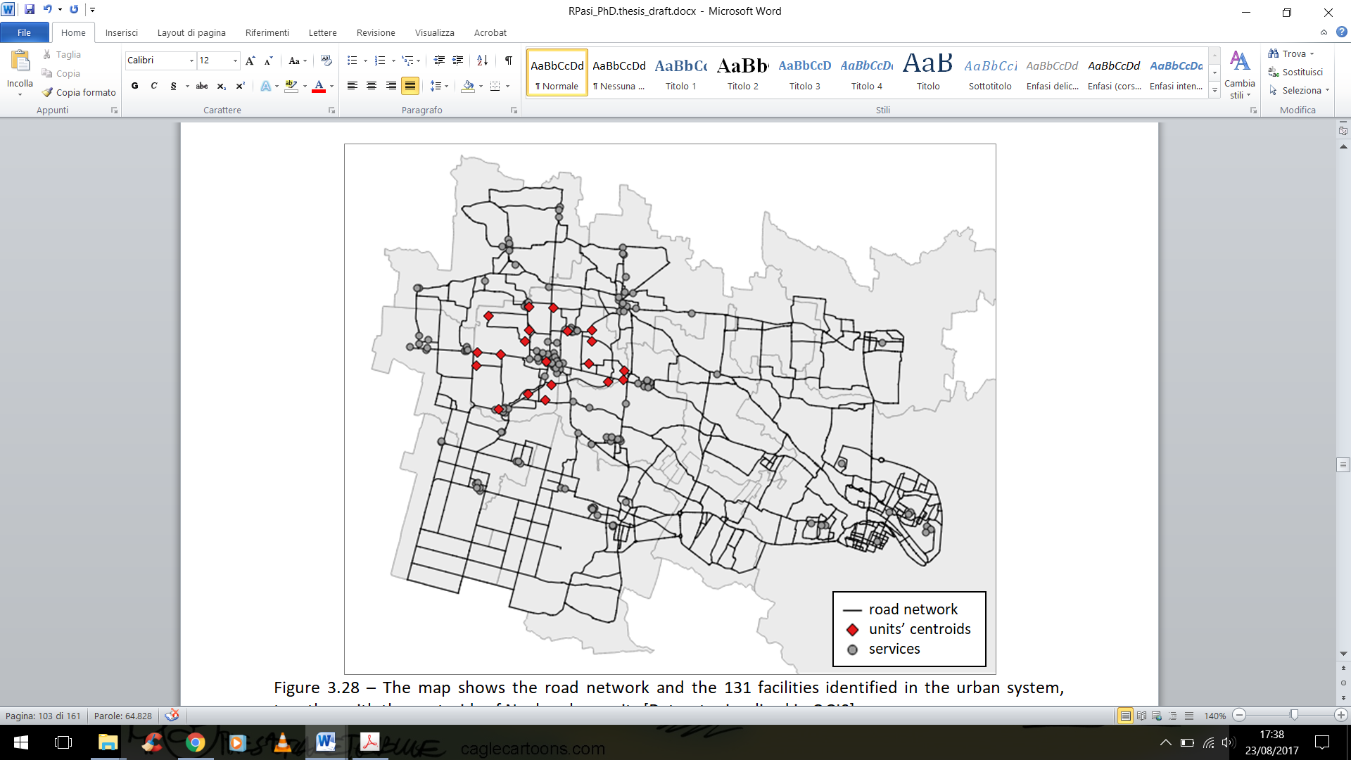

**Fig. 2**: The road network and the 131 facilities identified within the wider urban system (made up of eleven municipalities), together with the centroids of the 20 urban units of Noale municipality.

At this point, the method was applied in two different flood-hazard scenarios: one stemming from the main river network (the river flood, as modeled and mapped by the Eastern Alps river-basin district authority) and the other originating from local drains and channels (the pluvial flood, obtained by working with the extent of the historical events occurred in the last 20 years as recorded by the local land-reclamation authority). The two flood layers have been separately overlaid on the road-network graph and to the service-point shapefile; through simple spatial-analysis techniques, the exposure of road segments and service points has been detected (see Fig. 3). Edges and nodes of the road graph have been considered affected if intersecting any hazard area (regardless of both flood-water depths and structural features of roads); the same has been done for services. As a result, each facility has been assumed as affected if touched by any hazard area, and this information (i.e., flooded/not flooded) has been encoded in the attribute tables of all shapefiles, for both scenarios.

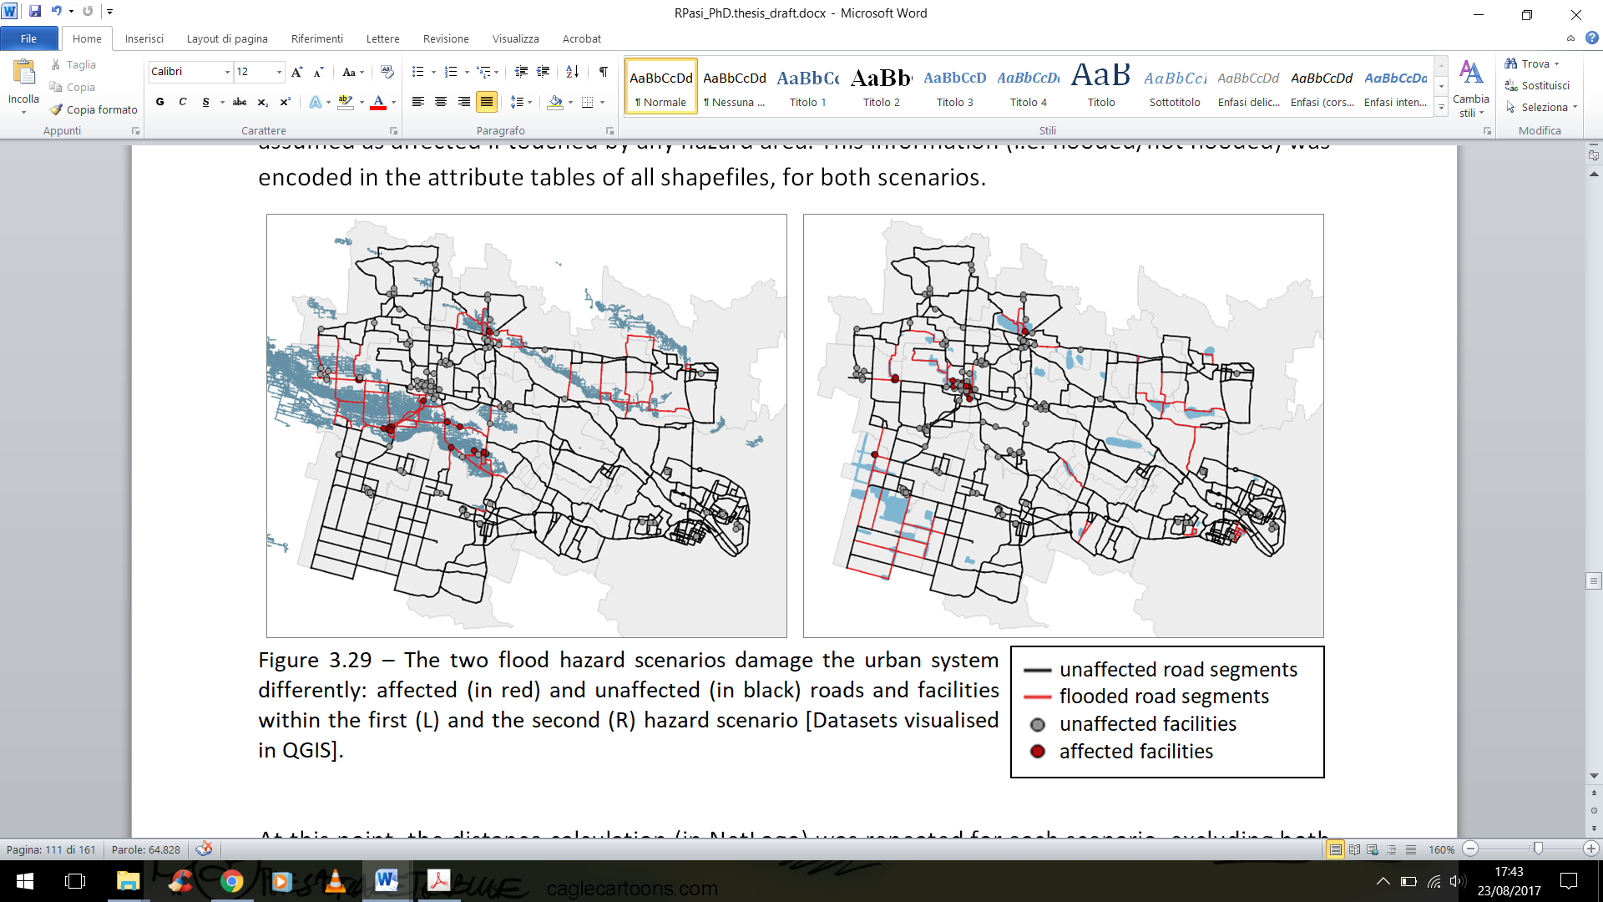

**Fig. 3**: The two flood hazard scenarios (river flood [L], pluvial flood [R]) and the affected urban system elements.

# Results and Discussion

The first hazard scenario affects 17 facilities, while the second one 18. Despite their spatial extents being very different, the two flood scenarios are comparable in terms of affected facilities. This is the first important lesson to be learned: flood potential effects can never be judged by the spatial extent of the flooding. Furthermore, through a spatial visualization of the impact scores (see Fig. 4), it emerges that Noale would suffer greater impacts and more problems for the functioning of the city as a whole from the pluvial flooding than from the river one. The first flood scenario mainly strikes suburban areas (the village of Briana, some southern fringes and the main industrial area), leaving them with no access. Being a wide flood, it affects several roads and produces a negative impact on all urban units. However, the impact suffered outside the flood areas is limited, except for some eastern localities (being closer to the adjacent urban center than to Noale, the impacts they suffer come from there). Once flood waters have receded, impacts too are greatly reduced. The worst scores remain inside the affected units, being particularly high in Briana (the village); many units do not even suffer from any inconvenience, except again for some peripheral units that suffer the flooding accrued outside Noale. The second flood scenario is much less extensive, but affects Noale’s urban center. As a result, almost all units suffer significant impacts, except for a few eastern settlements.[11] Even if small, the flooded areas cause the interruption of some main roads, again producing negative impacts on all units. However, the increase in distances due to road-network disruption is not decisive, given that higher impact scores persist after flood-water withdrawal. All units experience trouble during the recovery phase: the major impacts remain inside Noale (and its adjacent industrial area); the urban fringes of the town center and its nearest inhabited nuclei suffer more than the three villages and the farthest inhabited nuclei. The only exception is a western urban fringe, whose medium-high impact score is due to the partial flooding of the urban fabric of the adjacent municipality.

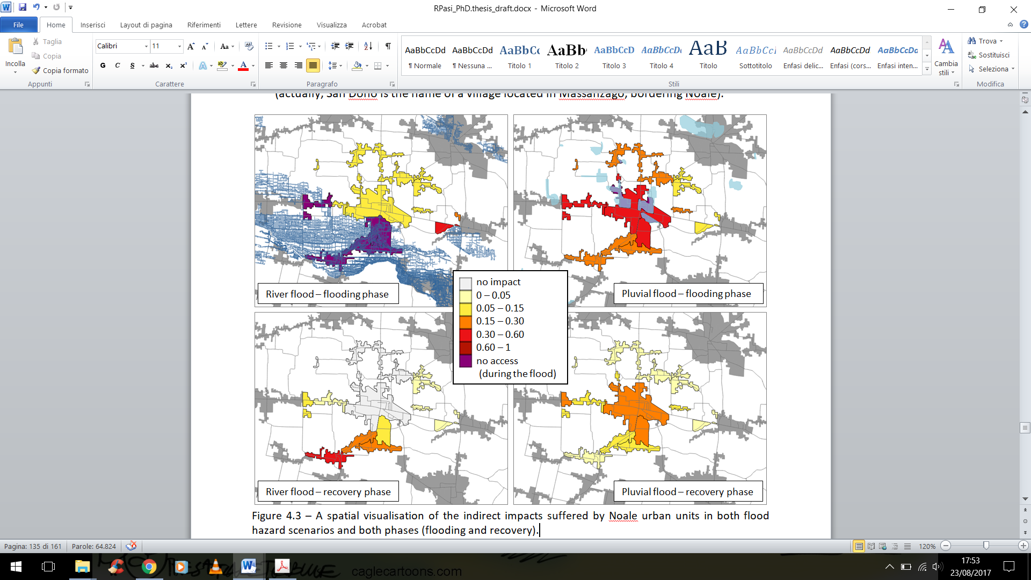

**Fig. 4**: A spatial visualization of the impact scores suffered by Noale urban units in both flood scenarios and phases.

Judging from the case-study evidence, urban centers and villages seem to be the most vulnerable unit types, whereas urban fringes and peripheral nuclei show less vulnerability. Having based the systemic vulnerability appraisal on service accessibility and having measured flood disruption in relative terms (compared to normal conditions), there is no doubt that in clustered urban settlements—where the majority of services are located—people are prone to suffer substantial levels of disruption given their high accessibility levels, whereas in fringe and scattered units—being already relatively far from any facility—residents are less sensitive to a flood-induced increase in the distance to be travelled to access facilities. However, on closer inspection, their resiliency is only apparent and is the result of poor accessibility to all services. More than being resilient or non-vulnerable, these types of settlements can be defined as non-sensitive. Good evidence of this can be found in their radical change of response if, hypothetically, a new facility is located close to one of them: following the method assumptions, their behavior would suddenly become similar to that of urban center and villages, showing the highest vulnerability rate. As a result, it can be deduced that increasing the number of services anywhere is not the right choice: increasing their redundancy, instead, is an efficient strategy, thus ensuring the inhabitants the opportunity to find many alternatives for replacing flooded facilities. But given the real-world constraints (e.g., resource scarcity, scale economies, the need for adequate demand etc.), a full and redundant range of services cannot be achieved everywhere. Municipal authorities should then support the concentration of services in the main residential areas, where some facilities already exist, pushing for the creation of one or more cores in the provision of services.

# Conclusion

Resilience thinking is becoming an important way for city planners to manage flood risks (Hammond et al. 2015); hence they need to assess and understand flood impacts—even the indirect ones—at the local level in order to build (and retrofit) flood-resilient cities. As highlighted by Musco (2012), adaptation actions need a strictly urban and extremely localized approach: there are no one-size-fits-all policies, given that adaptation is a complex mechanism based on local peculiarities. Despite many efforts to determine vulnerability, there is little agreement about what is the most appropriate scale, level of (dis-) aggregation, functional relationship and trade-off between its various constituents (Mysiak et al. 2013).

Assuming a multi-scalar and multidisciplinary approach, a quantitative method has been created to measure the systemic vulnerability of the urban fabric on the municipal level. Its main strength lies in the originality of the proposed approach: as far as it is known, it is the first time that urban system theories have been applied to depict citywide indirect flood impacts. On the other hand, many limitations affect the proposed method, such as: the assumption of service accessibility as the main indicator to depict indirect impacts on the urban scale; the lack of validation in a strict quantitative sense, given the lack of historical flood-damage records in the case-study area; and the lack of sensitivity analyses on the methodological choices assumed throughout the assessment steps. As a consequence, even if the proposed method has been developed in accordance with the literature, expert opinions and semi-structured interviews with local stakeholders, caution should be applied to interpretation of the results. Further research developments should address the robustness of the method and evaluate how results would differ if the previous methodological steps are changed. At the same time, further research is needed to reinforce the main findings of the work. The unresponsiveness to urban disruption of scattered and peripheral settlements, for example, should be further investigated in other territorial areas in order to verify its causes (is it a general feature of all inhabited nuclei or an outcome of the sprawling nature of the case-study area?). Furthermore, large towns and cities—having a full and redundant range of services—should exhibit a more resilient response, thus reversing the previous vulnerability ranking of urban units. Further research in different urban areas is required to prove this hypothesis.

However, from the evidence gained in the case-study area, Noale officials should pursue the following strategies for reducing the flood risk in their municipality:

* to invest in protection measures in the urban center (in order to reduce flood likelihood), given that it hosts most of the existing facilities used by the inhabitants of the wider urban area;
* to reduce the physical vulnerability of the buildings containing flood-prone facilities through retrofitting projects, thus ensuring a quick recovery of the system. This strategy should be followed in Briana, where an increase in service redundancy (thus reducing its systemic vulnerability) would be unwise given the high exposure to river flooding of this area;
* to increase service redundancy within the main residential areas. Two alternatives may be considered here: if the pluvial-flood hazard affecting the urban center can be reduced, the first option should be to increase the number of facilities (and the future urban growth) within the urban core; otherwise, the best solution is to increase service redundancy within the village of Moniego, thus creating a second urban core, complementary to (and not far from) the main one, where the inhabitants of both units might find nearby alternative facilities in case of a flood.

Acknowledgements

The paper contains some of the result of a Ph.D. research undertaken at the Department of Design and Planning in Complex Environments (IUAV University of Venice) by R. Pasi. G. La Loggia and C. Viavattene are—respectively—the Ph.D. supervisor and co-supervisor; F. Musco is the head of the IUAV ‘Planning Climate Change’ research group, where the work will be further developed.

# References

Aiken, M., Newton, K., Land, R. F., and Martinotti, G. (1987). *Urban systems theory and urban policy: a four-nation comparison*. British Journal of Political Science, 17(3), 341–358.

Albano, R., Sole, A., Adamowski, J., and Mancusi, L. (2014). *A GIS-based model to estimate flood consequences and the degree of accessibility and operability of strategic emergency response structures in urban areas*. Nat. Hazards Earth Syst. Sci., 14, 2847–2865.

Berry, B. (1964). *Cities as systems within systems of cities*. Papers of the Regional Science Association, 13(1), 147–163.

Brenner, N., & Schmid, C. (2012). Planetary urbanisation. In M. Gandy (Ed.), *Urban Constellations*. Berlin: Jovis, Berlin, 10–13.

Christaller, W. (1933). *Die Zentralen Orte in Suddeutscland*. Jena: Fischer. (1966) English translation by L. W. Baskin, Central places in Southern Germany. Englewood Cliffs, NJ: Prentice Hall.

Coombes, M., Casado-Diaz, J. M., Martinez-Bernabeu, L., and Carausu, F. (2012). *Study on comparable Labour Market Areas—Final Research Report*. Eurostat. Accessed at: <http://www.istat.it/it/files/2014/12/Final-Report_LMA-v1-0-17102012.pdf> [21/10/2017].

De Moel, H., Jongman, B., Kreibich, H., Merz, B., Penning-Rowsell, E., and Ward, P. J. (2015). *Flood risk assessments at different spatial scales*. Mitig. Adapt. Strateg. Glob. Change, DOI: 10.1007/s11027-015-9654-z.

DEFRA (2004). *Making space for water: developing a new government strategy for flood and coastal erosion risk management in England*. Department for Environment, Food and Rural Affairs, London.

Djordjević, S., Butler, D., Gourbesville, P., Mark, O., and Pasche, E. (2011). *New policies to deal with climate change and other drivers impacting on resilience to flooding in urban areas: the CORFU approach*. Environ. Sci. Pol., 14, 864–873.

EC (2013). *An EU strategy on adaptation to climate change* (COM 216 final). European Commission, Brussels.

EEA (2005). *Vulnerability and adaptation to climate change in Europe*. EEA Report No. 7/2005, European Environmental Agency, Copenhagen.

Erkip, F. (1997). *The distribution of urban public services: the case of parks and recreational services in Ankara*. Cities, 14(6), 353–361.

Finka, M., and Kluvánková, T. (2015). *Managing complexity of urban systems: A polycentric approach*. Land Use Policy, 42, 602–608.

Fregolent, L., and Tonin, S. (2010). The cost of sprawl: an Italian case study. In *XXXI Conferenza Italiana di Scienze Regionali*, *20–22 September 2010*. Aosta.

Hammond, M. J., Chen, A. S., Djordjević, S., Butler, D., & Mark, O. (2015). *Urban flood impact assessment: a state-of-the-art review*. Urban Water Journal, 12, 14–29.

Indovina, F. (1990). *La città diffusa*. Quaderno DAEST n. 1, Università IUAV di Venezia, Venice.

IPCC (2012). *Managing the Risks of Extreme Events and Disasters to Advance Climate Change Adaptation. A Special Report of Working Groups I and II of the Intergovernmental Panel on Climate Change*. Cambridge and New York: Cambridge University Press.

ISTAT (1992). *Anagrafe della popolazione: legge e regolamento anagrafico – Avvertenze, note illustrative e normativa AIRE*. Istituto Nazionale di Statistica, Metodi e Norme, serie B, n. 29, Roma.

ISTAT (2012). *Descrizione dei dati geografici e delle variabili censuarie per sezione di censimento - Anni 1991, 2001, 2011*. Istituto Nazionale di Statistica, Roma.

ISTAT (2015). *La nuova geografia dei sistemi locali*. Istituto Nazionale di Statistica, Roma.

Johnston, R. J., Gregory, D., Pratt, G., and Watts, M. (2000). *The Dictionary of Human Geography*. Oxford: Blackwell Publishing.

Jongman, B., Kreibich, H., Apel, H., Barredo, J. I., Bates, P. D., Feyen, L., Gericke, A., Neal, J., Aerts, J. C., & Ward, P. J. (2012). *Comparative flood damage model assessment: towards a European approach*. Nat. Hazards Earth Syst. Sci., 12(12), 3733–3752.

Lösch, A. (1940). *Die Raeumliche Ordnung der Wirtschaft*. Jena: Fischer. (1954) English translation by W. H. Woglom and W. F. Stolper, The economics of location. New Haven: Yale University Press.

Lotfi, S., and Koohsari, M. J. (2009). *Measuring objective accessibility to neighbourhood facilities in the city - A case study: Zone 6 in Tehran, Iran.* Cities, 26, 133–140.

Marinosci, I., Assennato, F., Luti, T., Munafò, M., Congedo, L., and Riitano, N. (2015). Forme di urbanizzazione e tipologia insediativa. In *Qualità dell’Ambiente Urbano – XI Rapporto ISPRA*, 156–173.

Menoni, S., Pergalani, F., Boni, M. P., and Pertini, V. (2002). *Lifelines earthquake vulnerability assessment: a systemic approach*. Soil Dynam. Earthq. Eng., 22, 9–12.

Merz, B., Kreibich, H., Schwarze, R., and Thieken, A. (2010). *Assessment of economic flood damage* (review article). Nat. Hazards Earth Syst. Sci., 10, 1697–1724.

Morris, J. M., Dumble, P. L., and Wigan, M. R. (1979). *Accessibility indicators for transportation planning*. Transportation Research A., 13, 91–109.

Musco, F. (2012). I piani clima, nuovi strumenti per la pianificazione locale: dalla mitigazione all'adattamento. In S. Verones & B. Zanon (eds.), *Energia e pianificazione urbanistica. Verso un’integrazione delle politiche urbane*. Milano: FrancoAngeli.

Mysiak, J., Testella, F., Bonaiuto, M., Carrus, G., De Dominicis, S., Ganucci Cancellieri, U., Firus, K., and Grifoni, P. (2013). *Flood risk management in Italy: challenges and opportunities for the implementation of the EU Floods Directive (2007/60/EC)*. Nat. Hazards Earth Syst. Sci., 13, 2883–2890.

Pascale, S., Sdao, F., and Sole, A. (2010). *A model for assessing the systemic vulnerability in landslide prone areas*. Nat. Hazards Earth Syst. Sci., 10, 1575–1590.

Penning-Rowsell, E., Priest, S., Parker, D., Morris, J., Tunstall, S., Viavattene, C., Chatterton, J., and Owen, D. (2013). *Flood and coastal erosion risk management: a manual for economic appraisal*. London: Routledge.

Pred, A. (1977). *City systems in advanced economies*. London: Hutchinson.

Ronco, P., Gallina, V., Torresan, S., Zabeo, A., Semenzin, E., Critto, A., and Marcomini, A. (2014). *The KULTURisk Regional Risk Assessment methodology for water-related natural hazards – Part 1: Physical–environmental assessment*. Hydrol. Earth Syst. Sci., 18, 5399–5414.

Sdao, F., Albano, R., Sivertun, A., Sole, A., Pascale, F., and Giosa, L. (2013). Model of systemic vulnerability assessment in urbanized areas exposed to combined risk of landslide and flood. In G. Borruso, S. Bertazzon, A. Favretto, B. Murgante, C. Torre (Eds.), *Geographic Information Analysis for Sustainable Development and Economic Planning: New Technologies*. Hershey: IGI Global.

Taleai, M., Sliuzas, R., and Flacke, J. (2014). *An integrated framework to evaluate the equity of urban public facilities using spatial multi-criteria analysis*. Cities, 40, 56–69.

Talen, E., and Anselin, L. (1998). *Assessing spatial equity: an evaluation of measures of accessibility to public playgrounds*. Environment and Planning A, 30, 595–613.

Thieken, A. H., Mariani, S., Longfield, S., and Vanneuville, W. (2014). *Preface: Flood resilient communities – managing the consequences of flooding*. Nat. Hazards Earth Syst. Sci., 14, 33–39.

Tsou, K. W., Hung, Y. T., and Chang, Y. L. (2005). *An accessibility-based integrated measure of relative spatial equity in urban public facilities*. Cities, 22, 424–435.

UNISDR (2004). *Living with risk*. United Nations International Strategy for Disaster Reduction, Geneva.

UNISDR (2009). *UNISDR terminology on disaster risk reduction.* United Nations International Strategy for Disaster Reduction Secretariat, Geneva.

UNISDR (2012). *Making cities resilient report: my city is getting ready—A global snapshot of how local governments reduce disaster risk* (2nd edition). United Nations International Strategy for Disaster Reduction Secretariat, Geneva.

Viavattene, C., Micou, A. P., Owen, D., Priest, S., and Parker, D. (2015). *Coastal vulnerability indicator library*. Deliverable 2.2 – FP7 EU Project RISC-KIT 603458.

White, A. N. (1979). *Accessibility and public facility location*. Economic Geography, 55(1), 18–35.

Witten, K., Exeter, D., & Field, A. (2003). *The quality of urban environments: mapping variation in access to community resources*. Urban Studies, 40, 161-177.

Zhou, H., Wang, J., Wan, J., & Jia, H. (2010). *Resilience to natural hazards: a geographic perspective*. Natural Hazards, 53, 21-41.

1. IUAV University of Venice—Department of Design and Planning in Complex Environments, Santa Croce 1957, 30135 Venezia, [riccardo.pasi@gmail.com](mailto:riccardo.pasi@gmail.com).
2. Flood Hazard Research Centre (FHRC)—Middlesex University, The Burroughs, Hendon, London, NW4 4BT.
3. University of Palermo—Department of Civil, Environmental, Aerospace, Materials Engineering, Viale delle Scienze, Ed. 8, 90128 Palermo.
4. IUAV University of Venice—Department of Design and Planning in Complex Environments, Santa Croce 1957, 30135 Venezia.
5. Travel-cost indexes measure the mean distance between each unit and all facilities, thus assuming citizens travel anywhere to visit any facility regardless distances. Since this assumption is unrealistic, the previously mentioned rule was introduced, reflecting the fact that households are likely to use the closest facilities. In practical terms, once the distance records of all facilities from each urban unit are sorted in ascending order, if the distance between two consecutive facilities increases more than half compared to the previous value, the farthest of the two and the following facilities must be ignored.
6. Distances increase because residents have to travel both longer alternative routes to access the usual facilities and longer itineraries for replacing the flooded ones.
7. Distances increase only because of the longer routes to be travelled for reaching alternative facilities.
8. Accessibility values obtained during the two flooding phases were compared with those in normal conditions, both in absolute and relative terms. The relative change ratio (0 = no increase; 1 = doubled distance; etc.) has been preferred: it can be assumed that inhabitants are used to travel certain distances according to their location within the system. As a result, a distance increase of 1,000 m is not a big issue for citizens accustomed to live far from all services, while it can be a real problem for those used to have all facilities within 500 m. However, relative change values have been capped at one, thus fixing an upper-impact threshold. In other words, if the worsening of the accessibility value of a unit is equal to or greater than double the ‘normal-condition’ value, the maximum impact score is assigned. In fact, once the access paths have changed and trips prolonged (leading perhaps to transport-mode shifts), it is no longer the additional distance to be travelled that worsens the impact.
9. Commuting flows are freely available at <http://gisportal.istat.it/bt.flussi/>.
10. <http://idt.regione.veneto.it/app/metacatalog/> - c0107024-Grafo strade, extracted on municipal base.
11. As already said, and in line with the previous findings, these neighborhoods are quite dependent on adjacent municipalities (Scorzé and Robegano), thus being less sensitive to what happens in Noale.