Evaluation of alternative pollutant emission control strategies to urban water systems using substance flow analysis

L. Lundy^{1*}, D.M. Revitt¹, E. Eriksson² and C. Viavattene¹
¹Middlesex University, The Burroughs, Hendon, UK
²Department of Environmental Engineering, Technical University of Denmark, Denmark.
*Corresponding author, e-mail L.Lundy@mdx.ac.uk

ABSTRACT
The EU Water Framework Directive (WFD) requires Member States to protect their inland (and coastal) surface and groundwater bodies. However, the way in which WFD requirements can be met, including the associated stringent environmental quality standards, is less clear. This paper presents selected results from the ScorePP project (an EU Framework Programme 6-funded consortium) which developed and assessed the performance of a series of emission control strategies (ECS) at an urban scale. Data from the literature, in combination with expert judgement (where data was not available), have been used to develop semi-hypothetical case cities (SHCCs), which represent virtual platforms for the evaluation of ECSs using substance flow analysis. The results indicate that the full implementation of existing legislation is capable of reducing total emissions of Cd and Hg by between 11% and 20%. Consideration of emissions on a compartment-by-compartment basis indicates that the impact of a particular ECS is sensitive to both pollutant and city-specific characteristics. Whilst reductions in emissions to one compartment are typically associated with an increase in emissions to an alternative compartment, the final compartment is influenced by the type of ECS selected. Limitations of the current approach are discussed.

KEYWORDS
Priority pollutants; semi-hypothetical case cities; substance flow analysis

INTRODUCTION
Point source discharges have been targeted through the implementation of several EU Directives (e.g. EU Integrated Pollution Prevention and Control Directive (2008) and the EU Urban Waste Water Directive (1991). Partly as a result of the on-going success of these Directives, increasing attention is being directed towards tackling diffuse pollution sources in many EU urban areas. For example, the EU Water Framework Directive (WFD) (2000) specifically refers to the need to mitigate both point and diffuse urban pollution sources in order to offer protection to aquatic ecosystems. Measures set out in the WFD include reducing emissions of specified priority substances (PSs) and the phase-out of discharges of priority hazardous substances (PHSs). Target concentrations, known as environmental quality standards (EQS), which should not be exceeded in receiving waters in order to protect human health and the environment have been defined for all currently identified PSs and PHSs (Environmental Quality Standards (EQS) Directive, 2008). However, whilst point source polluters such as industrial facilities and municipal wastewater treatment plants can be relatively easy to identify (and appropriate emission control measures developed and possibly future emission limit values established), sources of diffuse pollutants can be more difficult to locate and control, particularly in urban areas which are spatially and temporally dynamic.

The core objective of the recently completed EU 6th Framework Programme-funded project ScorePP (Source Control Options for Reducing the Emissions of Priority Pollutants) (www.scorepp.eu) was to develop and evaluate alternative strategies to reduce/eliminate the emissions of PS/PHS to receiving water bodies. Part of ScorePP’s innovative approach to tackling this challenge included the development of semi-hypothetical case cities (SHCCs), which are virtual cities in which parameters necessary to inform a comparison of alternative ECSs are defined using a combination of real city data and, where this is not available, expert judgement. Substance flow analysis (SFA) is an evaluation of the movement of a substance within a defined system including identification and quantification of inflows, stocks and outflows (e.g. exports and environmental emissions) and has been previously applied to priority pollutants (PPs) in urban stormwater (Bjorklund et. al., 2011). This paper presents the results of SFAs completed for two PHSs (cadmium (Cd) and mercury (Hg)) within two SHCCs possessing different characteristics. The results of the SFAs are used to inform a comparative evaluation of six alternative ECSs which are designed to take account of different legislative, technical and voluntary approaches for minimising the release of PS/PHS.

Materials and methods
Characteristics of the SHCCs necessary to inform the evaluative comparison of alternative ECS through the use of SFA were identified and defined through the collation of data from a range of sources. A total of 87 European water-related research projects were reviewed to identify key urban descriptors (Eriksson et al., 2009). Identified descriptors were then quantitatively benchmarked based on a review of the literature, including the Eurostat indicator statistical data set (2008) and Urban Audit (2008), and the use of expert judgement derived through discussions held within the EU FP6 ScorePP project (www.scorepp.eu). Using this approach, two SHCCs were defined: an Eastern European Inland (EI) city and a Northern European Coastal (NC) city. Key characteristics of EI are that it has a growing economy with many heavy industries, is experiencing substantial population growth and is situated by a large river. NC has a consumer-oriented industry, an environmentally-aware public sector and is located on the coast at the mouth of a medium-sized river (see Eriksson et al., 2010 for detailed descriptions). Data on the sources, pathways and loads of Cd and Hg released from various sources were extracted from the ScorePP Emission String Database (ES-DB) (Holten Lützhøft et al., 2008). ES data is available as pollutant release per unit (e.g. pollutant release per person equivalent, pollutant release per tonne of municipal waste etc), with the units subjected to a SHCC-specific multiplication factor (e.g. population size, tonnes of municipal waste produced, respectively) (Eriksson et al., 2011 and 2010).

Six ECSs were developed and are summarised in Table 1. ECS1 represents the current or ‘business-as-usual’ scenario and ECS2 relates to full implementation of the relevant legislation. ECSs 3-6 incorporate the measures implemented under ECS2 with the additional inclusion of a range of voluntary mitigation options (ECS3), industrial on-site treatment using best available technology (BAT) (ECS4), management of stormwater and combined sewer overflow using stormwater best management practices (BMPs) (ECS5) and the use of advanced wastewater treatment technologies (ECS6).

As the inherent physico-chemical properties, environmental fate and source patterns differ between Hg and Cd, so the most appropriate control measures, relevant legislation and associated/anticipated removal efficiencies also vary. The releases and emissions of Cd and Hg into surface waters, groundwaters, wastewater treatment plant (WWTP) sludges, stormwater BMP sediments and air under each ECS identified in Table 1 were calculated using substance flow analysis (SFA), a desk-based method for analysing the flows of a substance within a defined system. The results reported in this paper refer to the urban water systems in the SHCCs of NC and EI and are representative of a 1 year timeframe.

Table 1 Details of the Emission Control Strategies for Cd and Hg in the SHCC of EI and NC
 | Details of the ECS | Cd |  | Hg
 | Details of the ECS | EI | NC | EI | NC
ECS1 | Amount of stormwater in separate sewer (%) (% of which is treated) | 50 (0) | 10 (0) | 50 (0) | 10 (0)
ECS1 | Amount of wastewater discharged as combined sewer overflows (%) | 18 | 10 | 18 | 10
ECS1 | Amount removed in WWTP (%) | 46.8 | 60 | 62.5 | 76
ECS2¹ | Directive 2000/53/EEC restricts selected metals in vehicle components | 25 | 25 | 10 | 10
ECS2¹ | Directive 76/116/EEC restricts selected metals in fertilisers | 25 | 25
ECS2¹ | Directive 86/278/EEC restricts metals in sewage sludge for agriculture | 25 | 25 | 20 | 25
ECS2¹ | Directive 91/157/EEC regulates the management of batteries containing >0.25% Cd | 25 | 25
ECS2¹ | Directive 91/338/EEC prohibits Cd use in paints | 50 | 50
ECS2¹ | Directive 466/2001/EC sets maximum levels for Cd in foodstuffs | 25 | 25
ECS2¹ | Directive 2002/96/EC sets limits on Hg release from WEEE² |  |  | 20 | 25
ECS2¹ | Directive 199/31/EC sets limits regarding Hg discharge from landfill |  |  | 15 | 20
ECS2¹ | Directive 94/67/EEC requires incineration of Hg containing waste with limited harm to the environment |  |  | 15 | 20
ECS2¹ | Directive 89/677/EEC prohibits use of Hg in textile preservation |  |  | 20 | 20
ECS2¹ | Directive 2007/51/EC on the marketing of measuring devices. |  |  | 25 | 25
ECS2¹ | Directive 79/117/EEC prohibits the use of Hg in plant protection products |  |  | 25 | 25
ECS2¹ | Directive 2001/80/EEC restricts emissions from large combustion plants |  |  | 20 | 20
ECS2¹ | Directives 82/176 and 84/156/EEC set objectives for discharges by the chlor-alkali industry |  |  | 30 | 30
ECS2¹ | Amount of wastewater treated by wastewater treatment plant (%) | 100 | 100 | 100 | 100
ECS3 | ECS2 + (as % contribution reduction) ³  - reduction in an individual’s emissions  - collection an treatment of waste  - waste incineration  - energy production  - paint in households and battery recycling | 5-25 | 40  20  10  25 | 10-40 | 10-40
ECS4 | ECS2 + the amount of industrial wastewater treated using Best Available Technology with a removal efficiency of 80% (%) | 100 | 100 | 100 | 100⁴
ECS5 | ECS2 + (as amount removed from water column (%))  - 80% of stormwater treated in BMPs (70% of the 50% in separate systems) with an efficiency of 70%  - 80% of stormwater treated in BMPs  - 100% of the stormwater in the separate system (50% of all) treated  - 100% of the water in the storm sewer treated using BMPs | 56 | 63 | 72 | 72
ECS6 | ECS2 + advanced wastewater treatment (% removed from water column) | 75 | 82.5 | 87.5 | 91.2
Key: ¹ all figures relate to the level of reduction applied to the respective contribution as a percentage; ²WEEE = waste electrical and electronic equipment; ³ all percentages compared to ECS1; ⁴ 100% of the industrial wastewater applies BAT with an efficiency of 90%.

RESULTS AND DISCUSSION
Hg is emitted from a range of point and diffuse sources including combustion (e.g. transport, heat and electricity production), as an unavoidable by-product of industrial processes (e.g. metals, fertilisers and paper), dental amalgam and various household goods, as well as natural processes (e.g. volcanism and erosion) (Eriksson et al., 2010). Sources of Cd in the urban environment range from transportation and electricity generation to the production, use and waste management of Cd-containing products such as stabilisers, alloys and electrical components (Lecloux, 2008). Table 2 gives an overview of total emissions of Hg and Cd to the environment in EI and NC resulting from the application of SFA to each of the 6 ECSs. Results indicate that total emissions of Hg to the environment under the current situation (ECS1) are higher in NC (172 kg/yr) than EI (135 kg/yr). In contrast, total emissions of Cd are greater in EI (613 kg/yr) in comparison to NC (480 kg/yr), reflecting differences in city-specific characteristics such as the numbers and types of local industries, population size and waste management practices. Application of ECS2 (full implementation of legislation) results in reductions of total emissions to the environment of 11% (Hg in EI), 20% (Hg in NC) and 18% (Cd in both cities) (Table 2). Implementation of ECS3 (application of ECS2 together with voluntary measures (such as the Eurochlor voluntary agreement and battery collection programmes (Wickman et al., 2009)) further reduce total emissions in both cities. However, implementation of ECSs 3-6 (which all incorporate ECS2) do not result in any further reductions in total emissions for either metal in either city (Table 2) but do influence the final location of the released pollutant.

Table 2 Total emissions of Hg and Cd to the environment in two SHCCs (EI and NC) (kg/yr)
 | Total emissions of Hg (kg/yr) |  | Total emissions of Cd (kg/yr)
 | EI | NC | EI | NC
ECS1 | 135 | 172 | 613 | 480
ECS2 | 120 | 138 | 503 | 392
ECS3 | 110 | 130 | 423 | 285
ECS4 | 120 | 138 | 503 | 392
ECS5 | 120 | 138 | 503 | 392
ECS6 | 120 | 138 | 503 | 392

To examine the overall trends in more detail, the total emissions have been broken down to consider the pollutant loads emitted on a ‘compartment by compartment’ basis (see Figures 1-4). Major differences can be seen between the patterns of Hg emissions to identified compartments for the cities of EI and NC (Figures 1 and 2). In EI, emissions to surface water dominate under ECS1, with emissions to WWTP sludge and soil at lower but comparable levels (Figure 1).

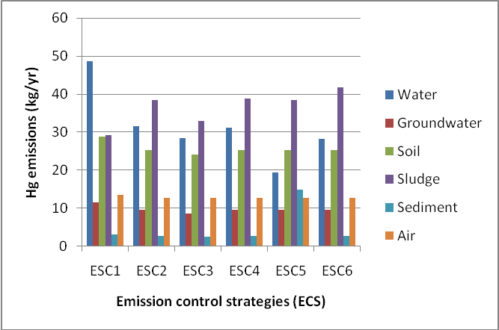
Figure 1. Relative distribution of Hg between environmental compartments in EI (kg/year)
This contrasts sharply with the patterns of Hg emissions in NC, where emissions to air are highest, followed by emissions to WWTP sludge and then emissions to surface water (Figure 2). Key quantified sources of Hg emissions to air identified in the ES-DB are releases from landfills, human cremation and coal combustion (Holten Lützhøft et al., 2008). Whilst the larger population in EI is associated with greater Hg emissions to air from cremations, it was not possible to source (or use expert judgement to derive) data on the amount of coal combusted in this locale. However, the most important factor in the comparatively greater aerial Hg emissions in NC (over60% of the total) is the higher amount of waste land-filled in this consumer-oriented city (1.71 tonnes/person/yr) in comparison to EI (0.23 tonnes/person/yr) (Eriksson et al., 2010). Emissions of Hg from landfill are associated with production and subsequent release of methyl mercury in landfill gases (Lindberg et al., 2001).

Within EI, patterns of emission show some variation between the application of ECSs 2-6, with the greatest level of variation associated with the release of Hg to receiving waters on application of ECS5 (implementation of relevant legislation together with use of stormwater BMPs). This equates to a reduction in Hg emissions to water of 60% and is related to the fact that diffuse sources such as heating and traffic are key sources of Hg with the subsequent incorporation of emitted Hg into stormwater runoff (Figure 1). In NC, emissions to air and water show the greatest variation, with the biggest reduction in emissions to air associated with ECS2 (implementation of relevant directives) and the greatest reduction in emissions to water associated with the application of ECS6 (implementation of relevant directives together with use of advanced wastewater treatment technologies such as nanofiltration) (Figure 2). The reduction in emissions of Hg to air in NC on application of ECS2 is associated with full implementation of relevant legislation, reducing the amount of Hg in use within the city as a whole (evidenced by a reduction in emissions to all compartments) (see Figure 2).

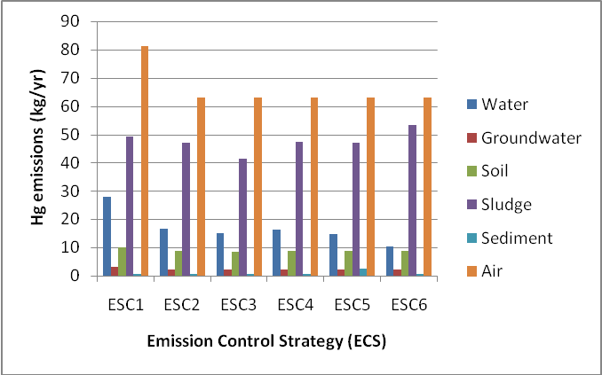
Figure 2 Relative distribution of Hg between environmental compartments in NC (kg/year)

In contrast, whilst emissions to most environmental compartments fall on application of ECS2 within EI, emissions to the wastewater treatment sludge compartment increase (from 29 kg/yr to 38 kg/yr) reflecting the impact of, for example, increasing the number of properties connected to the WWTP. Consistent with this trend, the reductions of Hg emissions to receiving waters noted on application of ECS5 in EI and ECS6 in NC are associated with increased emissions to stormwater BMP sediment (from 3 kg/yr to 15 kg/yr) and WWTP sludge (from 49 kg/year to 53 kg/yr). This translocation of Hg emissions from one compartment to another is in keeping with the fact that as a metal, Hg cannot be degraded (although it’s compounds can be biologically and chemically transformed).

The SFA results for Cd show similar trends in both EI and NC (Figures 3 and 4). In both cities, emissions to groundwater dominate under all scenarios followed by emissions to soil, although the total levels of Cd emitted to the environment are greater in EI than in NC. Cd emissions to groundwater and soil are associated with activities such as the land filling of municipal waste, waste incineration and the use and accidental spills of fertilisers in both cities. As with Hg in EI, loads of Cd emitted to all compartments fall on application of ECS2 in EI and NC with the exception of loads to WWTP sludge which increase by 43% and 13%, respectively. This increase in sludge loads may be associated with a combination of factors including the increased connection of homes to a WWTP under ECS2 in EI and the use of Cd in a wider range of products in both cities in comparison to Hg.

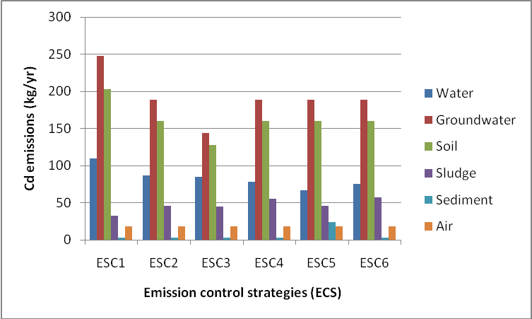
Figure 3. Relative distribution of Cd between environmental compartments in EI (kg/year)
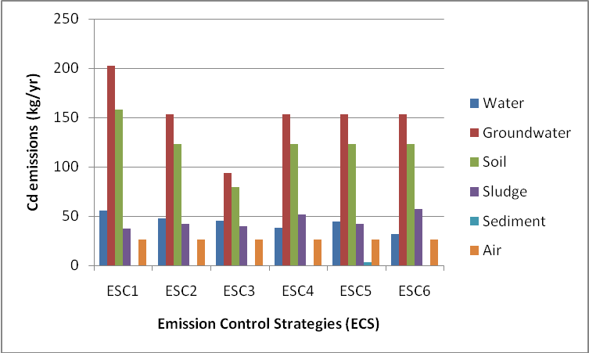
Figure 4. Relative distribution of Cd between environmental compartments in NC (kg/year)
The greatest reductions of Cd emissions to receiving surface waters are associated with the implementation of ECS5 in EI and ECS6 in NC. As with the similar reductions in Hg emissions reported for both cities, these reductions also correspond with increases in Cd loads in stormwater BMP sediments (from 3 kg/yr to 24 kg/yr on implementation of ECS5 in EI) and WWTP sludges (from 37 kg/yr to 57 kg/yr on implementation of ECS6 in NC). As for Hg, metallic Cd cannot be degraded further (although it’s compounds can be biologically or chemically transformed) and therefore treatment technologies (such as those identified in ECSs 4-6), translocate rather than reduce emissions to the environment as a whole.

CONCLUSIONS
Implementation of the EU WFD is a major challenge for many, if not all Member States, many of which are currently in the process of developing and implementing programmes of measures (POMs) to achieve the stringent objectives. In the absence of complete data sets on catchment characteristics and the efficiencies of treatment technologies for the removal of PS/PHS, the implementation of alternative ECS within SHCC platforms is put forward as an approach to support WFD practitioners by using a combination of available data and (in its absence) expert judgement. The presented results identify the potential of using SFA within a SHCC environment to distinguish at a sufficiently sensitive level between the application of alternative ECS on a ‘city-by-city’ and ‘pollutant-by-pollutant’ basis. Non-destructible pollutants such as metals are able to move between compartments, with reductions in the emissions to one compartment corresponding to increased emissions to another. Reductions in total emissions to the environment can only be achieved through targeting their use ‘at source’ through for example, the application of legislation (ECS2) and voluntary measures (ECS3) to limit their presence in the supply chain and resulting products. As an approach developed to address identified data gaps, it is not yet possible to ground-truth the methodology, with this lack of ‘real world’ validation identified as a key limitation to its wider application. Furthermore, the results presented here are based solely on the use of a mass-balance approach which does not include any consideration of socio-economic factors. The inclusion of these aspects is critical in terms of informing the development of POMs which are economically feasible and socially acceptable to industry, commercial operators and wider society. These aspects were considered in the latter stages of the ScorePP project and will form the basis of further research papers.

ACKNOWLEDGMENT
The presented results have been obtained within the framework of the project ScorePP - “Source Control Options for Reducing Emissions of Priority Pollutants”, contract no. 037036, a project coordinated by Institute of Environment & Resources, Technical University of Denmark within the Energy, Environment and Sustainable Development section of the European Community’s Sixth Framework Programme for Research, Technological Development and Demonstration

REFERENCES
Bjorklund, K, Malmqvist, P-A and Stromvall, A-M. (2011). Simulating organic pollutant flows in urban stormwater: development and evaluation of a model for nonylphenols and phthalates. Wat Sci Technol, 63(3), 508-515.

Eriksson, E, Revitt, DM, Holten Lützhøft, HC, Viavattene, C, Lundy, L and Mikkelsen, PS. (2011) Emission control strategies for short-chain chloroparaffins in two semi-hypothetical case cities. Submitted to the 10th Urban Environment Symposium on Urban Futures for a Sustainable World, Gothenburg, Sweden 9-11 June 2010.
Eriksson, E, Raggatt, L, Revitt, DM, Scholes, L, De Keyser, W, Viavattene, C, Holten Lützhøft, HC, Ledin A, Mikkelsen PS. (2010) Semi-hypothetical case cities and emission control strategies for selected priority pollutants. D9.6, -28 Kgs Lygby (Denmark), The Danish Technical University, Source Control Options for Reducing Emissions of Priority Pollutants.
Eriksson. E, Donner, E, Raggatt, L, Pettersson, M, Wickman, T and Mikkelsen, PS. (2009) Strategies for Controlling Emissions of Priority Pollutants from Case City Archetypes. WEFTEC Conference, Orlando, USA, 2009-10-14.
EU Environmental Quality Standards Directive. (2008). Directive 2008/105/EC of the European Parliament and of the Council of 16 December 2008 on environmental quality standards in the field of water policy. Retrieved from http://eur-lex.europa.eu/LexUriServ/LexUriServ.do?uri=OJ:L:2008:024:0008:0029:en:pdf in January 2009.
EU Integrated Pollution Prevention and Control. (2008). Directive 2008/1/EC of the European Parliament and of the Council of 15 January 2008 concerning integrated pollution prevention and control. Retrieved from http://eur-lex.europa.eu/LexUriServ/LexUriServ.do?uri=OJ:L:2008:348:0084:0097:en:pdf in May 2008.
EU Urban Wastewater Treatment Directive. (1991). Directive 91/271/EEC of the European Parliament and of the Council of 21 May 1991 concerning urban waste-water treatment. Retrieved from: http://eur-lex.europa.eu/LexUriServ/LexUriServ.do?uri=CELEX:31991L0271:en:not in May 2008.
EU Water Framework Directive. (2000). Directive 2000/60/EC of the European Parliament and of the Council of 23 October 2000 establishing a framework for Community action in the field of water policy. Retrieved from: http://eur-lex.europa.eu/LexUriServ/LexUriServ.do?uri=CELEX:3200L0060:en:html in May 2008.
Eurostat. (2008). EU Policy Indicators. Retrieved via http://epp.eurostat.ec.europa.eu/portal/page/portal/eurostat/home/ throughout 2008.
Holten Lützhøft, HC, Donner, E, Gevaert, V, De Keyser, W, Wickman, T, Cerk, M, Eriksson, E, Lecloux, A and Ledin A. (2008). Quantifying releases of priority pollutanst from urban sources. D3.4, 1-28 Kgs Lygby (Denmark), The Danish Technical University, Source Contyrol Options for Reducing Emissions of Priority Pollutants.
Lecloux, A. (2008). List of possible substitutes for each defined use of priority polluatnts in particular for diffuse sources. D4.1, 1-28 Kgs Lygby (Denmark), The Danish Technical University, Source Control Options for Reducing Emissions of Priority Pollutants.
Lindberg, SE, Wallschläger, D, Prestbo, EM, Bloom, NS, Price J and Reinhart, D. (2001) Methylated mercury species in municipal waste landfill gas sampled in Florida, USA, Atmos Environ 35, 4011–4015.
Urban Audit. (2008). Urban Audit. Retrieved from: http://www.urbanaudit.org throughout 2008.
Wickman, T, Lecloux, A and Scholes, L. (2009). Voluntary Initiatives for Reducing the Use of Priority Pollutant Containing Products. Deliverable No: D4.4 of the EU FP6 ScorePP project. Retrieved from: http://www.scorepp.eu/index.php?option=com_content&task=view&id=30&Itemid=56 in April 2011.

