An Integrated Approach to Correcting the High Bar Back Squat from ‘Excessive Forward Leaning’

**ABSTRACT**

The high bar back squat is often considered one of the cornerstones in an athlete’s physical training programme due to its capacity to enhance lower body strength development. However, movement compensations are common with many exhibiting an ‘excessive forward lean’ during their technique. This article aims to outline the potential reasons that may be contributing to this compensation. Furthermore, possible solutions that coaches could consider to remove the excessive forward lean and optimise high bar back squat technique have been offered.

**Key Words:** Squat Mechanics, Tightness, Weakness, Motor Planning

**INTRODUCTION**

The back squat is often considered one of the cornerstones of an athlete’s physical training programme and is fundamental to lower body strength development. The nature of bilateral loading allows for absolute loads to be considerably higher than unilateral alternatives such as the rear foot elevated split squat [39]. If full range of motion can be achieved, there is a high mobility requirement for the lower body joints [34], especially at the hips and ankles. In addition, numerous studies have highlighted a strong association between lower body strength (via the back squat) and acceleration [30,35], speed [1,35], and power [36]. Thus, developing maximal squat strength is a good pre-requisite for many high velocity movement patterns in sport. Consequently, when one exercise has the potential to successfully compliment an athlete’s overall athleticism and set a solid foundation for sporting performance, it is not surprising that many coaches spend time aiming to optimise an athlete’s back squat technique.

A common method of determining competency in a given task is via movement screening, which has gained a high level of interest in the last 10-15 years. Multiple methods exist such as the Functional Movement Screen™ [2,13,24], Movement Competency Screen [26,27], as well as the overhead and single leg squat assessments [3,4,5]. Whilst numerous variations of screening exist, a common theme amongst them all is the use of a squat pattern to get a generic impression of movement competency in this task. Furthermore, Myer et al. [34] has even suggested simply using an unloaded squat as a screening tool because it is in the coach’s interest to have a strong understanding of perfect technique given it is so commonly prescribed. At this point, the reader should note that squat mechanics will differ considerably depending on whether the focus is on the high bar or low bar technique [16]. The high bar squat is typically characterised by a more upright torso, deeper squat and increased quadriceps recruitment. The low bar position has been shown to require greater hip flexion range of motion and increase the forward lean during the lift [16]. Whilst both versions may have their respective advantages, it is suggested that the high bar version may be more favourable (discussed later) and will be used as a reference point for optimal technique. Thus, any corrections to technique have been suggested in line with this squat variation. Whilst numerous flaws in technique are possible, a common flaw is when athletes perform an ‘excessive forward lean’ during their squat pattern. To the author’s knowledge, little literature to date has aimed to outline guidance on how best to correct an athlete’s excessive forward lean, specifically in respect to the high bar back squat.

Therefore, the aim of this article is to provide coaches with an integrated system that may help to reinforce optimal movement competency in the high bar back squat exercise for those athletes that demonstrate an excessive forward lean. Variations of the back squat will be suggested in order to give coaches a reference point for how to correct this common flaw in technique.

**HIGH BAR VERSUS LOW BAR SQUAT**

One of the most important aspects of interpreting subjective movement quality is to understand what optimal looks like. Figure 1 provides a representation of optimal high bar back squat technique and Figure 2 shows the excessive forward lean compensation. It should be noted that this particular compensation can only be viewed clearly from a lateral view; thus, only figures from this perspective have been included. Furthermore, many powerlifters typically back squat with a low bar position which typically involves the barbell resting further down the spine [8]. In this instance, the natural response to this altered bar position is a purposeful increase in hip flexion and torso lean [16]; thus, accommodating the lower bar position and change in centre of mass. In addition, the low bar squat has been shown to recruit the erector spinae and gluteal complex to a greater extent than the high bar version [16]. Therefore, if increased posterior chain development is the goal from this exercise, then the low bar squat may be the preferred choice. However, some literature has suggested this variation may increase shear forces at the lumbar spine [8,14]. Considering the low bar squat is characterised by a naturally increasing forward lean [40], there may be a propensity to lose form under maximal loads, especially for those athletes unfamiliar with this variation or already exhibiting a forward lean during the squat pattern. It is not being suggested that the low bar squat automatically increases the risk of injury; however, if an excessive forward lean is present during screening or under light loads the low bar squat may further reinforce this movement compensation. As such, the low bar squat may not be the preferred choice in this instance. Thus, the remainder of this article will focus on correcting squat mechanics in relation to the technique and positioning seen in Figure 1.

*** INSERT FIGURES 1 AND 2 ABOUT HERE ***

**THE ‘EXCESSIVE FORWARD LEAN’**

Optimal alignment during a high bar back squat is essential due to the suggested heightened injury risk that accompanies any movement dysfunctions [21,24]. Optimal positioning is characterized by the trunk and tibia running parallel to one another. This has been further demonstrated in Figure 1 by the dotted lines which the reader may note will not intersect. In contrast, the excessive forward lean is characterized by the trunk and tibia becoming perpendicular to one another. As Figure 2 portrays, the tibia has increased vertically while the trunk has assumed a more horizontal position. Once practitioners are clear on what constitutes an excessive forward lean visually, it is important to understand what may be instigating this compensation.

Reduced ankle range of motion could be a potential cause for this compensation. The tibia translating anterior in relation to the ankle is crucial for achieving optimal alignment during a high bar back squat. Insufficient anterior translation of the tibia is often compensated with the forward trunk lean. Potential causes of this limitation include decreased mobility of the talocrural joint as well as shortened lower limb musculature [6]. In the event of reduced talocrural joint mobility, restricted posterior talar glide may be present [19]. This limits the ability of the tibia to translate anteriorly during dorsiflexion movements and may require increased mobility (discussed later) in order to optimise the high bar squat technique. Previous literature has highlighted that the gastrocnemius may also require increased lengthening to address for this compensation [9]. However, it is likely that the ‘relative length change’ in this muscle is small due to its origin above the knee joint. Essentially, whilst dorsiflexion occurs during a squat movement, the knee is also flexing which makes any relative length change in the gastrocnemius minor. However, the origin of the soleus is below the knee joint; thus, it is likely that any posterior tissue restriction is largely attributed to this muscle. Therefore, improving ankle mobility and reducing any posterior tissue restriction could be considered as appropriate strategies for enhancing back squat mechanics.

A second reason for an excessive forward lean occurring may simply be due to a weak ‘extensor profile’. This can be described as posterior chain muscles that perform extension movement patterns: namely the gluteal complex, hamstrings and erector spinae. The gluteus maximus is the primary hip extensor and is required to contract eccentrically during the descent of a squat. An inability to gain sufficient depth in the back squat (parallel as a minimum requirement) could partially be due to the fact that the gluteal complex is not strong enough eccentrically as depth increases. Consequently, the body compensates by going into an excessive forward lean to avoid increased depth that the gluteal complex cannot sustain which has been reported in previously established literature [9]. This is further supported by Isear et al. [22] and Caterisano et al. [7]. Isear et al. [22] analysed lower body muscle activation patterns during an unloaded squat (to 90°) in 41 healthy males and showed a tendency for gluteal activation to increase as depth increased. Furthermore, Caterisano et al. [7] used 10 experienced weightlifters (> 5 years training age) to investigate the effect of back squat depth on gluteal muscle activity. Load was programmed at 100-125% of each subject’s body mass with squat depths set at partial (2.36 rad at the knee joint), parallel (1.57 rad at the knee joint) and full (0.79 rad at the knee joint). Results identified that partial squats had significantly reduced contribution from the gluteal muscles compared to both parallel and full range of motion [7]. As such, strengthening the gluteal complex is likely a requirement for both athlete and non-athlete populations who exhibit an excessive forward lean and are unable to gain sufficient depth in the back squat. Similarly, the spinal extensors (erector spinae) may also require strengthening in order to encourage the torso to remain as upright as possible. With that in mind, variations of the back squat exercise (discussed later) could be considered useful in order to strengthen the glutes at a sufficient depth and ‘retrain’ appropriate spinal alignment for optimal high bar squat technique.

A potential third reason for the excessive forward lean compensation could be due to poor motor planning. This is perhaps more likely with less experienced athletes who have not had much exposure to back squat training; thus, it is plausible that this issue may be ‘coached out of them’ by practice. Arguably, this may be the first step for any strength and conditioning coach to see if improvements can be made with practice alone. Despite the paucity of literature pertaining to motor learning for the back squat specifically, research has highlighted the advantage of feedback in conjunction with practice [31]. Thus, the use of immediate coach feedback [33] and visual feedback in the form of video analysis [15] may further enhance an athlete’s learning if compensations are present. It is therefore suggested that the excessive forward lean may be a compensation that occurs due to three potential factors: reduced ankle mobility, a weak extensor profile, and/or poor motor planning in the exercise itself (Figure 3). It may well be a combination of these factors which is why an integrated approach to correcting technique is required and will be discussed next.

*** INSERT FIGURE 3 ABOUT HERE ***

**ASSESSING ANKLE MOBILITY**

Prior to discussing corrective strategies, it is essential that coaches understand how to assess for ankle range of motion. Ankle mobility is frequently measured via goniometry [17,25]; however, it should be noted that such methods likely have a high margin of error. Goniometry is a precise skill and coaches who are unfamiliar with the technique shouldn’t rely on this method given the reliability issues [11,18]. As an alternative, the weight bearing lunge test (Figure 4) offers a simple and reliable method of assessing ankle range of motion [20,25]. In addition, any compensations noted during the squat pattern are due to closed chain dorsiflexion mobility. Therefore, a closed chain assessment strategy likely retains more specificity to this task. This test can be easily administered if a few simple steps are adhered to.

The foot and ankle complex should be set straight and in neutral to avoid any external rotation (which would provide ‘free range of motion’ at the ankle). Secondly, the heel must remain completely flat during the test and coaches are encouraged to monitor this closely. A simple technique of placing a rubber band (on a stretch) underneath the heel will help to ensure that zero heel elevation occurs and a more accurate reading is obtained. Range of motion is measured from the end of the big toe to the wall in centimetres and scores will vary depending on the available range of motion. Normative data would appear to be ~12cm for healthy adults [20], although this will likely differ dependent on the population in question.

*** INSERT FIGURE 4 ABOUT HERE ***

**STRATEGIES TO CORRECT BACK SQUAT TECHNIQUE**

As Figure 3 shows, there likely needs to be a 3-staged approach to correcting back squat technique. It should be highlighted that none of these will be best served in isolation; but as part of an integrated programme that aims to optimise all aspects. Gaining strength within the squat pattern and correcting motor patterning are likely best served by practicing the squat pattern itself. As such, if an athlete is unable to get into the correct position due to a lack of strength in the hip and spinal extensors, then alternatives to the back squat could be considered. With that in mind, the authors suggest starting with two potential variations prior to programming the back squat exercise: starting with a box squat, progressing to a ‘touch squat’ and then onto the full back squat exercise (Figures 5-6 and Figure 1). This method will address both the weak extensor profile and poor motor patterning issues. If athletes are struggling to gain enough depth, providing them with a box or bench to sit on will teach them to drive up from a deeper position that they cannot support on their own. In addition, it will also cue them to ‘sit back’ using the hips, which has been suggested as a desired squatting trait [34,40]. Finally, if athletes are really struggling to gain control in deep squat positions, the use of a platform behind them can be manipulated gradually until the desired technique has been achieved.

The touch squat is a similar exercise and still has a box or bench positioned behind the athlete as a target to aim for. However, the athlete does not physically ‘sit down’ in this exercise (like the box squat), but descends until the glutes lightly touch the surface before driving up to finish the repetition. Coaches should be mindful of two things for this exercise. Firstly, athletes should not ‘bounce’ off the platform behind them as this will likely cause unwanted jarring forces through the spine. Secondly, by virtue of ‘not sitting down’ a small amount of depth will be lost in this variation; thus, if possible, the box or bench should be lowered slightly so that when touching at the lowest point, the athlete is still squatting to a comparable depth as when seated in the box squat position. In Figures 5 and 6, the bench is already positioned on a decline (and cannot be lowered further); however, the reader should note that the feet have been walked further forward for the touch squat (Figure 6) to facilitate the required extra depth.

Finally, once the touch squat has been mastered at an appropriate depth, coaches should be able to remove the box and get athletes’ back squat to be parallel without anything behind them. It is unknown how long this process takes to complete before competency in the back squat is evident and will likely vary from athlete to athlete. However, it seems logical to suggest that 4-week blocks for each of these variations could be considered so that athletes are back squatting without a box after approximately eight weeks. The authors are unaware of any motor planning studies that have enhanced the high bar back squat specifically. However, eight weeks has been shown to enhance functional movement inclusive of the squat pattern [23] and reduce lower back pain [10] in comparable motor control literature.

*** INSERT FIGURES 5-6 (AND FIGURE 1 AGAIN) ABOUT HERE ***

In addition, strategies should be incorporated that focus on improving ankle mobility, should these be deemed a problem. A 4-step approach inclusive of foam rolling posterior muscles below the knee, enhancing flexibility to the soleus, mobilising the talocrural joint, and incorporating functional exercises that challenge dorsiflexion dynamically will assist in improving long-term ankle range of motion. Details of important points accompanying these methods are provided in Table 1.

Improvements in flexibility can be addressed in multiple ways; however, this article will provide suggestions for athletes that can be performed without the use of support staff such as strength and conditioning coaches or athletic trainers. Foam rolling provides an easy method of targeting trigger points within a muscle and has been said to relieve soreness and correct muscular imbalances [29,37], which are likely restricting a muscle’s extensibility. Secondly, static stretching the soleus muscle (as previously mentioned) may allow some acute increases in ankle range if the muscles of the lower limb are causing a restriction in anterior movement of the tibia during the squat pattern. Step three should incorporate a mobility exercise such as the knee-to-wall drill, where dorsiflexion can be optimised once any posterior tissue restriction has been addressed. Finally, integrating more functional exercises such as the rear foot elevated split squat (RFESS) allows dorsiflexion to be targeted for each ankle individually which will likely be needed to get into the desired back squat position. Furthermore, the instability of a RFESS will enhance overall foot stability and has been shown to be an appropriate exercise choice for hip extensor muscle activation [32], also critical for optimal back squat mechanics.

**PRACTICAL APPLICATION**

Considering multiple strategies are being suggested to enhance back squat technique from an excessive forward lean, the author has provided some key points that coaches should be mindful of when implementing with their athletes (Table 1). The majority of suggestions to optimise ankle mobility are remedial in nature; thus, are likely to be performed as part of a warm up routine when aiming to correct an athlete’s motor patterning. As previously mentioned, when incorporating one of the bilateral squat variations (box squat, touch squat or back squat), it is recommended that these be programmed in the aforementioned order for four weeks separately, until optimal back squat technique can be maintained (Figure 1).

*** INSERT TABLE 1 ABOUT HERE ***

**CONCLUSION**

In summary, the excessive forward lean is a movement compensation that many athletes may exhibit. The cause may be attributed to reduced ankle mobility, insufficient strength, poor motor patterning or a combination of these factors. With that in mind, an integrated approach that addresses these issues is suggested to correct technique. Improving ankle mobility in isolation may not be enough to automatically correct technique; thus, a progression sequence using different bilateral squat variations may simultaneously allow strength and motor patterning to be developed over time. Finally, once sufficient technique has been achieved, coaches should ensure that athletes continue to train throughout full range of motion as this will likely be sufficient enough to maintain adequate mobility within the squat pattern for the future.

**REFERENCES**

1. Baker D, and Nance S. The relations between running speed and measures of strength and power in professional rugby league players. *J Str Cond Res* 13: 230-235, 1999.
2. Beardsley C, and Contreras B. The Functional Movement Screen: A review. *Str Cond J* 36: 72-80, 2014.
3. Bishop C, Brearley S, Read P, and Turner A. The single leg squat: When to prescribe this exercise. *Prof Str Cond J* 41: 17-26, 2016.
4. Bishop C, Edwards M, and Turner A. Screening movement dysfunctions using the overhead squat. *Prof Str Cond J* 42: 22-30, 2016.
5. Bishop C, Villiere A, and Turner A. Addressing movement patterns by using the overhead squat. *Prof Str Cond J* 40: 7-12, 2016.
6. Bishop C, Walker S, Read P, and Turner A. Assessing movement using a variety of screening tests. *Prof Str Cond J* 37: 17-26, 2015.
7. Caterisano A, Moss R, Pellinger T, Woodruff K, Lewis V, Booth W, and Khadra T. The effect of back squat depth on the EMG activity of 4 superficial hip and thigh muscles. *J Str Cond Res* 16: 428-432, 2002.
8. Chiu L, Heiler J, and Sorensen S. Sitting back in the squat. *Str Cond J* 31: 25-27, 2009.
9. Clark M, Lucett S, and Sutton B. Movement Assessments in NASM Essentials of Corrective Exercise Training. Lippincott Williams & Wilkins, 1st Ed. 24-30, 2011.
10. Costa L, Maher C, Latimer J, Hodges P, Herbert R, Refshauge K, McAuley J, and Jennings M. Motor control exercises for chronic low back pain: A randomized placebo-controlled trial. *Phys Ther* 89: 1275-1286, 2009.
11. Elveru R, Rothstein J, and Lamb R. Goniometric reliability in a clinical setting. *Phys Ther* 68: 672-677, 1988.
12. Fortenbaugh D, Sato K, and Hitt J. The effects of weightlifting shoes on squat kinematics. *Proceedings of the XXVIII International Symposium on Biomechanics in Sport*, Northern Michigan University, Michigan, USA, 167-170.
13. Frost D, Beach T, Callaghan J, and McGill S. Using the Functional Movement Screen to evaluate the effectiveness of training. *J Str Cond Res* 26: 1620-1630, 2012.
14. Fry A, Smith C, and Schilling B. Effect of knee position on hip and knee torques during the barbell squat. *J Str Cond Res* 17: 629-633, 2003.
15. Garcia-Gonzalez L, Moreno M, Moreno A, Gil A, and del Villar F. Effectiveness of a video-feedback and questioning programme to develop cognitive expertise in sport. *PLOS One* 8: 1-12, 2013.
16. Glassbrook D, Helms E, Brown S, and Storey A. A review of the biomechanical differences of the high-bar and low-bar back squat. *J Str Cond Res* Published ahead of print. DOI: 10.1519/JSC.0000000000002007.
17. Gogia P, Braatz J, Rose S, and Norton B. Reliability and validity of goniometric measurements at the knee. *Phys Ther* 67: 192-195, 1987.
18. Hayes K, Walton J, Szomor Z, and Murrell G. Reliability of five methods for assessing shoulder range of motion. *Aust J Physio* 47: 289-294, 2001.
19. Hoch M, and McKeon P. Joint mobilization improves spatiotemporal postural control and range of motion in those with chronic ankle instability. *J Ortho Res* 29: 326-332, 2011.
20. Hoch M, and McKeon P. Normative range of weight-bearing lunge test performance asymmetry in healthy adults. *Manual Ther* 16: 516-519, 2011.
21. Howe L, and Cushion E. A problem-solving process to identify the origins of poor movement. *Prof Str Cond J* 45: 7-15, 2017.
22. Isear J, Erickson J, and Worrell T. EMG analysis of lower extremity muscle recruitment patterns during an un-loaded squat. *Med Sci Sports Ex* 29: 532-539, 1997.
23. Kiesel K, Plisky P, and Butler R. Functional movement test scores improve following a standardized off-season intervention program in professional football players. *Scand J Med Sci Sports* 21: 287-292, 2011.
24. Kiesel K, Plisky P, and Voight M. Can serious injury in professional football be predicted by a preseason Functional Movement screen? *North Amer J Sports Phys Ther* 2: 147-158, 2007.
25. Konor M, Morton S, Eckerson J, and Grindstaff T. Reliability of three measures of ankle dorsiflexion range of motion. *Int J Sports Phys Ther* 7: 279-287, 2012.
26. Kritz M, Cronin J, and Hume P. The bodyweight squat: A movement screen for the squat pattern. *Str Cond J* 31: 76-85, 2009.
27. Kritz M, Cronin J, and Hume P. Using the bodyweight forward lunge to screen an athlete’s lunge pattern. *Str Cond J* 31: 15-24, 2009.
28. Legg H, Glaister M, Cleather D, and Goodwin J. The effect of weightlifting shoes on the kinetics and kinematics of the back squat. *J Sports Sci* 35: 508-515, 2017.
29. Macdonald G, Button D, Drinkwater E, and Behm D. Foam rolling as a recovery tool after an intense bout of physical activity. *Med Sci Sports Ex* 46: 131-142, 2014.
30. McBride J, Blow D, Kirby T, Haines T, Dayne A, and Triplett T. Relationship between maximal squat strength and five, ten, and forty yard sprint times. *J Str Cond Res* 23: 1633-1636, 2009.
31. McCullagh P, and Meyer K. Learning versus correct models: Influence of model type on the learning of a free-weight squat lift. *Res Quart Ex Sport* 68: 56-61, 1997.
32. McCurdy K, O’Kelley E, Kutz M, Langford G, Ernest J, and Torres M. Comparison of lower extremity EMG between the 2-leg squat and modified single-leg squat in female athletes. *J Sport Rehab* 19: 57-70, 2010.
33. Mouratidis A, Vansteenkiste M, Lens W, and Sideridis G. The motivating role of positive feedback in sport and physical education: Evidence for a motivational model. *J Sport Ex Psych* 30: 240-268, 2008.
34. Myer G, Kushner A, Brent J, Schoenfeld B, Hugentobler J, Lloyd R, Vermeil A, Chu D, Harbin J, and McGill S. The back squat: A proposed assessment of functional deficits and technical factors that limit performance. *Str Cond J* 36: 4-27, 2014.
35. Nimphius S, McGuigan M, and Newton R. Relationship between strength, power, speed, and change of direction performance of female softball players. *J Str Cond Res* 24: 885-895, 2010.
36. Parchmann C, and McBride J. Relationship between Functional Movement Screen and athletic performance. *J Str Cond Res* 25: 3378-3384, 2011.
37. Pearcey G, Bradbury-Squires D, Kawamoto J-E, Drinkwater E, Behm D, and Button D. Foam rolling for delayed-onset muscle soreness and recovery of dynamic performance measures. *J Ath Train* 50: 5-13, 2015.
38. Sato K, Fortenbaugh D, and Hydock D. Kinematic changes using weightlifting shoes on barbell back squat. *J Str Cond Res* 26: 28-33, 2012.
39. Speirs D, Bennett M, Finn C, and Turner A. Unilateral vs. bilateral squat training for strength, sprints and agility in academy rugby players. *J Str Cond Res* 30: 386-392, 2016.
40. Swinton P, Lloyd R, Keogh J, Agouris I, and Stewart A. A biomechanical comparison of the traditional squat, powerlifting squat, and box squat. *J Str Cond Res* 26: 1805-1816, 2012.

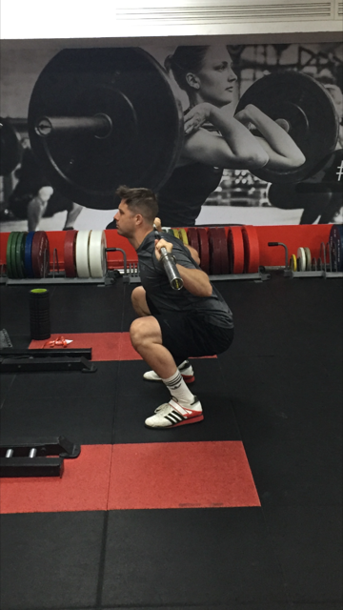 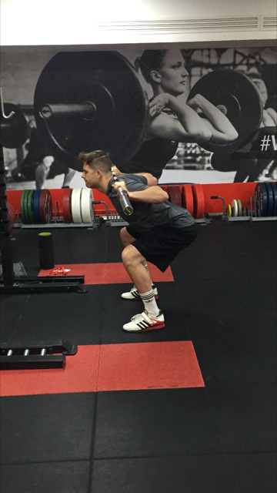

Figure 1: Optimal back squat technique Figure 2: Excessive forward lean

|  |
| --- |
| **Caption Box:** The reader should note that the subject in the above figures is wearing weightlifting shoes which may alter body position compared to regular running trainers. Fortenbaugh et al. (12) compared weightlifting shoes to running shoes and reported significantly lower horizontal trunk displacement (*p* = 0.04) for the weightlifting shoe condition when back squatting at 60% one repetition maximum (1RM). The results indicated that this type of shoe allows for a more erect trunk posture which the authors suggested may be a safer strategy for athletes to adopt under loaded squat conditions. Similar methods were employed by Sato et al. (38) who reported notably reduced forward trunk lean in weightlifting shoes at 60% 1RM. The authors deduced that weightlifting shoes may be the most appropriate option for athletes exhibiting a forward lean posture. Finally, Legg et al. [28] used novice and experienced lifters with experienced being quantified as > 1-year regularly using the back squat. A comparison was again undertaken between weightlifting and athletic shoes. Results highlighted that a more upright trunk posture can be facilitated by wearing weightlifting shoes and provide further evidence that this type of footwear could be considered for those athletes presenting an excessive forward lean. Consequently, the use of weightlifting shoes could be considered as an additional strategy to facilitate a more upright torso position in the high bar back squat. |

Figure 3: Causes for the excessive forward lean seen during the back squat exercise

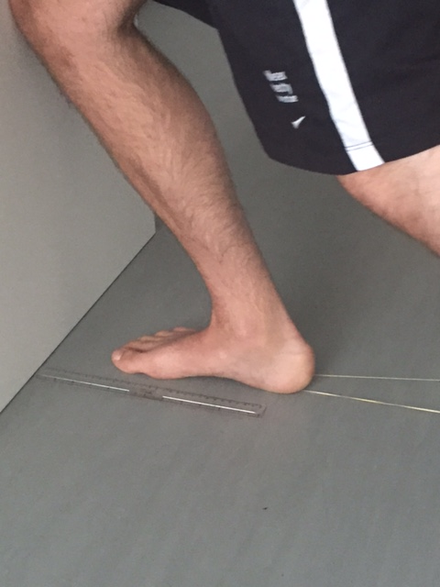

Figure 4: Weight bearing lunge test with a rubber-band placed on a stretch to ensure the heel remains flat throughout (distance from the wall is measured in cm)

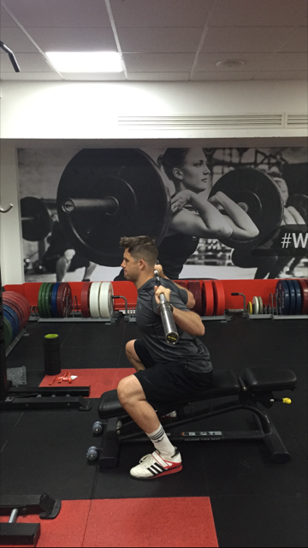 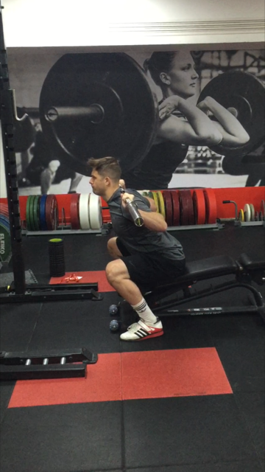 

Figures 5-6 and Figure 1: Progressive squat series (box squat 🡪 touch squat 🡪 back squat) to correct back squat technique from an excessive forward lean

Table 1: Summary of key points for each exercise when aiming to correct back squat technique

|  |  |
| --- | --- |
| **Exercise** | **Key Points for Coaches** |
| Optimising Ankle Mobility | |
| Foam Rolling | *Soleus and Gastrocnemius*. It is recommended that athletes hold their positioning on ‘tender spots’ for a minimum of 30 seconds or until discomfort is noticeably reduced. |
| Static Stretching | *Soleus*. This stretch can be performed in a number of ways but is arguably easiest done resting hands against a wall. Coaches should be mindful that the heel remains flat on the ground throughout and a bend at the knee joint is required as opposed to a straight leg for the gastrocnemius. Stretches should be held for a minimum of 30 seconds. |
| Mobilisation | *Knee-to-Wall Drill*. Similar to the weight bearing lunge test, athletes should find the distance from the wall where their knee can ‘just touch’ without any heel lift. One set of 15-20 repetitions should be performed at a slow, controlled tempo. |
| Functional Strength | *Rear Foot Elevated Split Squat*. As outlined by McCurdy et al. [32], the rear foot can be placed on a 12” box behind the athlete. However, perhaps the most important point is to ensure the heel of the front foot remains flat at the bottom position of each repetition, but also so that dorsiflexion is evident (i.e., the foot should not be placed too far forward so the shin appears vertical). Two sets of 6-8 repetitions can be performed with load increasing as long as stability and technique remain apparent. |
| Correcting the Squat Motor Pattern and Developing Strength | |
| Month 1 | *Box Squat*. As Figure 5 shows, athletes should aim to hinge backwards at the hips at a controlled speed until their glutes reach the box or bench. Once seated, coaches should ensure that the torso is ‘reset’ by elevating the chest if required, but it is essential that the spine remains locked with no flexion evident. |
| Month 2 | *Touch Squat*. Figure 6 shows the slightly altered position at the bottom point of the touch squat. The feet have been walked forward to ensure a comparable depth is achieved to the box squat and athletes must descend at a controlled tempo so no bouncing off the surface occurs. A light touch with the glutes is required prior to driving up explosively to complete the repetition. Coaches should note the change in torso angle at the base of this variation now that athletes are not fully seated. This is to better prepare athletes for stabilising their own centre of mass when the box or bench is removed. |
| Month 3 | *Back Squat*. Figure 1 demonstrates appropriate high bar back squat technique that athletes should aim for. Once mobility, strength and motor planning are sufficient, coaches should ensure that optimal technique (parallel as a minimum requirement) is adhered to on a regular basis as this will increase the chances of sufficient mobility being maintained throughout an athlete’s career. |