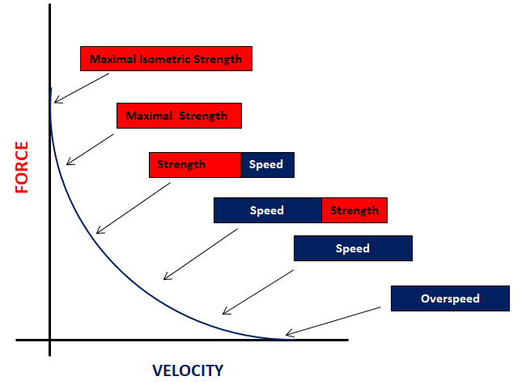

**FIGURE 1** – Concentric portion of the Force-Velocity curve

**Table 1** Examples of different resistance training prescriptions to enhance strength are included in the table. The assigned exercises are ordered from the lowest to the highest intensity. Potential physiological and performance adaptations are also listed.

|  |  |  |  |  |  |
| --- | --- | --- | --- | --- | --- |
| **Example of targeted muscle group** | **Stage 1** | **Stage 2** | **Stage 3** | **Stage 4** | **Stage 5** |
| *Quadriceps* | Isometric leg extension 45” x 5 reps @60° knee flexion and @>80%1RM | Isotonic leg extension  5 sets x until failure | Split squat  3-6 reps x 2-6 sets @85–93%1RM | Eccentric single leg box squat  3-6 reps x 2-6 sets @110-120% 1RM | Contrast approach -  Trap bar deadlift 4RM paired with triple hop x 4 sets |
| **Possible performance gains** | ↑ Peak Power  ↑ Strength  ↑ RFD  ↓ Inter-limb asymmetries  ↑ Horizontal force production  ↑ Vertical force production | | | | |

RM (repetition maximum), ↑(increased), ↓(decreased), →(unchanged)

**Table 2** Examples of exercises aiming to enhance RFD via ballistic/power are included in the table. Potential physiological and performance adaptations are also listed.

|  |  |  |  |  |
| --- | --- | --- | --- | --- |
| **Example of prescriptions** | **Example 1** | **Example 2** | **Example 3** | **Example 4** |
|  | Squat jumps (start position from static pause) 3 x 5 sets | Jump shrug 3 x 4 sets (30 to 45% 1RM of the Hang Clean) | Single leg countermovement jump 4 x 4 sets ( w/ variable loads) | Explosive contractions ( 10 isometric contractions “as fast and hard as possible” x 4 sets) |
| **Possible performance gains** | ↑ Peak Power  ↑ CoD performance  ↑ Early/Late RFD  ↑ Speed  ↑ Jump Performance  ↓ Inter-limb asymmetries  ↑ Running Economy | | | |

RM (repetition maximum), ↑(increased), ↓(decreased)

**Table 3** Example of plyometric exercises to improve SSC capabilities. The assigned exercises are ordered from the lowest to the highest intensity. Potential physiological and performance adaptations are also listed.

|  |  |  |  |  |
| --- | --- | --- | --- | --- |
| **Example of prescriptions** | **Phase 1** | **Phase 2** | **Phase 3** | **Phase 4** |
|  | Drop lands 6reps x 8sets | Pogo jumps 8 contacts x 8 sets | Skipping rope 15 contacts x 5 sets | Drop vertical jumps 5 x 3 sets (from a 30cm box) |
| **Possible performance gains** | ↑ Eccentric strength  ↑ Peak Power  ↑ CoD performance  ↑ Early RFD  ↑ RSI  ↑ Jump Performance  ↓ Inter-limb asymmetries  ↑ Running Economy  ↓ Ground Contact Time | | | |

↑(increased), ↓(decreased)

**Table 4** Example of exercises for Football player (midfielder) with persistent Achilles Tendinopathy presenting with maladaptive reduced triceps surae capacities aiming to full Rehabilitation and enhanced Performance over a 12 weeks period

|  |  |  |
| --- | --- | --- |
| **Rehabilitation Phase** | **Training Aim** | **Exercise Prescription** |
| Phase 1 – Work capacity/pain reduction emphasis | To increase strength-endurance and reduce pain | Unilateral seated calf raises (3 sets with manageable load until failure)  Isometric calf raises on smith machine (3 x 45s)  RFESS (3 x 8RM each leg) |
| Phase 2 – Strength emphasis | To increase muscle strength and musculotendinous stiffness | Eccentric heel drops (4 x 10)  Unilateral standing calf raises  (4 x 6-8RM)  RFESS (4 x 6RM)  Drop lands (4 x 4) |
| Phase 3 – Power and RFD emphasis | To increase power output and RFD | Split squat (3 x 3RM each leg)  Pogos (3 x 15-20 foot contacts)  Drop jumps (4 x 4 from 20cm) |
| Phase 4 – Peak power and RFD emphasis | To increase peak power, RFD and enhanced stiffness | Front squat (3 x 2RM)  Drop jumps (5 x 3 from 40cm)  Unilateral drop jumps (3 x 3 from 20cm each leg) |

RM = repetition maximum; RFD = rate of force development; RFESS = rear foot elevated split squat

**Table 5** Example of exercises for a soccer player (midfielder) at 6 months post-ACLR presenting with maladaptive reduced quadriceps capacities. The aim is to complete Rehabilitation fully and to enhance Performance over a 12-16 weeks period

|  |  |  |
| --- | --- | --- |
| **Rehabilitation Phase** | **Training Aim** | **Exercise Prescription** |
| Phase 1 – Work capacity emphasis | To increase strength-endurance of the quadriceps | Unilateral leg extension (3 sets with manageable load until failure)  Single leg squat (3 sets until failure) |
| Phase 2 – Strength emphasis | To increase quadriceps muscle strength | Front squat (4 x 6RM)  Split squat (4 x 6RM)  Romanian Deadlift (4 x 6RM) |
| Phase 3 – Power and RFD emphasis | To increase power output and RFD | Split squat (3 x 3RM each leg)  Squat jumps (3 x 4)  CMJ (3 x 4)  SL hop (3 x 4 each leg) |
| Phase 4 – Peak power and RFD emphasis | To increase peak power, RFD and enhanced stiffness | Front squat (3 x 2RM)  Drop jumps (5 x 3)  Repeated hurdle jumps (5 x 5)  SLCMJ (5 x 3 each leg) |

RM = repetition maximum; RFD = rate of force development