Hazard Perception Training and Assessment of Young Drivers in Mauritius: Investigating the Acceptance of the MauHazard Tool

Aditya Santokhee   
School of Science and Technology,  
Middlesex University Mauritius,Uniciti, Flic-en-Flac, Mauritius  
a.santokhee@mdx.ac.mu

Girish Bekaroo   
School of Science and Technology,  
Middlesex University Mauritius,Uniciti, Flic-en-Flac, Mauritius  
g.bekaroo@mdx.ac.mu

Divesh Roopowa   
School of Science and Technology,  
Middlesex University Mauritius,Uniciti, Flic-en-Flac, Mauritius  
d.roopowa@mdx.ac.mu

*Abstract*— During the past few years, there has been a growing concern over the number of road accidents taking place in Mauritius. A significant number of accidents involve young drivers and although various measures are being implemented by different stakeholders to address this issue, one factor that has not been well investigated is the hazard perception skills of these road users. This is also due to the unavailability of hazard perception training and test tool for drivers within Mauritius to use. In addition, from a research perspective, technology acceptance of such tools is important to study since it helps to comprehend issues that impact future adoptions. However, limited studies have been conducted to assess technology acceptance of hazard perception test tools. In order to address this limitation, this paper investigates and analyses the acceptance of a hazard perception training and test tool called MauHazard by young drivers in Mauritius. To investigate technology acceptance of such tool, the Technology Acceptance Model was applied in a study involving 40 participants to utilize the proposed tool. Results revealed positive acceptance of MauHazard by the young drivers although different issues were highlighted.

Keywords—MauHazard, Hazard Perception Skills, Technology Acceptance Model, Road Accidents, Mauritius.

# Introduction

Even though drivers have to go through training and testing phases before acquiring their driving license in Mauritius, the number of road accidents has become a growing concern over the past few years within the island. According to Central Statistics Office of Mauritius, the number of fatal accidents increased from 69 between January and June 2017 to 79 between January and June 2018 and during the same period in 2018, 14,634 road accidents were registered [1]. Amongst, young drivers are involved in an important number of accidents. In order to address this growing concern of road accidents in Mauritius, various measures have been implemented by different stakeholders. For instance, in order to control speeding on the road, various speed cameras have been fixed at different locations around the island [2]. Moreover, different mobile speed traps are also being randomly deployed on a daily basis around Mauritius so as to further detect drivers exceeding the speed limit in regions not having fixed speed cameras. For controlling drunken drivers, several patrolling teams are regularly deployed to various regions within the island to perform Alco-test exercises in suspected cases [3]. Sensitization campaigns have also been implemented on road safety [4]. Among the various measures, limited work has done in the area of road hazard and hazard perception of drivers in Mauritius. Hazard perception relates to the ability for drivers to identify possible risks or dangers on or near the road, in order to react in a timely manner [5].

With the growing concern on the number of road accidents in the island, the inclusion of such a test in Mauritius is becoming necessary as hazard perception training was found to significantly decrease the reaction time of drivers and a reduced reaction time also means quicker response to hazardous situations which could potentially avoid accidents [6, 7]. With technological innovations, the hazard perception skills of drivers can be assessed through the use of interactive tools. From a research perspective, even though various studies have been conducted towards improving the methodology used to assess hazard perception of drivers [8], limited work has been undertaken about whether such technology and tools are accepted by the intended users or not. Technology acceptance here is about the method by which individuals perceive and accept the utilization of technology and technological tools [12]. Technology acceptance is essential to study since it helps to comprehend issues that impact future adoptions of such tools [9], while also providing sound predictions of usage [10]. As such, this paper investigates and analyses the acceptance of a hazard training and perception test tool by young drivers in Mauritius. The findings enlightened in this paper are expected to provide key insights to different stakeholders. Firstly, key regulatory institutions in Mauritius could consider the integration of such tools in the driving test process based on findings of this study. Also, the research and development community could further improve hazard perception tools based on limitations revealed in this paper.

# Related Works

Since driver hazard perception is considered as a vital driving ability that allows drivers to detect impending collision risks within a complicated traffic environment [11], various studies have been conducted in this area although focus has been to improve the underlying methodology or apply existing hazard perception assessment approaches. For instance, a previous study assessed the hazard perception skills of older drivers aged above 65 years and findings were insightful showing that hazard perception ability declines with increasing age principally due to cognitive and vision related factors [12]. In another study, a methodology for assessing and improving the hazard perception skills of drivers was proposed [8]. Another study proposed five principles for effective hazard perception test creation that are expected to be used as guide for implementation of such tests and following evaluation, results confirmed its suitability for use in the graduated driver licensing system [13]. As such, limited work has been undertaken to assess the acceptance of hazard perception test tools, as discussed earlier.

# Assessing and Improving the Hazard Perception Skills of Drivers Through MauHazard

In order to address the limitations pertaining to acceptance assessment of hazard perception test tools, a web-based application named MauHazard was designed, implemented and tested. This innovative tool was proposed due to unavailability of such tool for free use for the context of Mauritius since hazards vary from region to region. MauHazard aims to train and assess the hazard perception skills of drivers in Mauritius towards eventually aiming to prepare drivers to better react to hazards in the island. During the design process, the approach to be used for conducting the hazard perception test had to be determined and these include static hazard perception tests, driving simulators and dynamic hazard perception tests [14]. The static hazard perception test consists of static pictures or textual test questions that are presented to candidates, who are required to indicate the conflict points that may cause road accidents, or is likely to cause a road hazard. The second approach uses a driving simulator to train and test drivers, and the simulator is designed so that environmental conditions and hazardous situations can be controlled and eventually, the candidates’ driving behaviours during the test are observed. Finally, dynamic hazard perception tests uses visualization for a hazard perception test in which candidates watch video scenes that have been made from real traffic footage and have to identify hazardous conditions in a timely manner. Among these approaches, the dynamic hazard perception test approach was chosen due to its popularity and that such approach has been well validated [15]. For implementing this approach, videos on road hazards had to be recorded for different risks including risk of dog emerging and trying to cross the road, risk of car overtaking dangerously and risk of cyclist emerging suddenly from branch into main road. These videos were recorded from the interior of a car so as to obtain traffic footage from the driver’s viewpoint and thus simulating the real view of a driver. After the recording and editing process, relevant experts from the Mauritius Police Force, in addition to academics reviewed the videos in terms of “hazard perception relevance” and as applicable to Mauritian context. Furthermore, in order to deliver a good experience to end-users of MauHazard, the usability heuristics recommended by Nielsen for User Interface design were implemented and these include aesthetic design, flexibility and efficiency of use and consistency and proper standards, among others [16].

Following the design phase, MauHazard was developed using the Spring Framework integrated development environment, which is an open source platform that provides comprehensive infrastructure support for developing Java-based applications [17]. As key features of MauHazard, drivers need to register to the system to be able to use it and following login, a tutorial is provided in order to prepare the end-user to utilize the system as shown in Fig. I. Three levels of the hazard perception tutorial are available, namely, Beginner, Intermediate and Advanced, which vary in terms of reduced reaction time with increasing level. After the tutorial, the user can start the hazard perception test (HPT) which consists of a series of 13 videos having a combined total of 15 developing hazards. Part of the screen of the HPT interface is depicted in Fig. II. As soon as a hazard is detected, the user has to react in a timely manner by clicking on the screen and the reaction time is recorded by system along with the number of clicks, among other parameters. After the test, the detailed results for each video, along with the overall average reaction time is provided to the end user.

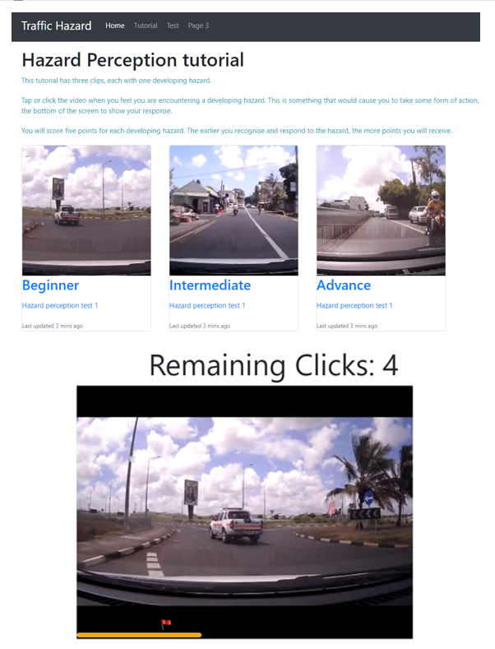

**Fig. I – Tutorial Screen**

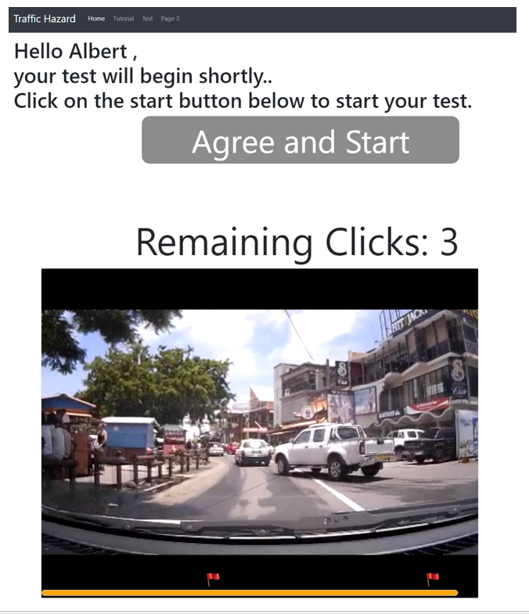

**Fig. II – Hazard Perception Test**

# Evaluation Method

To assess the technology acceptance of MauHazard, the Technology Acceptance Model (TAM) was selected as it is the most experimentally validated among acceptance assessment models including the Innovation Diffusion Theory [18]. TAM is an adaptation of the theory of reasoned action [19] and was conceptualized with the aim to investigate the reasons why users accept or reject a particular technology or system [20, 21]. TAM has been used in different studies, notably, to investigate the acceptance of marine litter tracking application [22] and m-learning [23], among others. Also, TAM is combined with different constructs that relate to weight related factors and each construct has different measured items that enable acceptance evaluation [24]. These constructs are defined as follows [20, 25]:

* *Perceived ease of use*: The level to which users of a particular technology feel its use will be effort free.
* *Perceived usefulness*: Level to which users feel that utilizing a particular technology will help in enhancing their task accomplishments.
* *Perceived convenience*: Level of convenience toward time, place and execution that one feels when performing a particular task with the application.
* *Attitude towards using*: Attitude that one feels positively toward the application.
* *Continuance intention to use*: One’s willingness to continue using the application in the future.

In terms of procedures, a TAM questionnaire was designed as data collection instrument. This questionnaire consisted of six sections that related to the five TAM constructs and to gather details on the demographic details of the participants. The questions within this questionnaire were adapted from previous studies [26, 27, 28] that involved the application of this model and each question was assessed through the Likert-5 scale, where 1 represented strongly disagree and 5 represented strongly agree. The constructs and statements used within the TAM questionnaire is given in Table I.

Table I – TAM Constructs and Statements

|  |  |
| --- | --- |
| **Attribute** | **Construct Statement** |
| Perceived Ease of Use | PEOU1: Learning to use MauHazard was easy for me.  PEOU2: MauHazard was easy to interact with.  PEOU3: Through the use of MauHazard, it was easy to understand the importance of hazard perception training. |
| Perceived Usefulness | PU1: Using MauHazard enhances my awareness on the concept of hazard perception training.  PU2: Using MauHazard will help me improve my hazard perception skills.  PU3: I find MauHazard as a useful tool to help drivers assess their hazard perception skills. |
| Perceived Convenience | PC1: I can assess my hazard perception level anytime via MauHazard tool.  PC2: I can assess my hazard perception level at any place via MauHazard tool.  PC3: MauHazard is convenient for me to test my hazard perception skills. |
| Attitude towards using | ATU1: Learning about the concept of hazard perception testing via MauHazard was a good idea  ATU2: Learning about the concept of hazard perception testing via MauHazard was a wise idea.  ATU3: Learning about the concept of hazard perception testing via MauHazard was a pleasant idea.  ATU4: Learning about the concept of hazard perception testing via MauHazard was a positive idea. |
| Continuance intention to use | CIU1: In the coming weeks, I plan to learn more about the concept of hazard perception testing via MauHazard web application  CIU2: I intend to use MauHazard web application when it becomes readily available.  CIU3: I intend to use MauHazard web application on a regular basis to my hazard perception level. |

Data was then collected within Middlesex University Mauritius by targeting local undergraduate students who possess driving licenses. In total, forty young drivers were targeted so as to fulfill the requirement of the minimum number of users involved for application of this model [29, 28]. Within the higher education institution, students were individually and directly approached and their driving license were verified. Participants were individually briefed on the purpose of the research using a face to face approach and consent to participate in the study was sought. Then, the participant had to use MauHazard so as to assess their hazard perception skills and this process involved going through the tutorial as shown in Fig. I before conducting the test. Following utilization of the tool, the participant had to fill-in the TAM questionnaire in order to provide feedback on the acceptance of MauHazard. After completion, the questionnaire was collected and thoroughly verified so as to ensure that all required items were correctly filled-in. Any irregularity detected was quickly resolved in order to ensure reliability and validity of every questionnaire collected. This procedure was repeated until the minimum number of participant required was fulfilled. After the data collection process, data from the questionnaires were input on SPSS for statistical analysis.

# Results And Discussions

As demographic details of participants, 28 were male and 12 were female, representing 70% and 30% respectively. Also, 77.5% of participants were aged between 21 and 30, whilst the remaining 22.5% were aged between 18 and 20. Results following application of the TAM are presented and discussed in the next sections, notably for each construct of the model. Within each section, the respective table of results are provided to show response of participants based on the Likert-5, where 1 represented strongly disagree, 2 meant disagree, 3 signified neutral, 4 denoted agree and 5 represented strongly agree. In addition, the mean score is provided in the respective table of results ranging between 1 and 5.

## Perceived Ease Of Use

For this construct, participants perceived that MauHazard was easy to use on overall, as depicted in Table II. Among the construct statements, 82.5% agreed or strongly agreed that interacting and learning to use MauHazard was easy. 10.0% of participants disagreed that learning to use the tool particularly due to confusion about when should the user click in order to some hazards. These users also mentioned that further information could be added in the test screen to complement learning on how reaction time for particular hazards could be improved. Among the different constructs, PEOU3 obtained the highest mean score where most participants agreed or strongly agreed that through the use of MauHazard, it was easy to understand the importance of hazard perception training. 15% of participants were however neutral for this statement and these participants felt that such training could be improved using better simulators which make use of Haptics to give feedback upon accidents.

Table II - Results for Perceived Ease of Use

|  |  |  |  |  |  |  |
| --- | --- | --- | --- | --- | --- | --- |
| **Construct Statement** | **1** | **2** | **3** | **4** | **5** | **Avg Score** |
| PEOU1: Learning to use MauHazard was easy for me. | 0.0% | 10.0% | 7.5% | 52.5% | 30.0% | 4.0 |
| PEOU2: MauHazard was easy to interact with. | 0.0% | 5.0% | 12.5% | 60.0% | 22.5% | 4.0 |
| PEOU3: Through the use of MauHazard, it was easy to understand the importance of hazard perception training. | 0.0% | 5.0% | 15.0% | 42.5% | 37.5% | 4.1 |

## Perceived Usefulness

MauHazard was also perceived as a useful tool according to the participants of the study, where an average score of 4.3 was obtained for this construct as given in Table III. For this construct, the least mean score was obtained for PU2 where although 85% of participants agreed or strongly agreed that using the tool will help to improve individual hazard perception skills, 15% were neutral on this statement. This was because these participants felt that for each hazard, different scenarios and hazard videos could have been used rather than using only one video for each hazardous situation. On the other hand, the participants found MauHazard as a useful tool to help drivers assess their hazard perception skills overall where PU3 received the highest mean score.

Table III - Results for Perceived Usefulness

|  |  |  |  |  |  |  |
| --- | --- | --- | --- | --- | --- | --- |
| **Construct Statement** | **1** | **2** | **3** | **4** | **5** | **Avg**  **Score** |
| PU1: Using MauHazard enhances my awareness on the concept of hazard perception training. | 0.0% | 2.5% | 5.0% | 52.5% | 40.0% | 4.3 |
| PU2: Using MauHazard will help me improve my hazard perception skills. | 0.0% | 0.0% | 15.0% | 52.5% | 32.5% | 4.2 |
| PU3: I find MauHazard as a useful tool to help drivers assess their hazard perception skills. | 0.0% | 0.0% | 12.5% | 40.0% | 47.5% | 4.4 |

## Perceived Convenience

Results indicated that the participants found MauHazard convenient to use with an average score of 4.2 obtained for this construct as shown in Table IV. PC1 and PC3 received the highest mean score as most participants perceived that the tool could be used to assess hazard perception level anytime and is also convenient to test hazard perception skills. However, for PC3, 22.5% of participants were neutral about this statement and this was because this group felt that such tool can only be used within quiet places as it entails focus to react to hazards. Similarly, 17.5% were neutral about PC2 and according to this group of participants, the tool makes heavy use of video which is mostly meant for use over Wi-Fi, which is not available everywhere in Mauritius. Moreover, participants from the same group mentioned that using MauHazard over mobile data packages is costly and not very appropriate.

Table IV - Results for Perceived Convenience

|  |  |  |  |  |  |  |
| --- | --- | --- | --- | --- | --- | --- |
| **Construct Statement** | **1** | **2** | **3** | **4** | **5** | **Avg**  **Score** |
| PC1: I can assess my hazard perception level anytime via MauHazard tool. | 0.0% | 0.0% | 15.0% | 55.0% | 30.0% | 4.2 |
| PC2: I can assess my hazard perception level at any place via MauHazard tool. | 0.0% | 2.5% | 17.5% | 52.5% | 27.5% | 4.1 |
| PC3: MauHazard is convenient for me to test my hazard perception skills. | 0.0% | 0.0% | 22.5% | 40.0% | 37.5% | 4.2 |

## Attitude Towards Using

Overall, a positive attitude was noted amongst participants while using MauHazard and an average score of 4.3 was obtained for the different statements investigated, as shown in Table V. For this construct, the highest mean score was obtained for ATU4 where 100% of participants perceived that learning about the concept of hazard perception testing via MauHazard was a positive idea. According to comments from some participants, it was the first time for them to assess their reaction time and were positive about the integration of such tool in the driving test for the context of Mauritius. For all the constructs, the participants somewhat agreed or strongly agreed with the different statements although there were minimal instances where participants were neutral. For instance for ATU2, 5.0% of participants were neutral and this was because according to this small group, further technological tools including simulators and haptic feedback could have been considered as discussed earlier.

Table V - Results for Attitude towards Using

|  |  |  |  |  |  |  |
| --- | --- | --- | --- | --- | --- | --- |
| **Construct Statement** | **1** | **2** | **3** | **4** | **5** | **Avg**  **Score** |
| ATU1: Learning about the concept of hazard perception testing via MauHazard was a good idea | 0.0% | 0.0% | 2.5% | 65.0% | 32.5% | 4.3 |
| ATU2: Learning about the concept of hazard perception testing via MauHazard was a wise idea. | 0.0% | 0.0% | 5.0% | 65.0% | 30.0% | 4.3 |
| ATU3: Learning about the concept of hazard perception testing via MauHazard was a pleasant idea. | 0.0% | 0.0% | 5.0% | 72.5% | 22.5% | 4.2 |
| ATU4: Learning about the concept of hazard perception testing via MauHazard was a positive idea. | 0.0% | 0.0% | 0.0% | 65.0% | 35.0% | 4.4 |

## Continuance Intention To Use

As compared to the other constructs investigated, results revealed lower scores for the different statements on continuance intention to use. As shown in Table VI, the highest mean score was obtained for CIU2 where most participants agreed or strongly agreed to use MauHazard when it becomes readily available. For this same statement, 27.5% of participants were neutral and this could be due to the fact that these drivers already had a driving license and did not feel the need to further improve their hazard perception skills and reaction time. Results are even lower when participants were asked whether to use the tool on a regular basis (CIU3) and the number of neutral cases escalated to 55%. According to the participants, results could have been otherwise if this type of test was mandated in the driving legislations within Mauritius.

Table VI - Results for Continuance Intention to Use

|  |  |  |  |  |  |  |
| --- | --- | --- | --- | --- | --- | --- |
| **Construct Statement** | **1** | **2** | **3** | **4** | **5** | **Avg Score** |
| CIU1: In the coming weeks, I plan to learn more about the concept of hazard perception testing via MauHazard. | 0.0% | 0.0% | 37.5% | 50.0% | 12.5% | 3.8 |
| CIU2: I intend to use MauHazard when it becomes readily available. | 0.0% | 0.0% | 27.5% | 60.0% | 12.5% | 3.9 |
| CIU3: I intend to use MauHazard on a regular basis to my hazard perception skills. | 0.0% | 0.0% | 55.0% | 35.0% | 10.0% | 3.6 |

## Discussions

Considering the number of accidents in Mauritius, as discussed earlier, tools like MauHazard is becoming essential to integrate in the driving test in Mauritius to assess and train drivers’ ability to detect hazards and take timely actions (e.g. changing speed or direction) to eventually prevent accidents. In the evaluation conducted in this study, positive overall score was obtained for the different constructs investigated within the Technology Acceptance Model. Overall, a mean score of 4.1 was obtained for technology acceptance which implies acceptance of the tool by the participants. The young drivers found the tool useful, easy to use, convenient, showed a positive attitude when using it while also expressing their intention to use such tool in the future. However, none of the constructs however earned the maximum possible score of 5 and limitations were identified as there were participants who disagreed or were neutral with statements, as discussed in the previous sections. Among the constructs, perceived usefulness and attitude towards using scored the highest points, notably 4.3 for each, as shown in Fig. III. On the other hand, the least score was obtained for continuance intention to use, particularly due to the perceptions discussed in the previous section.

This study was also limited in a few ways. Firstly, only young drivers were targeted as part of the study due to the involvement of this group in a number of accidents as discussed earlier. However, acceptance might vary with different categories of drivers as well as varying demographic details (e.g. age group, gender, etc.). Moreover, the study inherits the limitations of TAM. Amongst, although TAM is known to be powerful in predicting acceptance, it does not help to comprehend and enlighten acceptance in ways that guide implementation beyond recommending that properties of systems impact ease of use [30].

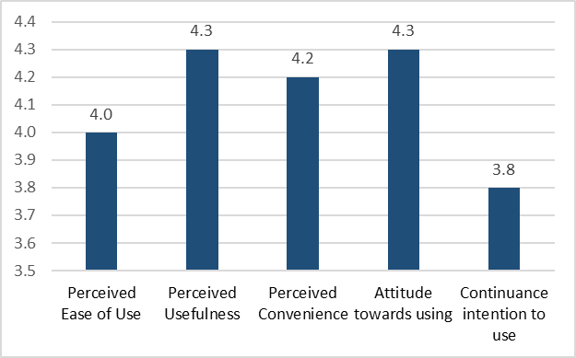

**Fig. III – Comparison of TAM Constructs**

# Concluding Remarks

This paper investigated and analysed the acceptance of a hazard perception training and test tool among young drivers in Mauritius. In order to achieve the purpose of this paper, a web application called MauHazard was implemented and this tool has the training and test mode to improve and assess the hazard perception skills of drivers. Acceptance of the tool was evaluated through application of the Technology Acceptance Model where 40 young drivers participated and utilized the proposed tool. During evaluation, feedback from participants was sought on 5 TAM constructs, notably, perceived ease of use, perceived usefulness, perceived convenience, attitude towards using and continuance intention to use. Results revealed a positive overall score of 4.1, which also meant acceptance of the tool by the participants. Among the constructs investigated, highest score was obtained for perceived usefulness and attitude towards using, whereas the least score was obtained for continuance intention to use. Even though an overall positive score was obtained, application of TAM provided insights on different issues that could influence adoption of the tool. These limitations could be taken on board by different studies implementing and investigating hazard perception tools.

As future works, further evaluation is being planned in this funded research project. A larger population of drivers is being targeted to investigate the influence of different variables (e.g. demographic details of participants, experience and category of drivers) on the hazard perception skills of drivers. Furthermore, improvements enlightened in this study will be considered towards improving MauHazard before its official release. Also, other usability evaluation models including Nielsen’s principles could be applied so as to further investigate the usability of the tool.

##### Acknowledgment

The authors wish to thank the Mauritius Research Council (MRC) for funding this research project as well as all stakeholders who participated in this study, including the Mauritius Police Force.

##### References

|  |  |
| --- | --- |
| [1] | Central Statistics Office of Mauritius, “Road Transport and Road Traffic Accident Statistics (Island of Mauritius) - Jan-Jun 2018,” Central Statistics Office of Mauritius, 2018. [Online]. Available: http://statsmauritius.govmu.org/English/Publications/Pages/RT_RTA_Jan-Jun18.aspx. [Accessed 12 Jan 2019]. |
| [2] | R. Rajaysur, “Routes: un nouveau système de contrôle des excès de vitesse à l’étude,” 16 September 2015. [Online]. Available: https://www.lexpress.mu/article/268766/routes-un-nouveau-systeme-controle-exces-vitesse-letude. [Accessed 20 October 2017]. |
| [3] | Mauritius Police Force, “Safety Driving,” 2005. [Online]. Available: http://police.govmu.org/English/Pages/Safety-Driving.aspx. [Accessed 22 September 2017]. |
| [4] | Government Information Service, “Road Safety: National Campaign organised to target whole population,” Government Information Service, 2018. [Online]. Available: http://www.govmu.org/English/News/Pages/Road-Safety-National-Campaign-organised-to-target-whole-population.aspx. [Accessed 13 Jan 2019]. |
| [5] | S. Jewon and D. Nathoo, “Road Accidents Mauritius, An Engineering perspective,” 2002. |
| [6] | J. Crick and F. McKenna, “Hazard perception: can it be trained?,” 1992. |
| [7] | H. A. Deery, “Hazard and Risk Perception among Young Novice Drivers.,” 1999. |
| [8] | F. McKenna and J. Crick, “Hazard perception in drivers: A methodology for testing and training,” *TRL contractor report,* vol. 313, 1994. |
| [9] | V. Venkatesh and M. Morris, “Why don't men ever stop to ask for directions? Gender, social influence, and their role in technology acceptance and usage behavior,” *MIS quarterly,* vol. 24, no. 1, pp. 115-139, 2000. |
| [10] | B. Wixom and P. Todd, “A theoretical integration of user satisfaction and technology acceptance,” *Information systems research,* vol. 16, no. 1, pp. 85-102, 2005. |
| [11] | A. Borowsky, T. Oron-Gilad, A. Meir and Y. Parmet, “Drivers’ perception of vulnerable road users: A hazard perception approach.,” *Accident Analysis & Prevention ,* vol. 1, no. 44, pp. 160-166, 2012. |
| [12] | M. Horswill, S. Marrington, C. McCullough, J. Wood, N. Pachana, J. McWilliam and M. Raikos, “The hazard perception ability of older drivers,” *The Journals of Gerontology Series B: Psychological Sciences and Social Sciences,* vol. 63, no. 4, pp. 212-P218, 2008. |
| [13] | M. Wetton, A. Hill and M. Horswill, “The development and validation of a hazard perception test for use in driver licensing,” *Accident Analysis & Prevention,* vol. 43, no. 5, pp. 1759-1770, 2011. |
| [14] | W.-S. Chou and P.-C. Chuang, “A Study on the Analysis and Design of Drivers’ Hazard Perception Test,” *Asian transport studies, ,* vol. 3, no. 2, pp. 220-233, 2014. |
| [15] | C. Scialfa, M. Deschênes, J. Ference, J. Boone, M. Horswill and M. Wetton, “A hazard perception test for novice drivers,” *Accident Analysis & Prevention,* vol. 43, no. 1, pp. 204-208, 2011. |
| [16] | J. Nielsen, “10 Usability Heuristics for User Interface Design,” 1995. [Online]. Available: https://www.nngroup.com/articles/ten-usability-heuristics/. [Accessed 25 January 2016]. |
| [17] | R. Johnson, J. Hoeller, K. Donald, C. Sampaleanu and R. Harrop, “The spring framework–reference documentation,” 2014. [Online]. Available: https://docs.spring.io/autorepo/docs/spring-framework/4.1.8.RELEASE/spring-framework-reference/pdf/spring-framework-reference.pdf. |
| [18] | W. King and J. He, “A meta-analysis of the technology acceptance model,” *Information and Management,* vol. 43, no. 6, p. 740–755, 2006. |
| [19] | M. Fishbein and I. Ajzen, Belief, Attitude, Intention, and Behavior: An Introduction to Theory and Research, Reading. MA,: Addison-Wesley, 1975. |
| [20] | F. Davis, “Perceived usefulness, perceived ease of use, and user acceptance of information technology,” *MIS quarterly,* pp. 319-340, 1989. |
| [21] | F. Davis, R. Bagozzi and P. Warshaw, “User acceptance of computer technology: a comparison of two theoretical models,” *Management science,* vol. 35, no. 8, pp. 982-1003, 1989. |
| [22] | A. Thanacoody, G. Bekaroo, A. Santokhee and S. Juddoo, “Analyzing the Prospects and Acceptance of Mobile-based Marine Debris Tracking,” in *International Conference on Emerging Trends in Electrical, Electronic and Communications Engineering*, 2018. |
| [23] | M. Al-Emran, V. Mezhuyev and A. Kamaludin, “Technology Acceptance Model in M-learning context: A systematic review,” *Computers & Education,* vol. 125, pp. 389-412, 2018. |
| [24] | T. Chesney, “An Acceptance Model for Useful and Fun Information Systems,” *Human Technology: An Interdisciplinary Journal on Humans in ICT Environments,* vol. 2, no. 2, pp. 225-235, 2006. |
| [25] | F. Davis, “User acceptance of information technology: system characteristics, user perceptions and behavioral impacts,” *International journal of man-machine studies,* vol. 38, no. 3, pp. 475-487, 1993. |
| [26] | B. Landry, R. Griffeth and S. Hartman, “Measuring student perceptions of blackboard using the technology acceptance model,” *Decision Sciences Journal of Innovative Education,* vol. 4, no. 1, pp. 87-99, 2006. |
| [27] | C. Chang, C. Yan and J. Tseng, “Perceived convenience in an extended technology acceptance model: Mobile technology and English learning for college students,” *Australasian Journal of Educational Technology,* vol. 28, no. 5, 2012. |
| [28] | G. Bekaroo, R. Sungkur, P. Ramsamy, A. Okolo and W. Moedeen, “Enhancing awareness on green consumption of electronic devices: The application of Augmented Reality,” *Sustainable Energy Technologies and Assessments,* vol. 30, pp. 279-291, 2018. |
| [29] | V. Venkatesh and H. Bala, “Technology acceptance model 3 and a research agenda on interventions,” *Decision sciences,* vol. 39, no. 2, pp. 273-315, 2008. |
| [30] | V. Venkatesh, “Determinants of perceived ease of use: Integrating control, intrinsic motivation, and emotion into the technology acceptance model,” *Information systems research,* vol. 11, no. 4, pp. 342-365, 2000. |