Title page

Temporal expectation improves recognition memory for spatially attended objects

Alexander Jones*, Emma V. Ward*, Enida L. Csiszer & Joanna Szymczak
Middlesex University, London

*Jones and Ward contributed equally to this manuscript and share first authorship

Corresponding author: Alexander Jones, Psychology Department, Faculty of Science and Technology, Middlesex University, London, NW4 4BT. Email: a.j.jones@mdx.ac.uk.

Abstract
Recent evidence suggests that temporal expectation is beneficial to memory formation. Rhythmic presentation of stimuli during encoding enhances subsequent recognition and is associated with distinct neural activity compared with when stimuli are presented in an arrhythmic manner. However, no prior study has examined how temporal expectation interacts with another important form of facilitation – spatial attention – to affect memory. This study systematically manipulated temporal expectation and spatial attention during encoding to examine their combined effect on behavioural recognition and associated ERPs. Participants performed eight experimental blocks consisting of an encoding phase and recognition test, with EEG recorded throughout. During encoding, pairs of objects and checkerboards were presented and participants were cued to attend to the left or right stream and detect targets as quickly as possible. In four blocks stimulus presentation followed a rhythmic (constant, predictable) temporal structure, and in the other four blocks stimulus onset was arrhythmic (random, unpredictable). An interaction between temporal expectation and spatial attention emerged, with greater recognition in the rhythmic than the arrhythmic condition for spatially attended items. Analysis of memory specific ERP components uncovered effects of spatial attention. There were late positive component (LPC) and FN400 old/new effects in the attended condition for both rhythmic and arrhythmic items, while in the unattended condition there was an FN400 old/new effect, and no LPC effect. The study provides new evidence that memory improvement as a function of temporal expectation is dependent upon spatial attention.

Keywords: temporal expectation; rhythmic encoding; spatial attention; recognition memory; ERP

Introduction
Successful memory is dependent upon effective encoding. One important factor is the allocation of attention and processing resources to particular information, which increases the probability that it will be remembered later (Aly & Turk-Browne, 2017). In the spatial attention literature the effect of allocating attention to particular locations has been extensively studied. Orienting attention to a location in space has shown to enhance perceptual processing (e.g., Mangun & Hillyard, 1990; Yeshurun & Carrasco, 1998) and facilitate response times (e.g., Posner et al., 1980) to visual stimuli at attended compared to unattended locations (for a review see Carrasco, 2014). In memory research attention has been manipulated during encoding in various different ways, where it has been shown that attending to a particular object feature or location produces greater subsequent recognition and recall of attended relative to unattended items (e.g., Berry et al., 2010; Ballesteros, Reales, García, & Carrasco, 2006; Butler & Klein, 2009; Eich, 1984; Merikle & Reingold, 1991; Rock & Gutman, 1981; Yi & Chun, 2005; Uncapher et al., 2011; Turk-Brown, Golomb & Chun, 2013; see Chun & Turk-Browne, 2007, for a review). For example, presenting overlapping shapes in different colours, and instructing participants to attend to one of the two colours during encoding, leads to enhanced memory for attended over unattended shapes (Rock & Gutman, 1981; MacDonald & MacLeod, 1998). In other studies Posner cueing paradigms, similar to those used in the spatial attention literature (see Chica et al., 2014, for a review), have uncovered memorial benefits for spatially attended over unattended items. For example, Merikle and Reingold (1991) presented participants with pairs of words on the top and bottom of a computer screen and instructed them to read the cued (arrowed) words aloud. Subsequent recognition was greater for attended relative to unattended items (see also Berry, Shanks, & Henson, 2006; Hauer & MacLeod, 2006). Using a central cue, Turk-Browne et al. (2013) instructed participants to covertly orient attention to the left, right or centrally before presenting a target image to either the left or right. Subsequent recognition was enhanced for items that had appeared at cued relative to uncued locations, suggesting that memory encoding is enhanced by attentional facilitation of perceptual processing.
In the last decade or so interest has also turned to how temporal expectations – the anticipation of when an event will occur – shape behaviour. Temporal expectations can be generated in different ways, such as by varying the probability of when an event will occur, or the presence of a pattern or rhythm (Nobre & van Ede, 2018). This has been shown to improve perceptual discrimination (Correa, Lupiáñez, & Tudela, 2005; Rohenkohl, Gould, Pessoa, & Nobre, 2014), and enhance neural processing of expected over unexpected items (Buhusi & Meck, 2005; Correa, Lupiáñez, Madrid, & Tudela, 2006; Rohenkohl & Nobre, 2011; Zanto et al., 2011). Given the wide implications and application of temporal expectation as a method of enhancing cognitive function, the recent rise in interest in examining its impact on memory is unsurprising (see e.g., Wilsch, et al., 2018; Cravo, Rohenkohl, Santos, & Nobre, 2017; Jin, Nobre, & van Ede, 2020; van de Ven et al., 2020). Several recent studies have reported enhanced recognition – the capacity to judge whether an item has been presented before in a particular context – for items encoded in a rhythmic or temporally structured manner (e.g., Jones & Ward, 2019; Thavabalasingam et al., 2016; Hickey et al., 2020a; 2020b). Thavabalasingam et al. (2016) found greater recognition of items that were presented with a fixed repeating sequence of onset timings compared to random onset timings during encoding. Moreover, we recently reported greater recognition and distinct neural processing of items presented in a rhythmic compared to an arrhythmic manner during encoding (Jones & Ward, 2019). Participants were exposed to objects in a series of blocks with rhythmic or arrhythmic onset timings. In the rhythmic condition a constant rhythm was generated by fixing the interstimulus interval (ISI) at 600 ms, while in the arrhythmic condition the ISI was randomly generated, making stimulus onset unpredictable. As well as examining behavioural recognition we recorded electroencephalography (EEG) and uncovered differential neural activity as a function of the temporal manipulation in memory-specific event-related potential (ERP) components. At recognition, the FN400 old/new effect (thought to reflect shallow or familiarity-based processing; e.g., Curran & Doyle, 2011) was unaffected by temporal structure during encoding, while the late positive component (LPC) old/new effect (thought to reflect deeper, recollection-based processing; e.g., Rugg & Curran, 2007) was observed only for rhythmically encoded items.
In other recent studies, Johndro et al. (2019) found enhanced recognition of nonverbal visual stimuli (faces) that were presented in synchrony with a rhythmic auditory background beat during encoding, and Hickey et al. (2020a) uncovered evidence that neural tracking of a rhythmic auditory background beat was associated with greater subsequent recognition of visual objects that appeared in-synchrony with the beat compared to those that appeared out-of-synchrony. Taken together, the observations may be explained by the Dynamic Attending Theory (DAT, Large & Jones, 1999), which suggests that rhythmic presentation of stimuli during encoding generates peaks of attention focus, creating a processing advantage for items occurring at attended peaks. Indeed, in studies examining ERPs, stimuli appearing in synchrony with a rhythm show a larger amplitude for early perceptual components such as P1 (Rohenkohl & Nobre, 2011) and N1 (Escoffier et al., 2015). In spatial attention research this has been associated with increased visual analysis of attended over unattended stimuli through a gain control mechanism (Hillyard & Annlo-Vento 1998; Luck et al., 2000). Consistent with this is a range of evidence that neuronal firing automatically entrains to external rhythms. That is, the phase of intrinsic brain oscillations entrain to ongoing external rhythms, aligning the firing pattern of neurons, such that stimuli presented in phase with the oscillations are at a processing advantage compared to those presented out of phase (Arnal & Giraud, 2012; Lakatos et al., 2008; reviewed in Calderone et al., 2014; Henry & Herrmann, 2014).
Overall, two separate strands of research point to benefits of spatial attention and temporal expectation – that is, where and when stimuli will appear during encoding – on subsequent memory. The relatively new and emerging evidence in relation to temporal expectation suggests that memory is affected by temporal aspects of the presentation of to-be-remembered stimuli themselves, as well as by task-irrelevant temporal cues such as the presence of an auditory background beat. However, an important unanswered question is how temporal expectation interacts with spatial attention at encoding to influence subsequent memory. A number of prior studies have sought to understand the combined effect of these factors on other behavioural measures and neural responses (Rohenkohl et al., 2014; Heideman et al., 2018; Kizuk & Mathewson, 2017; Sharp, Melcher & Hickey, 2019; Seibold, Stepper, & Rolke, 2020 Wilsch, et al., 2020). Measuring response times, research from our lab shows that spatial attention and temporal expectation generated by a rhythm interact when both modes are exogenous (Jones, 2019), while endogenous spatial attention is independent from temporal expectancy (Jones, 2015, 2019). Moreover, in an EEG study Doherty et al. (2005) manipulated temporal and spatial expectancies by presenting participants with a ball that moved from left to right across a screen. Towards the right side of the screen was a section that occluded the ball before it reappeared. Doherty et al. reported faster responses when the ball reappeared from behind the occluding band in synchrony with the preceding rhythm of movement and at the same spatial location predicted by its trajectory across the screen. Interestingly, effects were additive, with fastest responses when temporal and spatial expectancies matched. This additive effect was also demonstrated on the visual P1 component, suggesting that spatial and temporal effects interact at early perceptual processing stages. In another study by Rohenkohl et al. (2014), a visual arrow simultaneously indicated the likely location and onset time of a target, which improved target discrimination at attended but not unattended spatial locations, showing a synergistic interaction between temporal and spatial expectations.
Understanding the combined effect of temporal expectation and spatial attention on memory is both practically and theoretically important. The practical use of these factors as memory aids (for example, in memory interventions) demands evidence in relation to their interaction, allowing us to understand whether they have shared features that influence memory, or are associated with separate and additive benefits. To address this gap, this this study is the first to systematically manipulate temporal expectation and spatial attention during encoding to examine their combined effect on later recognition. Temporal expectation (rhythmic versus arrhythmic item presentation timings) and spatial attention (attended versus unattended item location) were manipulated during blocks of encoding prior to recognition testing, with EEG recorded to examine neural activity at recognition as a function of the encoding manipulations. Participants were presented with pairs of objects and checkerboards under instructions to attend to either the left or right stream and detect animals at the attended location as quickly as possible. Stimuli were presented for a fixed duration, but their onset followed either an isochronous rhythm or random and unpredictable timings in a blocked design, and participants were not made aware of this temporal manipulation. Following this, participants judged whether individual items (half studied / half new) were presented in the prior detection task. Greater recognition was expected for spatially attended than unattended items, and items encoded in a rhythmic versus an arrhythmic manner, and of key interest was the nature of the interaction between spatial attention and temporal expectation.
To shed further light on how temporal and spatial processes influence subsequent memory, two recognition ERP components were examined; 1) the FN400 old/new effect thought to reflect shallow or familiarity-based processing (e.g., Curran & Doyle, 2011; Ecker, Zimmer, Groh-Bordin, & Mecklinger, 2007; Rugg & Curran, 2007; Groh- Bordin, Zimmer, & Ecker, 2006; Duarte et al., 2004; Curran & Cleary, 2003; Curran, 2000; Düzel, Yonelinas, Mangun, Heinze, & Tulving, 1997; Smith, 1993), and the LPC old/new effect thought to reflect deeper, recollection-based processing (e.g., Griffin, DeWolf, Keinath, Liu, & Reder, 2013; Voss et al., 2010; Rugg & Curran, 2007; Woodruff et al., 2006; Duarte et al., 2004; Curran & Cleary, 2003; Curran, 1999, 2000; Allan, Wilding, & Rugg, 1998). In line with our previous work (Jones & Ward, 2019), we anticipated that temporal expectation would affect the LPC with an old/new effect for rhythmic but not arrhythmic items, and FN400 old/new effects for both rhythmic and arrhythmic items. In relation to spatial attention, although no prior study has directly contrasted ERP effects at recognition following endogenous spatial attention encoding manipulations, based on other manipulations of selective attention (see Curran, 2004) we expected a similar effect as for temporal expectation. That is, an LPC old/new effect for attended items that are associated with greater processing during encoding, but not for unattended items, and FN400 old/new effects for both attended and unattended items. Finally, the ERP analyses were intended to provide insight into whether effects of temporal expectation and spatial attention independently affect the recognition components or interact at the FN400 and LPC.

Materials and Methods
Participants and sample size
Thirty-two students (17 male, mean age = 23.75 years, SD = 4.33 years) from Middlesex University London participated. Four were excluded prior to analysis, two due to technical errors and two who failed to follow instructions in the encoding phase (see Procedure). All participants were fluent in English language, right-handed, with normal or corrected vision. Ethical approval was granted by the Middlesex University Research Ethics Committee, and all participants provided written informed consent. Participants received a £20 Amazon voucher in exchange for their participation.
Our a priori sample size estimation was based on our previous work (Jones & Ward, 2019). The same paradigm was used in the present study to manipulate temporal expectancy, where we aimed to replicate the novel effect of enhanced recognition following rhythmic encoding. Jones and Ward (2019) included 23 usable participants, with an actual effect size of d = 0.30, so to account for potential data loss we increased the sample size in the present study to N=32, resulting in 28 usable participants. Importantly, no data “peeking” or analyses were conducted prior to collection of the full sample. Raw data has been provided on the OSF here: https://osf.io/dzw2h/
Design
The experiment involved the within-participants comparison of the effect of Temporal expectation (rhythmic versus arrhythmic timings) and Spatial attention (attended versus unattended items) on recognition memory. Each participant was exposed to eight encoding-test blocks, half with rhythmic timings during encoding and half with arrhythmic timings, in a counterbalanced alternation. Half of the participants witnessed a rhythmic block first and the other half witnessed an arrhythmic block first. In four blocks participants were cued to attend to objects appearing on the left, and in the other four they were cued to attend to the right (see Procedure).
Stimuli
The stimuli were 640 400 x 400 pixel greyscale images of familiar everyday objects taken from the Bank of Standardized Images (BOSS) (Brodeur et al., 2014). Each encoding phase contained a unique set of 52 objects, half of which appeared on the left of the screen and the other half on the right, randomly interspersed among 156 presentations of a 400 x 400 pixel checkerboard (Figure 1), resulting in a ratio of 3:1 checkerboard to stimulus presentations. Target items during encoding were images of animals. Sixteen animals were presented in each encoding phase, equally distributed to the right and left of the screen (approximately 30% of trials). The test phase within each block contained 36 objects presented in the encoding phase immediately prior (52 real objects minus 16 animal targets), along with 36 new objects. Items were counterbalanced between participants such that each set of objects appeared an equal number of times in each block, and an equal number of times as studied (old) or new type.
Procedure
Participants were tested individually and the duration as approximately one and a half hours not including EEG preparation. The task was programmed in Matlab 2013a and performed on a PC with a screen resolution of 1280 x 1024 pixels in sound attenuated cubicle. Participants were informed that the experiment consisted of eight blocks, each with two separate tasks: a detection task and a memory task.
Detection task
In the detection task participants were presented with a stream of objects and checkerboards on the left and right of a central black fixation point on a white background (Figure 1A). Each trial comprised either an object and a checkerboard or two checkerboards, and participants were informed that most of the images would be checkerboards. A ratio of 3:1 checkerboards to objects was used to extend the duration of the encoding phase and generate a rhythm, and at least one checkerboard was presented between two objects. Participants were instructed to fixate their gaze on the central fixation point (< or >), which remained on the screen at all times, but focus covert attention to either the left or right as indicated by the arrow. They were instructed to press the spacebar as quickly as possible whenever they saw an animal on the attended side. In four of the eight blocks (two rhythmic and two arrhythmic) participants attended to the right and in the other four they attended to the left. Images of animals appeared equally often on the left and right.
In all blocks, objects and checkerboards were presented for precisely 600 ms, but the interstimulus interval (ISI) differed in the rhythmic and arrhythmic blocks. Participants were not made aware of this temporal manipulation. In the rhythmic blocks the ISI was held constant at 600 ms, generating a rhythmic presentation of stimuli at 1.67Hz. In the arrhythmic blocks the ISI was randomly generated from a uniform distribution with a range of 70 ms to 1130 ms and a mean of 600 ms. Thus, all events in the rhythmic condition were constant and predictable, while stimulus onset was not predictable in the arrhythmic blocks. The total duration of the detection task in each block was equivalent. Accuracy and speed of target detection was recorded.
Following each detection task, participants solved simple algorithmic problems for three minutes prior to the recognition phase.
Recognition task
The recognition task included 36 objects from the detection task immediately prior (excluding animal targets), along with 36 new items, in a new random order for each participant. On each trial an object was presented in the center of the screen for 600 ms, before the instruction “Was this object shown in the last detection task?” and response scale “6 = sure yes, 5 = think yes, 4 = guess yes, 3 = guess no, 2 = think no, 1 = sure no” appeared below the object (Figure 1B). Participants were required to indicate their response via a number keypress. They were informed that half of the items were shown in the detection task and half were new. No time limit was imposed, and the object and response scale remained on the screen until a keypress was made. A central fixation point was presented for a random duration ranging from 70 ms to 1130 ms prior to the next trial.
At the start of the experiment participants performed a short practice block including eight detection trials and 16 recognition trials (half studied, half new). On completion of the experiment, participants were probed for awareness of the temporal manipulation. They were asked whether they noticed any difference in the detection task between blocks, and if yes, to explain it. Participants who correctly identified the manipulation were asked whether they became aware during the task or in hindsight.

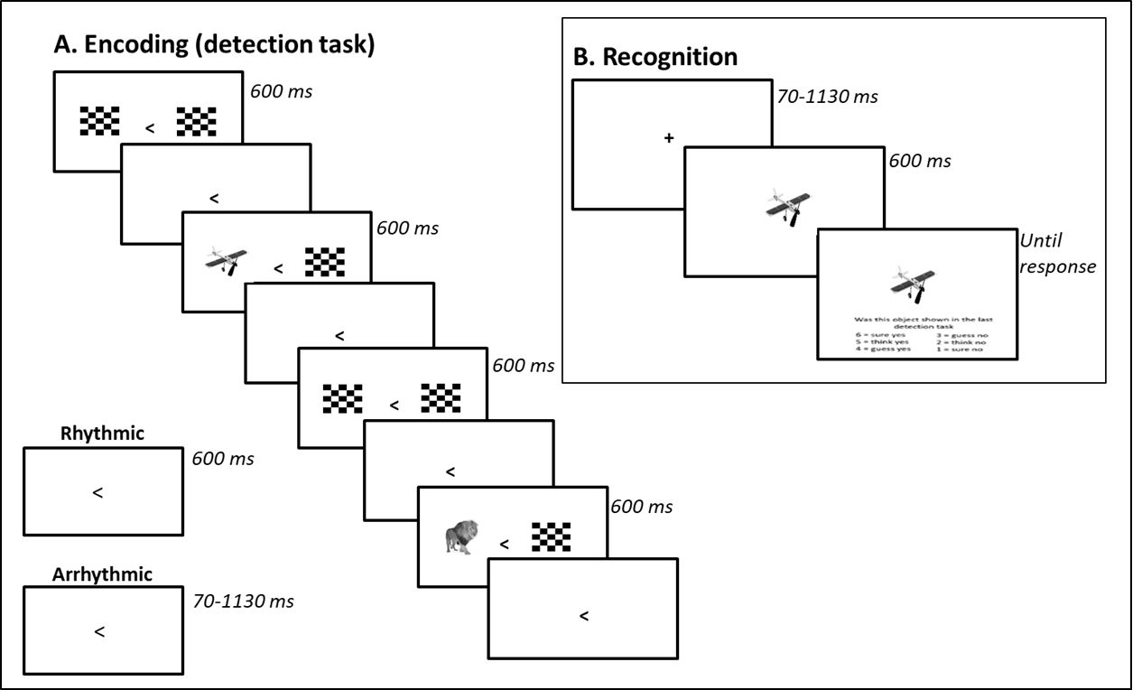
Figure 1. (A) Events in the encoding phase. Participants were presented with a stream of objects and checkerboards to the left and right of a central arrow. The arrow indicated the side to which the participant was to focus their covert attention and the participant responded to targets (animals) only when they appeared at the attended side. The interval between stimuli was either a fixed (600 ms) or random (70-1130 ms) interval. (B) Recognition phase followed an encoding block. Participants were presented with an image (old or new) and asked whether they had seen the image before.

EEG Recording and Analysis
EEG (BioSemi Active Two system) was recorded from 64 locations on the scalp throughout the experiment with a sample rate of 2048Hz and reference to the CMS-DRL (common mode sense-driven right leg). Horizontal electro-oculogram (HEOG) was recorded from the outer canthi of the eyes (for three participants HEOG electrodes were faulty and not part of the artefact rejection). Offline data analysis (Brain Vision Analyzer v2.1.1, Brain Products GmbH). Bad channels identified manually and topographically interpolated. No channels included in the data analyses (Fz, P3) were interpolated. A second order Butterworth zero-phase band-pass filter with low cut-off of 0.1 Hz and a high cut-off of 40 Hz, and a 50 Hz zero-phase notch filter were applied to each participant's continuous data. Data were then re-referenced to the average of all 64 electrodes. Eye-blinks were corrected in a semi-automatic mode, using independent component analysis (ICA, Brain Vision Analyzer). ERPs were epoched into 900 ms segments ranging from 100 ms pre-stimulus onset to 800 ms post-stimulus onset. A 100 ms pre-stimulus baseline correction was performed on each ERP by subtracting the mean voltage in that interval from every voltage point (1 / ms) in the ERP. Artefact rejection was performed on all channels excluding segments with amplitudes than ±100 µV.
Average ERPs were computed for each participant in the rhythmic and arrhythmic conditions, separately for hits, misses, correct rejections, and false alarms. Hits and misses were also averaged separately for attended and unattended items. Mean amplitudes were compared for hits (old) and correct rejections (CR; new) at mid-frontal electrode Fz in the 300-500 ms interval, for FN400 and for the LPC the left-parietal electrode P3 was selected in the 500-800 ms interval. The electrode choice and time intervals were based upon a large body of research (e.g., Bergstrom et al., 2016; see Rugg & Curran, 2007, for a review). Separate analyses were conducted for attended and unattended items. For each interval, mean amplitudes were submitted to a 2x2 repeated measures analysis of variance (ANOVA) with factors Item (old, new) and Temporal expectation (arrhythmic, rhythmic). Moreover, to directly contrast effects of Spatial attention, hits in each interval (FN400 and LPC) were submitted to a 2x2 repeated measures ANOVA with factors Spatial attention (attended, unattended) and Temporal expectation (arrhythmic, rhythmic).

Results
An alpha level of .05 was used for all statistical tests, and t-tests are two-tailed. Where the assumption of sphericity is violated, Greenhouse–Geisser adjusted degrees of freedom and probability levels are reported. For all nonsignificant effects, a Bayes Factor (BF) analysis was conducted and a BF10 value less than 1/3 is considered support for the null hypothesis (Dienes, 2014).

Behavioural Results
Detection task
The number of targets correctly detected, the associated mean response time (RT), and number of erroneous responses to non-targets was computed across the rhythmic and arrhythmic blocks (see Table 1). Correct detection of targets and erroneous keypresses did not significantly differ between conditions (t(27) = 1.98, p = .058, d = 0.37, BF10 = 1.095, and t(27) = 0.95, p = .350, d = 0.18, BF10 = 0.303, respectively). However, participants were significantly faster in detecting targets in the rhythmic than the arrhythmic condition (t(27) = 2.05, p = .050, d = 0.39).

Table 1. Performance in the detection task
 | Rhythmic  M (SD) | Arrhythmic  M (SD)
Correct detection of targets (%)  Erroneous responses (%)  RT (correct) (ms) | 96.65 (5.76)  0.64 (0.59)  529 (54) | 94.87 (6.26)  0.77 (0.88)  550 (66)

Recognition
Across blocks, ratings 1–3 and 4–6 on the scale were collapsed into ‘no’ (new) and ‘yes’ (old) responses, respectively. The response scale was used to minimise individual differences in response bias (i.e., encouraging a range of high confidence responses as well as guesses), but responses were not analysed according to confidence as this was not directly relevant to the aim and there were too few trials within intervals. The proportion of hits (old items judged old) and false alarms (FA; new items judged old) (Table 2) were used to calculate d' for attended and unattended items: z[Hit rate (attended/unattended)] – z[FA rate] (Figure 2).
Recognition was significantly greater than chance (d' > 0) in the rhythmic condition (t(27) = 12.61, p < .001, d = 2.38, and t(27) = 8.01, p < .001, d = 1.51, for attended and unattended items, respectively) and the arrhythmic condition (t(27) = 12.58, p < .001, d = 2.37, and t(27) = 8.97, p < .001, d = 1.69, for attended and unattended items, respectively). A repeated measures ANOVA revealed a main effect of Temporal expectation (F(1, 27) = 6.39, p = .018, η_{p}² = .19), a main effect of Spatial attention (F(1, 27) = 48.46, p < .001, η_{p}² = .64), and a significant interaction (F(1, 27) = 6.76, p = .015, η_{p}² = .20). Recognition was greater in the rhythmic than the arrhythmic condition for attended items (t(27) = 3.04, p = .005, d = 0.57), but not for unattended items (t(27) = 1.40, p = .173, d = 0.26, BF10 = 0.480).

Table 2. Proportions of hits, misses, false alarms, and correct rejections in the Recognition Task
 | Rhythmic  M (SD) | Arrhythmic  M (SD)
Hits (attended)  Hits (unattended)  Misses (attended)  Misses (unattended)  False Alarms  Correct Rejections | 0.65 (0.17)  0.42 (0.16)  0.35 (0.17)  0.58 (0.16)  0.21 (0.11)  0.79 (0.11) | 0.62 (0.14)  0.42 (0.14)  0.38 (0.14)  0.57 (0.14)  0.24 (0.10)  0.76 (0.10)

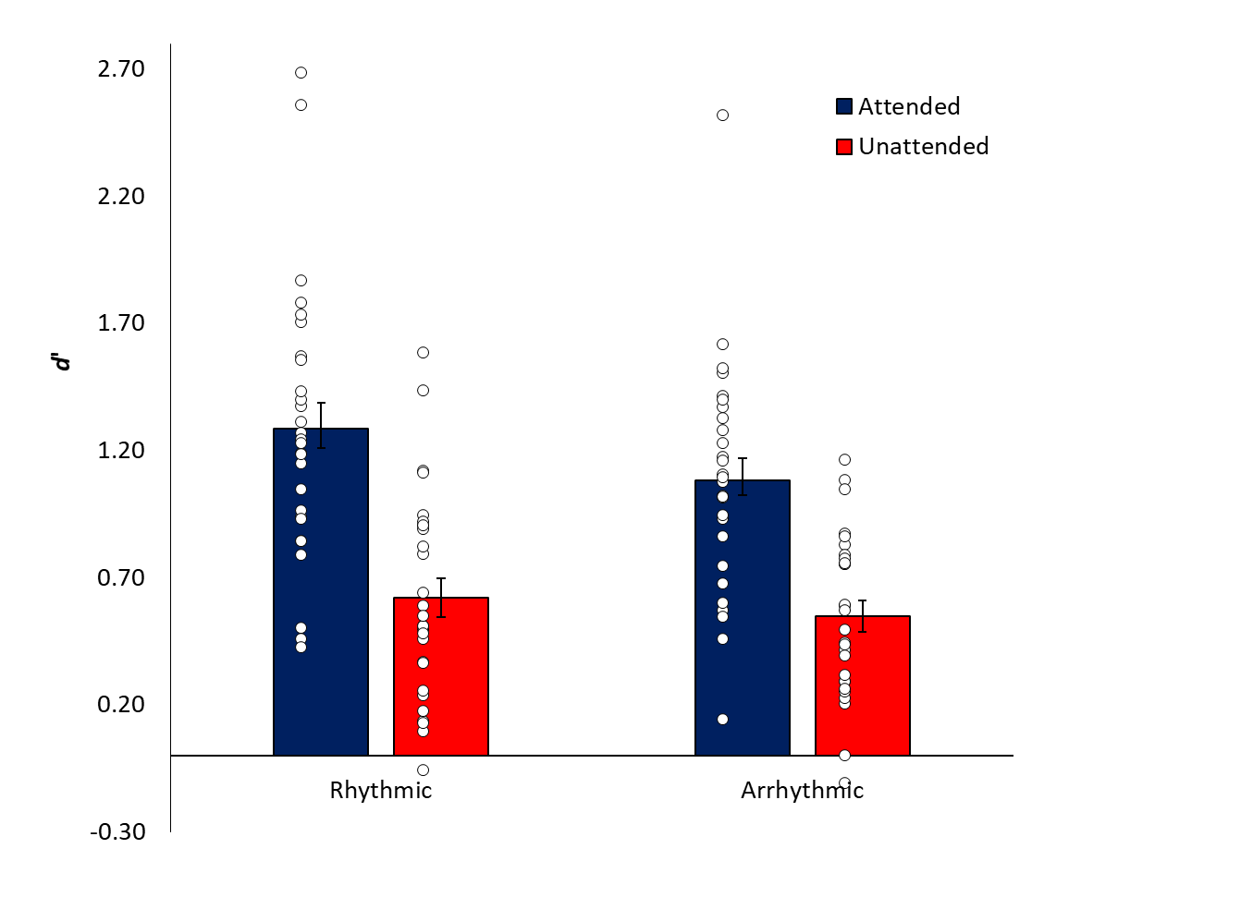
Figure 2. Mean d' scores for attended and unattended items in the Rhythmic and Arrhythmic conditions (standard error bars). White dots represent individual participant scores.

To examine possible variation of recognition accuracy across blocks, repeated measures ANOVAs were performed on attended and unattended items, indicating no significant main effect of block (attended: F(7, 182) = 1.04, p = .404, η_{p}² = .04, BF10 = 0.042; unattended: F(4.23, 109.84) = 1.99, p = .097, η_{p}² = .07, BF10 = 0.444), no significant main effect of the counterbalanced order of conditions (attended: F(1, 26) = 0.86, p = .362, η_{p}² = .03, BF10 = 0.456; unattended: F(7, 26) = 0.06, p = .810, η_{p}² = .002, BF10 = 0.277), and no significant interaction (attended: F(7, 182) = 0.97, p = .454, η_{p}² = .04, BF10 = 0.113; unattended: F(4.23, 109.84) = 0.76, p = .563, η_{p}² = .03, BF10 = 0.072). Overall mean RTs for recognition judgments did not differ in the rhythmic condition (M = 1169 ms; SD = 608 ms) and the arrhythmic condition (M = 1207 ms, SD = 679 ms) (t(27) = 0.92, p = .365, d = 0.17, BF10 = 0.295).
Seven participants reported awareness that presentation timings in the detection task varied across blocks, but means were similar to the group means (rhythmic: 1.23 and 0.73; arrhythmic: 0.99 and 0.56, for attended and unattended items, respectively). Comparison of recognition between aware participants and the 21 unaware participants, although based on a large imbalance in sample size, revealed no significant differences (all t’s < 1, p’s > .415).

ERP Results
To briefly summarise the outcome of the ERP analysis of recognition components, for attended items there were mid-frontal negative (FN400) and late positive component (LPC) old/new memory effects for items presented in both the rhythmic and arhythmic blocks (Figure 3). For unattended items there was an FN400 old/new effect but no LPC old/new effect (Figure 4). A direct comparison of the hits showed a larger LPC for attended over unattended items in the 500-800 ms time interval in both the rhythmic and arrhythmic conditions. Attended and unattended items did not differ in the FN400 time interval (Figure 5).

Old/new effects
Attended items
FN400
There was a main effect of Item (F(1, 27) = 15.87, p < .001, η_{p}² = .37) with larger negativity for new (M = -3.81 SE = 0.55) than old items (M = -2.94, SE = 0.59). There was no effect of Temporal expectation (p = .959, η_{p}² = .<.001, BF10 = 0.006) or Temporal expectation*Item interaction (p = .329, η_{p}² = .04, BF10 = 0.367).
LPC
There was a main effect of Item (F(1, 27) = 11.14, p = .002, η_{p}² = .29) with larger positive amplitude for old (M = 2.84, SE = 0.49) compared to new items (M = 1.86, SE = 0.44). There was no effect of Temporal expectation (p = .215, η_{p}² = .06, BF10 = 0.004) or Temporal expectation*Item interaction (p = .760, η_{p}² = .004, BF10 = 0.236).
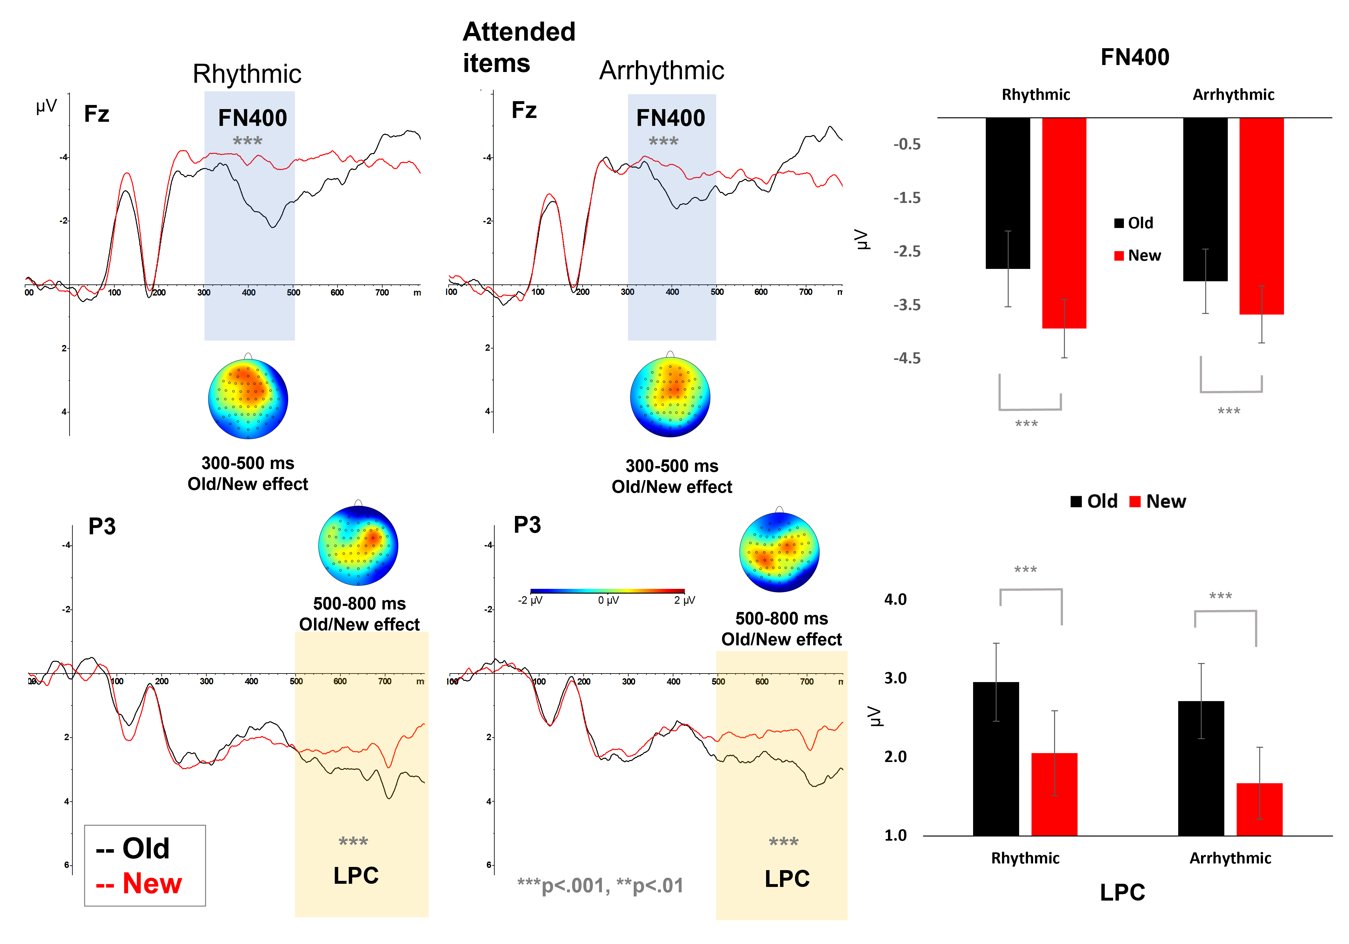

Figure 3. Attended items at recognition. Left; Grand average ERPs time locked (0 ms) to item onset at recognition. Top row shows Fz electrodes used to analyze the FN400 in the 300–500 msec interval (blue shaded area). The bottom row shows P3 electrodes included in the LPC analysis in the 500–800 msec time interval. Topographical maps shows the effect (old-new) in each time interval, separately for rhythmic and arrhythmic items. Right and top: Average ERP amplitudes in the 300–500 msec interval at electrode Fz for old (black) and new (red) trials. The asterisks show a significant FN400 old/new effect for both items presented rhythmically and arrhythmically during encoding. Right and bottom: Average ERP amplitudes in the 500–800 msec interval plotted for electrode P3. There was a significant LPC old/new effect for both rhythmic and arrhythmic items.

Unattended items
FN400
As with attended items there was a main effect of Item (F(1, 27) = 13.86, p = .001, η_{p}² = .34) with larger negativity for new (M = -3.81, SE = 0.55) compared to old items (M = -3.01, SE = 0.51). There was also no effect of Temporal expectation (p = .890, η_{p}² = .001, BF10 = 0.009), or Temporal expectation*Item interaction (F(1, 27) = 1.00, p = .326, η_{p}² = .04; BF10 = 0.372).
LPC
There was no main effect of Item (p = .604, η_{p}² = .010, BF10 = 0.225), Temporal expectation (p = .542, η_{p}² = .014, BF10 = .254), or Item*Temporal expectation interaction (p = .420, η_{p}² = .024, BF10 = 0.347).
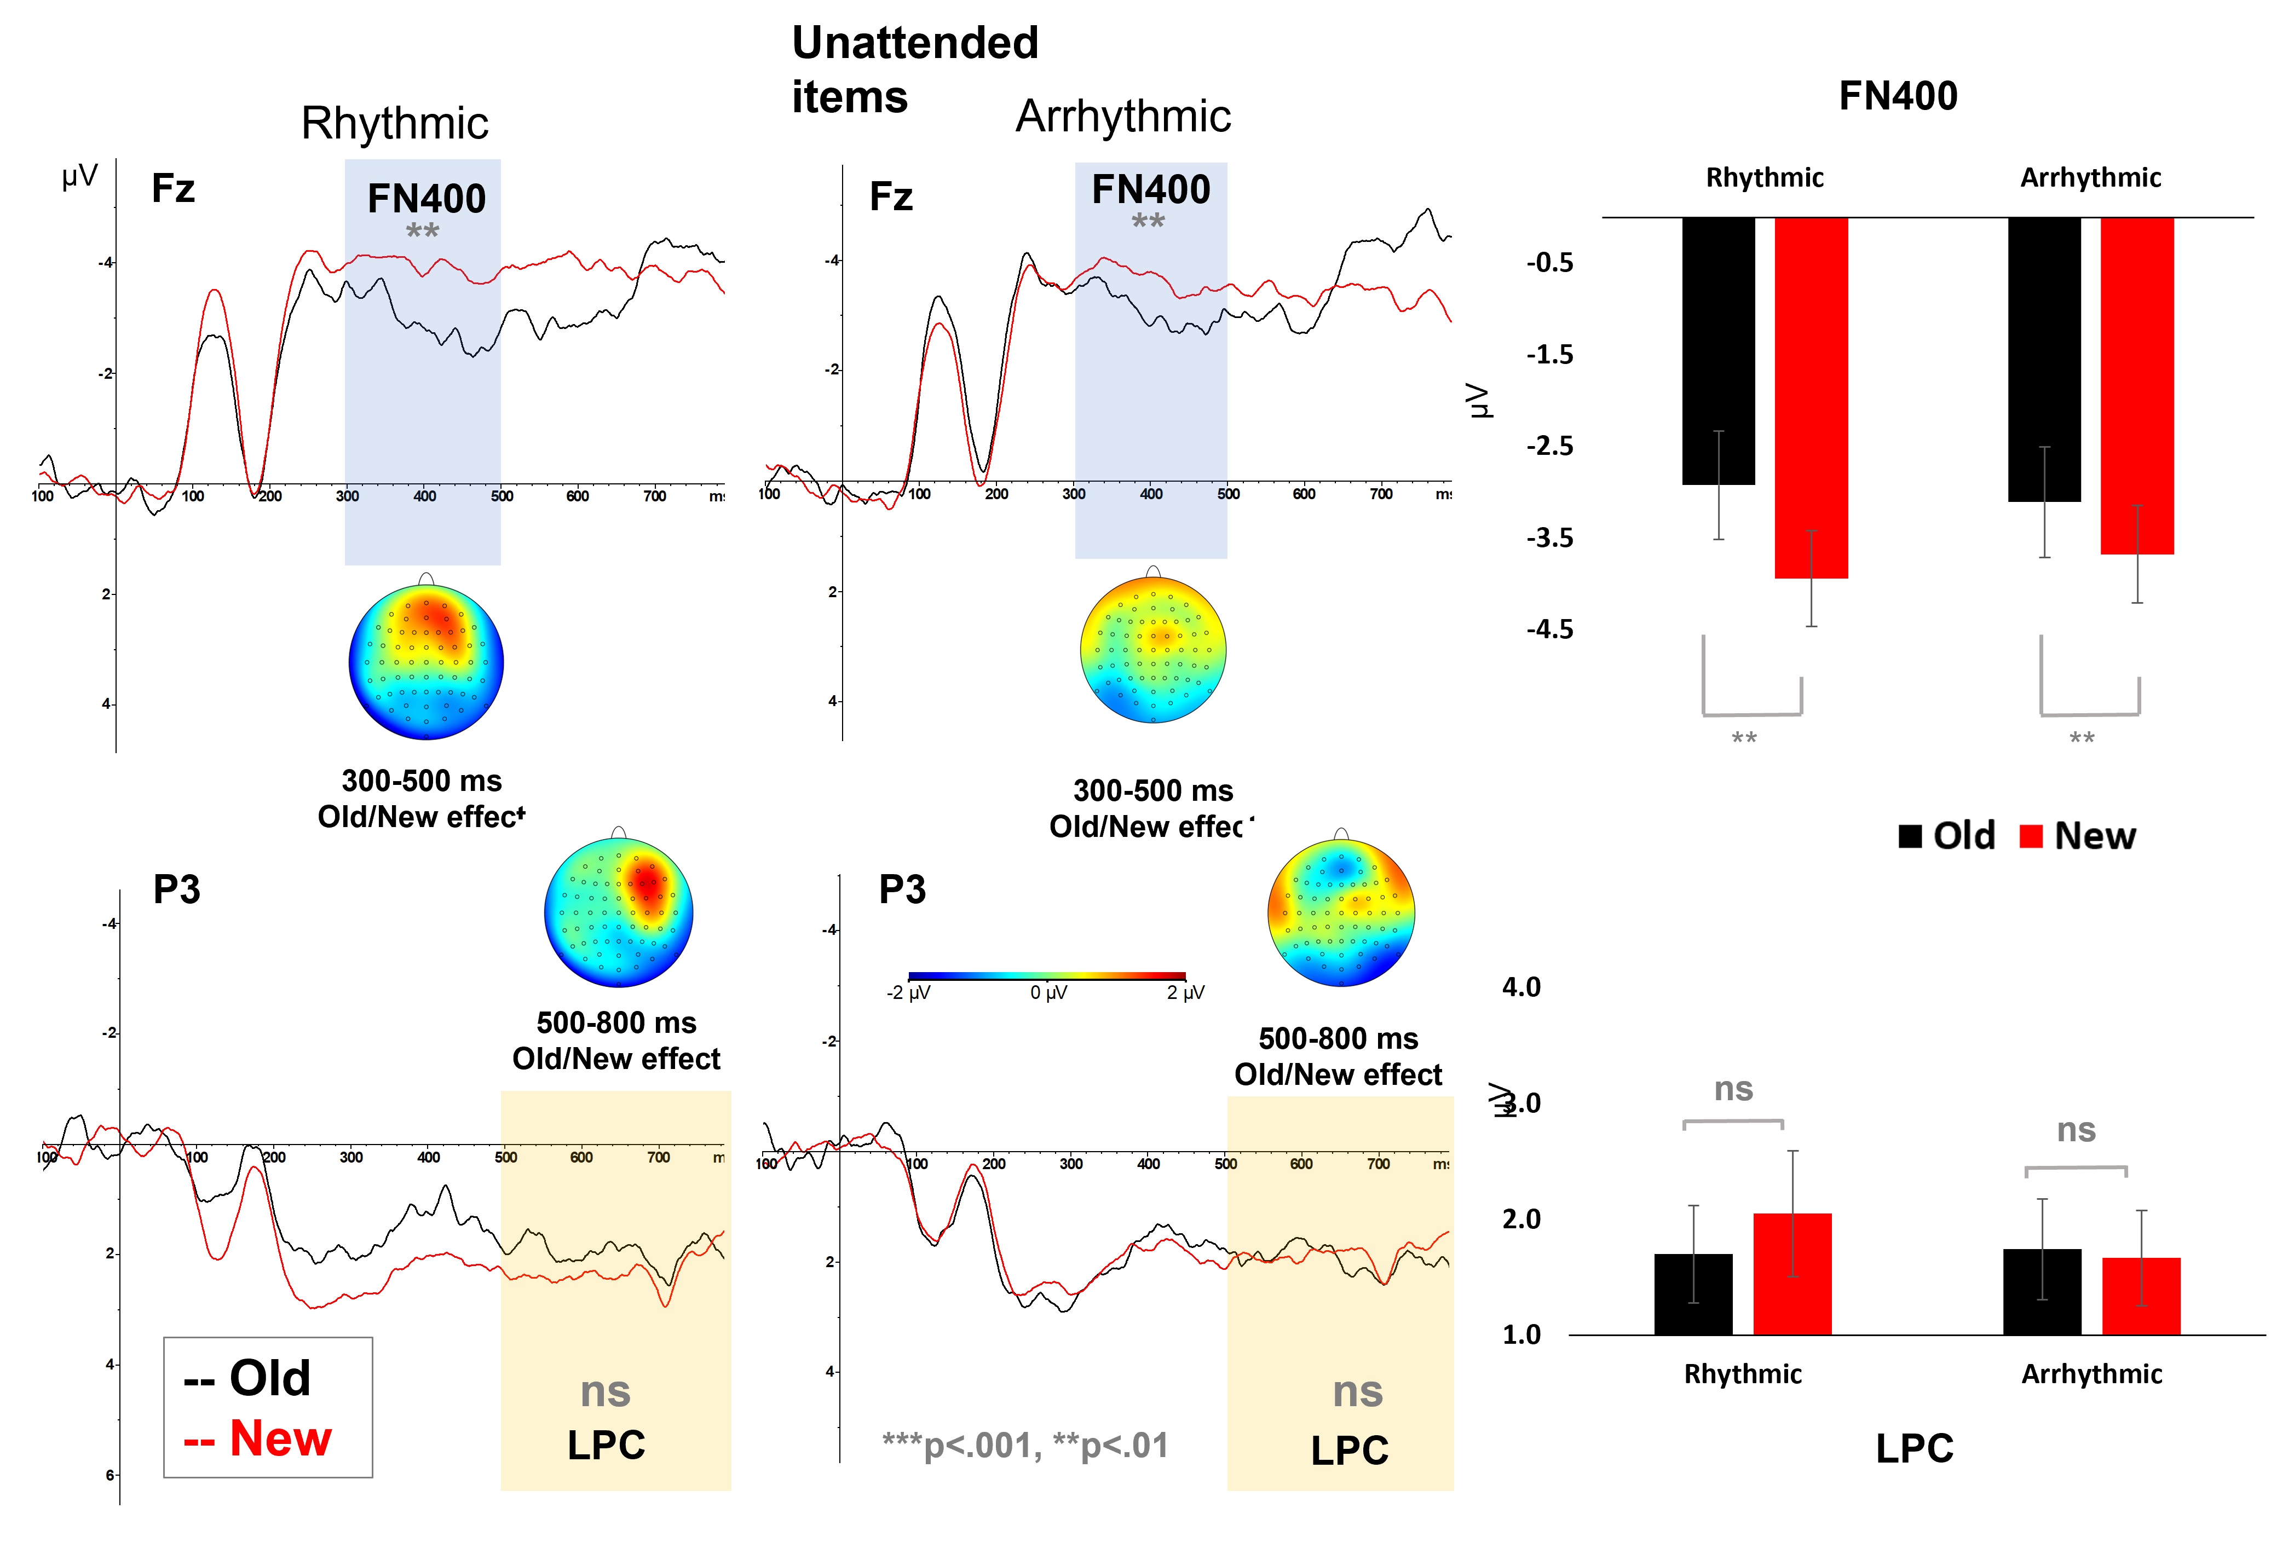
Figure 4. Unattended items at recognition. Left; Grand average ERPs time locked (0 ms) to item onset at recognition. There was a significant FN400 old/new effect in the rhythmic and arrhythmic trials. There was no LPC old/new effect in either rhythmic or arrhythmic conditions for unattended items. Right, the average ERP amplitude in each condition plotted as a bar graph. Note: ns = non-significant effect.

Attention and Temporal expectancy comparison
FN400
There was no main effect of Temporal expectation (p = .593, η_{p}² = .011, BF10 = 0.250), Spatial attention (p = .758, η_{p}² = .004, BF10 = 0.199) or Temporal expectation*Spatial attention interaction (p = .920, η_{p}² <.001, BF10 = 0.295) (Figure 5).
LPC
There was a main effect of Spatial attention (F(1, 27) = 23.16, p < .001, η_{p}² = .462) with larger positive amplitude for attended (M = 2.84, SE = 0.49) compared to unattended items (M = 1.72, SE = 0.46). There was no effect of Temporal expectation (p = .750, η_{p}² = .004, BF10 =0.001) or Temporal expectation*Spatial attention interaction (p = .549, η_{p}² =.013, BF10 =0.267).
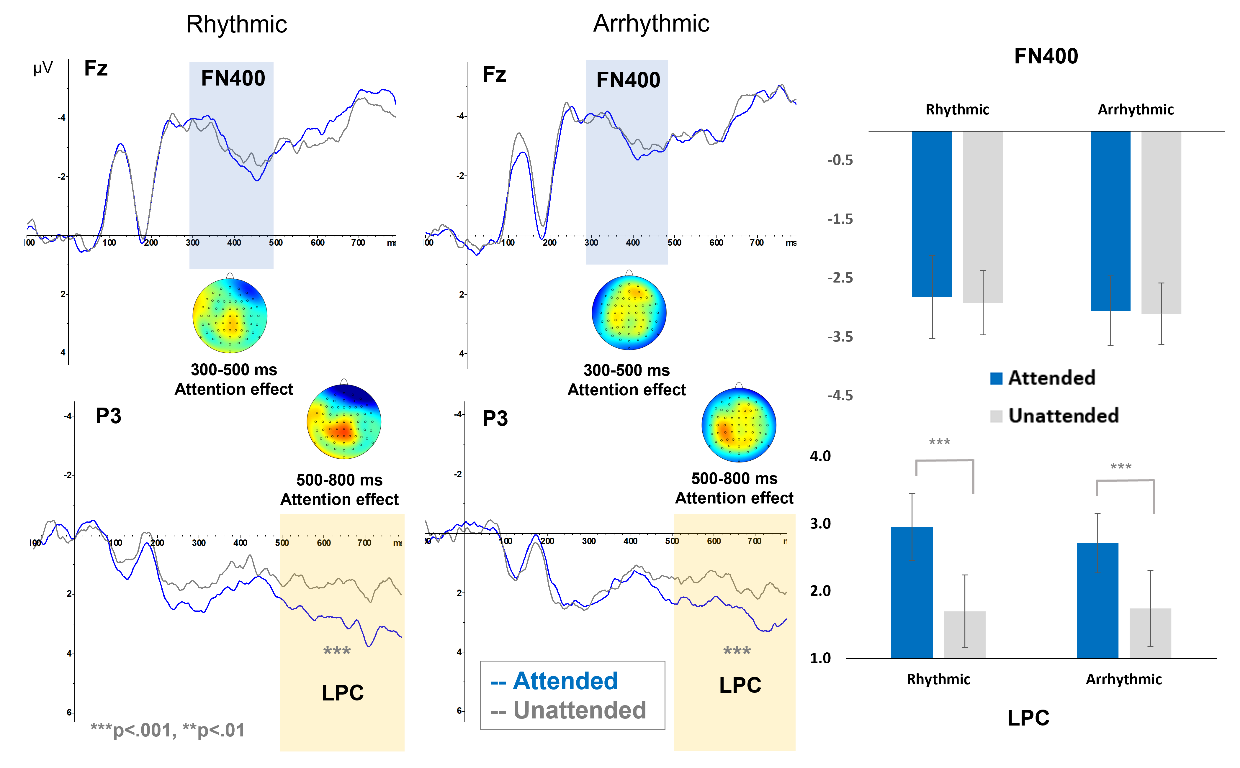
Figure 5. ERPs at recognition comparing items (hits) that were spatially attended (blue) and unattended (grey) during encoding, separately for rhythmic and arrhythmic items. Left; Grand average ERPs time locked (0 ms) to item onset at recognition. Topographical maps show the spatial attention effect (attended-unattended) in each time interval, separately for rhythmic and arrhythmic items. Right and top: Average ERP amplitudes in the 300–500 msec interval at electrode Fz for attended and unattended trials. The effect of spatial attention was observed in the 500-800 ms LPC time interval.

Discussion
This study examined the independent and combined effects of temporal expectation and spatial attention during encoding on subsequent recognition. Behavioural findings uncovered an interaction between the factors, with significantly greater recognition following rhythmic than arrhythmic encoding for spatially attended but not unattended items. Analysis of recognition ERPs showed effects of spatial attention but not temporal expectancy. There were FN400 and LPC old/new memory effects for attended items, while for unattended items there was an FN400 old/new effect and no LPC old/new effect. A direct comparison between attention conditions confirmed a significant difference between attended and unattended items at the LPC and not the FN400.
The behavioural findings are consistent with previous studies showing a benefit to recognition memory of attention during encoding (e.g., Berry et al., 2010; Butler & Klein, 2009; Eich, 1984; Merikle & Reingold, 1991; Rock & Gutman, 1981; Yi & Chun, 2005; Uncapher et., 2011; Turk-Brown, Golomb and Chun, 2013). In particular, the observed effects are in line with previous studies showing that location-based cueing of attention during encoding is associated with greater recognition of attended versus unattended items (e.g., Uncapher et al., 2011; Turk-Brown, Golomb & Chun, 2013). Further, the greater recognition of rhythmic compared to arrhythmic items (Figure 2) is consistent with a growing body of recent research that has manipulated temporal expectation (e.g., Hickey et al., 2020a; 2020b; Johndro et al., 2019; Jones & Ward, 2019; Thavabalasingam et al., 2016). In some of these studies temporal expectation has been generated through the rhythmic onset of visual items (e.g., Jones & Ward, 2019), while in others rhythm has been a task-irrelevant background feature (e.g., a rhythmic auditory tone), with stimuli presented in or out of synchrony with the rhythm (e.g., Johndro et al., 2019; Hickey et al., 2020a; 2020b). In Thavabalasingam et al.’s (2016) study no rhythm was used, but temporal structure was manipulated by presenting stimuli in a fixed repeating sequence of onset timings (500 – 1000 – 2000 – 100 ms) versus random onset timings. In all of these studies the presentation of items in the rhythmic/structured conditions was temporally predictive, meaning that participants were able to anticipate the onset of items, and in all cases this significantly bolstered memory.
One theoretical explanation for the benefit of temporal expectation concerns the DAT (Large & Jones, 1999), which suggests that rhythms automatically entrain peaks of attention focus with a processing advantage for stimuli presented in time with the rhythm. In a similar framework, the advantage for rhythmically presented items can be explained through the notion that intrinsic brain oscillations entrain to ongoing external rhythms, aligning the firing pattern of neurons such that stimuli presented in phase are at a processing advantage compared to those presented out of phase (reviewed in Calderone et al., 2014; Henry & Herrmann, 2014). Indeed, Hickey et al. (2020a) showed neural tracking of a rhythmic auditory beat at encoding, evidenced by increased electrophysiological power and inter-trial phase coherence at the perceived beat frequency. Moreover, the enhanced neural tracking at encoding was associated with greater recognition for in- than out-of-synchrony items. In light of observations of enhanced memory following rhythmic encoding we previously suggested (see Jones & Ward, 2019) that rhythmic encoding creates optimal conditions for the intake of new information, leading to the formation of stronger memory traces compared with when items presented in an arrhythmic manner. This sits well with the present observations, but can be extended in light of the interaction with spatial attention: rhythm can only provide good encoding conditions if items are attended to.
As outlined in the Introduction, combined effects of spatial attention and temporal expectation have been reported in paradigms examining perceptual processes and response times (e.g., Rohenkohl et al., 2014; Heideman et al., 2018; Kizuk & Mathewson, 2017; Sharp, Melcher & Hickey, 2019; Seibold, Stepper, & Rolke, 2020 Wilsch, et al., 2020; Jones, 2019, Doherty et al., 2005, but see Weinbach, Shofty, Gabay, & Henik, 2015; Jones, 2015, for independent effects of spatial attention and temporal expectation). The present behavioural findings build upon this within the memory domain, demonstrating an additive benefit of temporal expectation on recognition of spatially attended items. Recognition was greater in the rhythmic than the arrhythmic condition only for attended and not unattended items, suggesting that the manipulations produced separate effects but rhythm provided an additive benefit for spatially attended items. It is worth considering the possibility that weak encoding of unattended items explains the lack of effect of temporal expectation in this condition. That is, effects of rhythm might emerge for unattended items if memory for these items was greater. However, recognition of unattended items was significantly greater than chance (i.e., d' significantly above zero, p’s < .001, see Results section). Thus, although memory was reduced for unattended compared to attended items, they were still associated with significant levels of recognition.
It is unlikely that the greater recognition following rhythmic than arrhythmic encoding for spatially attended items can be explained by participants adopting different strategies. Participants were largely unaware of the temporal manipulation, with only seven of the 28 participants reporting awareness that presentation times during encoding varied across blocks. Means for aware participants were similar to overall group means, and this is consistent with prior studies, including Jones and Ward (2019) and Thavabalasingam et al. (2016). This may suggest an implicit mechanism underlying the effect of temporal expectation on memory.
In the present study, attended items (rhythmic and arrhythmic) were associated with reliable old/new effects at both the FN400 and LPC recognition components (Figure 3). However, for unattended items (rhythmic and arrhythmic), there was an old/new effect at the FN400 but no LPC effect (Figure 4). A number of studies have associated the FN400 old/new effect with the process of familiarity (Curran & Doyle, 2011; Ecker et al., 2007; Rugg & Curran, 2007; Groh-Bordin et al., 2006; Duarte et al., 2004; Curran & Cleary, 2003; Curran, 2000; Düzel et al., 1997; Smith, 1993, but see Tsivilis, Otten, & Rugg, 2001; Olichney et al., 2000) and the LPC with recollection (Griffin et al., 2013; Voss et al., 2010; Rugg & Curran, 2007; Woodruff et al., 2006; Duarte et al., 2004; Curran & Cleary, 2003; Curran, 1999, 2000; Allan et al., 1998, but see Finnigan, Humphreys, Dennis, & Geffen, 2002). The process of recollection is usually characterised by the detailed conscious retrieval of some specific information, while familiarity is merely the feeling that some specific information has been encountered before, and recognition can be based upon either process or a combination of the two (e.g., Jacoby, 1991; Rotello, Macmillan, & Reeder, 2004; Wixted, 2007; Yonelinas, 2002; Yonelinas & Levy, 2002). Thus, the observed LPC old/new effect for spatially attended but not unattended items is consistent with deeper or more elaborate encoding of these items supporting subsequent recollection (Curran, 2004). Moreover, the FN400 old/new effect for unattended items indicates that these items were at least minimally processed during encoding, and may reflect weaker processing leading to recognition based on familiarity. In other words, the observed higher levels of recognition for attended items, and associated LPC and FN400 effects, may reflect recognition based on recollection, whereas the lower recognition for unattended items together with an FN400 effect and no LPC effect may reflect recognition driven by familiarity. Although selective attention (e.g., to object features, background colours, locations) has produced effects on recognition (Berry et al., 2010; Ballesteros et al., 2006; Butler & Klein, 2009; Eich, 1984; Merikle & Reingold, 1991; Rock & Gutman, 1981; Yi & Chun, 2005; Uncapher et al., 2011; Turk-Brown, Golomb & Chun, 2013; Wynn, Nyhus & Jensen, 2020; see Chun & Turk-Browne, 2007 for a review), this is the first study, known to us, to report effects of endogenous spatial attention during encoding on the FN400 and LPC recognition ERP components.
The present study uncovered an interaction between temporal expectation and spatial attention in behavioural recognition but not in the ERPs. To note is that the behavioural effect of spatial attention was stronger compared to the effect of temporal expectation. Moreover, there were clear effects of spatial attention on the recognition ERPs but no evidence of an effect of temporal expectancy. This may be unsurprising when considering the nature of the task. Spatial attention here was endogenous (voluntary), whilst temporal expectancy was stimulus driven. Prior studies investigating spatial attention and temporal expectation effects typically show larger effects following endogenous orienting of spatial attention compared to exogenous temporal expectancy effects (e.g., Rohenkohl et al., 2014, Jones, 2015). In our previous study using a similar paradigm (in which all items were attended to during encoding) we observed an LPC old/new effect for rhythmic but not for arrhythmic items (Jones & Ward, 2019), while in the present study there was no such effect on the LPC. Whether the introduction of spatial attention to the task masked or diluted the effect of temporal expectation on the LPC, or perhaps shifted it to another neural component, is difficult to know. However, it should be noted that effects of temporal expectancy on memory appear less robust compared to selective attention effects, with some recent studies reporting no effect of temporal expectancy on memory formation (Kunert & Jongman, 2017; Kulkarni & Hannula, 2021). Future studies aiming to examine the neural basis of effects of temporal expectation on memory may benefit from attempting to increase the overall strength of the effect, perhaps by making this process task relevant or engaging more cognitive resources.

Conclusions
This study provides a novel contribution to our understanding of how attentional resources in space and time influence memory. We provide evidence of an interaction between spatial attention and temporal expectation, with greater recognition following rhythmic than arrhythmic encoding only for spatially attended items. ERP analysis uncovered LPC and FN400 old/new effects for attended items irrespective of temporal expectation, while for unattended items there was only an FN400 old/new effect, suggesting weaker encoding of these items. Taken together this holds important theoretical and practical implications, providing insight into the optimal conditions for the successful intake and storage of new information: A combination of rhythmic presentation and orienting of spatial attention.

Author Contributions
*Ward and Jones contributed equally and share first authorship. Ward and Jones developed the concept and design. Ward developed the experimental programme. Data collection was performed by Csiszer and Szymczak, and all authors contributed to analysis. Ward led the behavioural analysis and Jones led the ERP analysis. Ward and Jones jointly drafted the manuscript, and all authors approved the submitted version.

Acknowledgements
This work was supported by a grant from the Bial Foundation [grant number 111/18].
References
Allan, K., Wilding, E. L., & Rugg, M. D. (1998). Electrophysiological evidence for dissociable processes contributing to recollection. Acta psychologica, 98(2-3), 231-252. doi.org/10.1016/S0001-6918(97)00044-9
Aly, M., & Turk-Browne, N. B. (2017). How hippocampal memory shapes, and is shaped by, attention. The hippocampus from cells to systems (pp. 369-403). Springer, Cham. doi.org/10.1007/978-3-319-50406-3_12
Arnal, L. H., & Giraud, A. L. (2012). Cortical oscillations and sensory predictions. Trends in Cognitive Sciences, 16(7), 390–398. https://doi.org/10.1016/j.tics.2012.05.003
Ballesteros, S., Reales, J. M., García, E., & Carrasco, M. (2006). Selective attention affects implicit and explicit memory for familiar pictures at different delay conditions. Psicothema, 88-99. https://reunido.uniovi.es/index.php/PST/article/view/8401
Bergström, Z. M., Williams, D. G., Bhula, M., & Sharma, D. (2016). Unintentional and intentional recognition rely on dissociable neurocognitive mechanisms. Journal of cognitive neuroscience, 28(11), 1838-1848. https://doi.org/10.1162/jocn_a_01010
Berry, C. J., Shanks, D.R., & Henson, R. (2006). On the status of unconscious memory: Merikle and Reingold (1991) revisited. Journal of Experimental Psychology: Learning, Memory, and Cognition, 32(4), 925-934. https://doi.org/10.1037/0278-7393.32.4.925
Berry, C. J., Shanks, D. R., Li, S., Rains, L. S., & Henson, R. N. (2010). Can “pure” implicit memory be isolated? A test of a single-system model of recognition and repetition priming. Canadian Journal of Experimental Psychology/Revue canadienne de psychologie expérimentale, 64(4), 241. https://doi.org/10.1037/a0021525
Brodeur, M.B., Guérard, K., & Bouras, M. (2014). Bank of Standardized Stimuli (BOSS) Phase II: 930 New Normative Photos. PloS One. https://doi.org/10.1371/journal.pone.0106953
Butler, B. C., & Klein, R. (2009). Inattentional blindness for ignored words: Comparison of explicit and implicit memory tasks. Consciousness and Cognition, 18(3), 811-819. https://doi.org/10.1016/j.concog.2009.02.009
Buhusi, C. V., & Meck, W. H. (2005). What makes us tick? Functional and neural mechanisms of interval timing. Nature reviews neuroscience, 6(10), 755-765. https://doi.org/10.1038/nrn1764
Calderone, D. J., Lakatos, P., Butler, P. D., & Castellanos, F. X. (2014). Entrainment of neural oscillations as a modifiable substrate of attention. Trends in Cognitive Sciences, 18(6), 300–309. https://doi.org/10.1016/j.tics.2014.02.005
Carrasco, M. (2014) Spatial covert attention: perceptual modulation. In: K. Nobre, and S. Kastner, (Eds.). The Oxford Handbook of Attention. Oxford University Press. https://doi.org/10.1093/oxfordhb/9780199675111.013.004
Chica, A. B., Martín-Arévalo, E., Botta, F., & Lupiánez, J. (2014). The Spatial Orienting paradigm: How to design and interpret spatial attention experiments. Neuroscience & Biobehavioral Reviews, 40, 35-51. https://doi.org/10.1016/j.neubiorev.2014.01.002
Chun, M. M., & Turk-Browne, N. B. (2007). Interactions between attention and memory. Current opinion in neurobiology, 17(2), 177-184. https://doi.org/10.1016/j.conb.2007.03.005
Correa, A., Lupianez, J., & Tudela, P. (2005). Attentional preparation based on temporal expectancy modulates processing at the perceptual level. Psychonomic Bulletin & Review, 12(2), 328–334. https://doi.org/10.3758/BF03196380
Correa, Á., Lupiáñez, J., Madrid, E., & Tudela, P. (2006). Temporal attention enhances early visual processing: A review and new evidence from event-related potentials. Brain research, 1076(1), 116-128. https://doi.org/10.1016/j.brainres.2005.11.074
Cravo, A. M., Rohenkohl, G., Santos, K. M., & Nobre, A. C. (2017). Temporal anticipation based on memory. Journal of cognitive neuroscience, 29(12), 2081-2089. https://doi.org/10.1162/jocn_a_01172
Curran, T. (2000) Brain potentials of recollection and familiarity. Memory and Cognition. 28, 923–938. https://doi.org/10.3758/BF03209340
Curran, T. (2004). Effects of attention and confidence on the hypothesized ERP correlates of recollection and familiarity. Neuropsychologia, 42(8), 1088-1106. https://doi.org/10.1016/j.neuropsychologia.2003.12.011
Curran, T., & Cleary, A. M. (2003). Using ERPs to dissociate recollection from familiarity in picture recognition. Cognitive Brain Research, 15(2), 191-205. https://doi.org/10.1016/S0926-6410(02)00192-1
Curran, T., & Doyle, J. (2011). Picture superiority doubly dissociates the ERP correlates of recollection and familiarity. Journal of Cognitive Neuroscience, 23(5), 1247-1262. https://doi.org/10.1162/jocn.2010.21464
Dienes, Z. (2014). Using Bayes to get the most out of non-significant results. Frontiers in psychology, 5, 781. https://doi.org/10.3389/fpsyg.2014.00781
Doherty, J. R., Rao, A., Mesulam, M. M., & Nobre, A. C. (2005). Synergistic effect of combined temporal and spatial expectations on visual attention. Journal of Neuroscience, 25(36), 8259–8266. https://doi.org/10.1523/JNEUROSCI.1821-05.2005
Duarte, A., Ranganath, C., Winward, L., Hayward, D., & Knight, R. T. (2004). Dissociable neural correlates for familiarity and recollection during the encoding and retrieval of pictures. Cognitive Brain Research, 18(3), 255-272. https://doi.org/10.1016/j.cogbrainres.2003.10.010
Düzel, E., Yonelinas, A. P., Mangun, G. R., Heinze, H. J., & Tulving, E. (1997). Event-related brain potential correlates of two states of conscious awareness in memory. Proceedings of the National Academy of Sciences, 94(11), 5973-5978. 10.1073/pnas.94.11.5973
Ecker, U. K., Zimmer, H. D., Groh-Bordin, C., & Mecklinger, A. (2007). Context effects on familiarity are familiarity effects of context—An electrophysiological study. International Journal of Psychophysiology, 64(2), 146-156. https://doi.org/10.1016/j.ijpsycho.2007.01.005
Eich, E. (1984). Memory for unattended events: Remembering with and without awareness. Memory & Cognition, 12(2), 105-111. https://doi.org/10.3758/BF03198423
Escoffier, N., Herrmann, C. S., & Schirmer, A. (2015). Auditory rhythms entrain visual processes in the human brain: evidence from evoked oscillations and event-related potentials. Neuroimage, 111, 267-276. https://doi.org/10.1016/j.neuroimage.2015.02.024
Finnigan, S., Humphreys, M. S., Dennis, S., & Geffen, G. (2002). ERP ‘old/new’effects: memory strength and decisional factor (s). Neuropsychologia, 40(13), 2288-2304. https://doi.org/10.1016/S0028-3932(02)00113-6
Griffin, M., DeWolf, M., Keinath, A., Liu, X., & Reder, L. (2013). Identical versus conceptual repetition FN400 and parietal old/new ERP components occur during encoding and predict subsequent memory. Brain research, 1512, 68-77. https://doi.org/10.1016/j.brainres.2013.03.014
Groh-Bordin, C., Zimmer, H. D., & Ecker, U. K. (2006). Has the butcher on the bus dyed his hair? When color changes modulate ERP correlates of familiarity and recollection. Neuroimage, 32(4), 1879-1890. https://doi.org/10.1016/j.neuroimage.2006.04.215
Hauer, B. J., & MacLeod, C. M. (2006). Endogenous versus exogenous attentional cuing effects on memory. Acta psychologica, 122(3), 305-320. https://doi.org/10.1016/j.actpsy.2005.12.008
Heideman, S. G., Rohenkohl, G., Chauvin, J. J., Palmer, C. E., van Ede, F., & Nobre, A. C. (2018). Anticipatory neural dynamics of spatial-temporal orienting of attention in younger and older adults. Neuroimage, 178, 46-56. https://doi.org/10.1016/j.neuroimage.2018.05.002Henry, M. J., & Herrmann, B. (2014). Low-frequency neural oscillations support dynamic attending in temporal context. Timing & Time Perception, 2(1), 62-86.
Hickey, P., Merseal, H., Patel, A. D., & Race, E. (2020a). Memory in time: Neural tracking of low-frequency rhythm dynamically modulates memory formation. Neuroimage, 213, 116693. https://doi.org/10.1016/j.neuroimage.2020.116693
Hickey, P., Barnett-Young, A., Patel, A. D., & Race, E. (2020b). Environmental rhythms orchestrate neural activity at multiple stages of processing during memory encoding: Evidence from event-related potentials. Plos One, 15(11), e0234668. https://doi.org/10.1371/journal.pone.0234668
Hillyard, S. A., & Anllo-Vento, L. (1998). Event-related brain potentials in the study of visual selective attention. Proceedings of the National Academy of Sciences, 95(3), 781-787. http://www.jstor.org/stable/44189.
Jacoby, L. L. (1991). A process dissociation framework: Separating automatic from intentional uses of memory. Journal of memory and language, 30(5), 513-541. https://doi.org/10.1016/0749-596X(91)90025-F
Jin, W., Nobre, A. C., & van Ede, F. (2020). Temporal expectations prepare visual working memory for behavior. Journal of cognitive neuroscience, 32(12), 2320-2332. https://doi.org/10.1162/jocn_a_01626
Johndro, H., Jacobs, L., Patel, A. D., & Race, E. (2019). Temporal predictions provided by musical rhythm influence visual memory encoding. Acta psychologica, 200, 102923. https://doi.org/10.1016/j.actpsy.2019.102923
Jones, M., 2010. Attending to sound patterns and the role of entrainment. In: Nobre, A.C., Coull, J.T. (Eds.), Attention and Time. Oxford University Press, New York, 317–330. ISBN 0199563454, 9780199563456 https://doi.org/10.1093/acprof:oso/9780199563456.003.0023
Jones, A. (2015). Independent effects of bottom-up temporal expectancy and top-down spatial attention. An audiovisual study using rhythmic cueing. Frontiers in integrative neuroscience, 8, 96. https://doi.org/10.3389/fnint.2014.00096
Jones, A. (2019). Temporal expectancies and rhythmic cueing in touch: The influence of spatial attention. Cognition, 182, 140-150. https://doi.org/10.1016/j.cognition.2018.09.011
Jones, A., & Ward, E. V. (2019). Rhythmic temporal structure at encoding enhances recognition memory. Journal of cognitive neuroscience, 31(10), 1549-1562. https://doi.org/10.1162/jocn_a_01431
Kizuk, S. A., & Mathewson, K. E. (2017). Power and phase of alpha oscillations reveal an interaction between spatial and temporal visual attention. Journal of Cognitive Neuroscience, 29(3), 480-494. https://doi.org/10.1162/jocn_a_01058
Kunert, R., & Jongman, S. R. (2017). Entrainment to an auditory signal: Is attention involved? Journal of experimental psychology: general, 146(1), 77. https://doi.org/10.1037/xge0000246
Kulkarni, M., & Hannula, D. E. (2021). Temporal Regularity May Not Improve Memory for Item-Specific Detail. Frontiers in psychology, 12, 662. https://doi.org/10.3389/fpsyg.2021.623402
Lakatos, P., Karmos, G., Mehta, A. D.., Ulbert, I., & Schroeder, C. E. (2008). Entrainment of neuronal oscillations as a mechanism of attentional selection. Science, 320(5872), 110–3. https://doi.org/10.1126/science.1154735
Large, E. W., & Jones, M. R. (1999). The dynamics of attending: How people track time-varying events. Psychological review, 106(1), 119. ttps://doi.org/10.1037/0033-295X.106.1.119
Luck, S. J., Woodman, G. F., & Vogel, E. K. (2000). Event-related potential studies of attention. Trends in cognitive sciences, 4(11), 432-440. https://doi.org/10.1016/S1364-6613(00)01545-X
MacDonald, P. A., & MacLeod, C. M. (1998). The influence of attention at encoding on direct and indirect remembering. Acta Psychologica, 98(2-3), 291-310. https://doi.org/10.1016/S0001-6918(97)00047-4
Mangun, G. R., & Hillyard, S. A. (1990). Allocation of visual attention to spatial locations: tradeoff functions for event-related brain potentials and detection performance. Perception & Psychophysics, 47(6), 532-550. https://doi.org/10.3758/BF03203106
Merikle, P. M., & Reingold, E. M. (1991). Comparing direct (explicit) and indirect (implicit) measures to study unconscious memory. Journal of Experimental Psychology: Learning, Memory, and Cognition, 17(2), 224. https://doi.org/10.1037/0278-7393.17.2.224
Nobre, A. C., & van Ede, F. (2018). Anticipated moments: temporal structure in attention. Nature Reviews Neuroscience, 19(1), 34. https://doi.org/10.1038/nrn.2017.141
Olichney J.M., Petten C.V., Paller K.A., Salmon D.P., Iragui V.J., Kutas M. (2000) Word repetition in amnesia: electrophysiological measures of impaired and spared memory Brain, 123, 1948–1963. https://doi.org/10.1093/brain/123.9.1948
Posner, M. I. (1980). Orienting of attention. Quarterly journal of experimental psychology, 32(1), 3-25. https://doi.org/10.1080/00335558008248231
Rock, I., & Gutman, D. (1981). The effect of inattention on form perception. Journal of Experimental Psychology: Human Perception and Performance, 7(2), 275. https://doi.org/10.1037/0096-1523.7.2.275
Rohenkohl, G., Gould, I. C., Pessoa, J., & Nobre, A. C. (2014). Combining spatial and temporal expectations to improve visual perception. Journal of Vision, 14(4), 1–13. https://doi.org/10.1167/14.4.8
Rohenkohl, G., Coull, J. T., & Nobre, A. C. (2011). Behavioural dissociation between exogenous and endogenous temporal orienting of attention. PLoS One,6(1), e14620. https://doi.org/10.1371/journal.pone.0014620
Rotello, C. M., Macmillan, N. A., & Reeder, J. A. (2004). Sum-difference theory of remembering and knowing: A two-dimensional signal-detection model. Psychological Review, 111(3), 588. https://doi.org/10.1037/0033-295X.111.3.588
Rugg, M.D. & Curran, T. (2007). Event-related potentials and recognition memory. Trends Cogn. Sci. 11, 251–257. doi.org/10.1016/j.tics.2007.04.004
Seibold, V. C., Stepper, M. Y., & Rolke, B. (2020). Temporal attention boosts perceptual effects of spatial attention and feature-based attention. Brain and Cognition, 142, 105570. https://doi.org/10.1016/j.bandc.2020.105570
Sharp, P., Melcher, D., & Hickey, C. (2019). Different effects of spatial and temporal attention on the integration and segregation of stimuli in time. Attention, Perception, & Psychophysics, 81(2), 433-441. https://doi.org/10.3758/s13414-018-1623-7
Smith, M. E. (1993). Neurophysiological manifestations of recollective experience during recognition memory judgments. Journal of cognitive Neuroscience, 5(1), 1-13. doi.org/10.1162/jocn.1993.5.1.1
Thavabalasingam, S., O’Neil, E. B., Zeng, Z., & Lee, A. C. (2016). Recognition memory is improved by a structured temporal framework during encoding. Frontiers in psychology, 6, 2062. doi.org/10.3389/fpsyg.2015.02062
Tsivilis, D., Otten, L. J., & Rugg, M. D. (2001). Context effects on the neural correlates of recognition memory: an electrophysiological study. Neuron, 31(3), 497-505. doi.org/10.1016/s0896-6273(01)00376-2
Turk-Browne, N. B., Golomb, J. D., & Chun, M. M. (2013). Complementary attentional components of successful memory encoding. NeuroImage, 66, 553-562. doi.org/10.1016/j.neuroimage.2012.10.053
Uncapher, M. R., Hutchinson, J. B., & Wagner, A. D. (2011). Dissociable effects of top-down and bottom-up attention during episodic encoding. Journal of Neuroscience, 31(35), 12613-12628. doi.org/10.1523/JNEUROSCI.0152-11.2011
van de Ven, V., Lee, C., Lifanov, J., Kochs, S., Jansma, H., & De Weerd, P. (2020). Hippocampal‐striatal functional connectivity supports processing of temporal expectations from associative memory. Hippocampus, 30(9), 926-937. https://doi.org/10.1002/hipo.23205Voss, J. L., Lucas, H. D., & Paller, K. A. (2010). Conceptual priming and familiarity: different expressions of memory during recognition testing with distinct neurophysiological correlates. Journal of Cognitive Neuroscience, 22(11), 2638-2651. doi.org/10.1162/jocn.2009.21341
Weinbach, N., Shofty, I., Gabay, S., & Henik, A. (2015). Endogenous temporal and spatial orienting: Evidence for two distinct attentional mechanisms. Psychonomic Bulletin & Review, 22(4), 967-973. doi.org/10.3758/s13423-014-0750-y
Wilsch, A., Henry, M. J., Herrmann, B., Herrmann, C. S., & Obleser, J. (2018). Temporal expectation modulates the cortical dynamics of short-term memory. Journal of Neuroscience, 38(34), 7428-7439. https://doi.org/10.1523/JNEUROSCI.2928-17.2018
Wilsch, A., Mercier, M. R., Obleser, J., Schroeder, C. E., & Haegens, S. (2020). Spatial attention and temporal expectation exert differential effects on visual and auditory discrimination. Journal of cognitive neuroscience, 32(8), 1562-1576. https://doi.org/10.1162/jocn_a_01567
Wixted, J. T. (2007). Dual-process theory and signal-detection theory of recognition memory. Psychological review, 114(1), 152. doi.org/10.1037/0033-295X.114.1.152
Woodruff, C. C., Hayama, H. R., & Rugg, M. D. (2006). Electrophysiological dissociation of the neural correlates of recollection and familiarity. Brain research, 1100(1), 125-135. doi.org/10.1016/j.brainres.2006.05.019
Wynn, S. C., Nyhus, E., & Jensen, O. (2020). Alpha modulation in younger and older adults during distracted encoding. European Journal of Neuroscience. 1-14, https://doi.org/10.1111/ejn.15086
Yeshurun, Y., & Carrasco, M. (1998). Attention improves or impairs visual performance by enhancing spatial resolution. Nature, 396(6706), 72-75. doi.org/10.1038/23936
Yi, D. J., & Chun, M. M. (2005). Attentional modulation of learning-related repetition attenuation effects in human parahippocampal cortex. Journal of Neuroscience, 25(14), 3593-3600. doi.org/10.1523/JNEUROSCI.4677-04.2005
Yonelinas, A. P. (2002). The nature of recollection and familiarity: A review of 30 years of research. Journal of memory and language, 46(3), 441-517. doi.org/10.1006/jmla.2002.2864
Yonelinas, A. P., & Levy, B. J. (2002). Dissociating familiarity from recollection in human recognition memory: different rates of forgetting over short retention intervals. Psychonomic bulletin & review, 9(3), 575-582. doi.org/10.3758/BF03196315
Zanto, T. P., Pan, P., Liu, H., Bollinger, J., Nobre, A. C., & Gazzaley, A. (2011). Age-related changes in orienting attention in time. Journal of Neuroscience, 31(35), 12461–12470. doi.org/10.1523/JNEUROSCI.1149-11.2011

The average number of trials in the ERP analysis for each condition was: Rhythmic Attended hits (M: 40.6, SD: 11.1), Rhythmic Unattended hits (M: 26.2, SD: 10.7), Rhythmic Correct rejections (M: 77.3, SD: 31.5), Arrhythmic Attended hits (M: 39.5, SD: 10.4), Arrhythmic Unattended hits (M: 26. 3, SD: 8.6), Arrhythmic Correct rejections (M: 77.7, SD: 28.5).

